Madison’s Garden
Madison is getting ready to plant her garden for the season.
- She is planting three vegetables and two sections with cut flowers for bouquets.
- The garden has a width of 30 feet.
- The length of the section where corn is going to be planted is two times the width of that section.
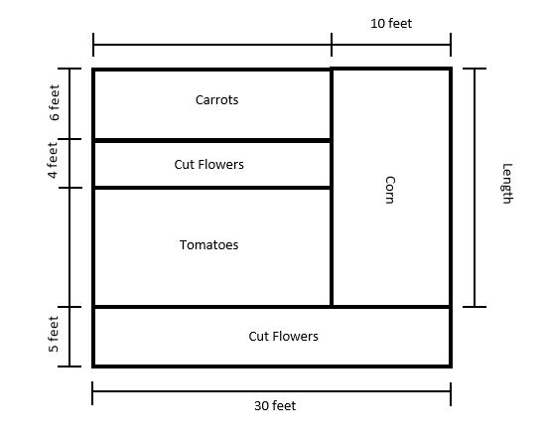
What is the area of each section of the garden?
- What is the area of the section where corn is going to be planted?
- What is the area of the section where tomatoes are going to be planted?
- What is the area of the section where carrots are going to be planted?
- What is the total area of the garden?
Enter your work and your answers in the space provided.

