Aiden’s Work

Aiden thinks that ¼ = ½. He drew the number lines below to show that ¼ = ½.
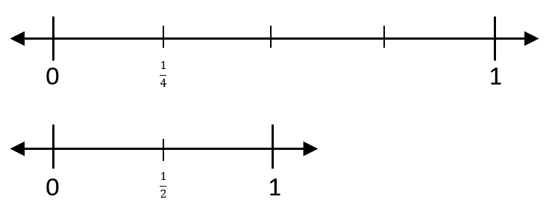

- Explain why Aiden’s thinking is incorrect.
- Write the correct comparison for 1/4 and 1/2 using < or >.

Enter your explanation and answer below.

