Pizza for Dinner

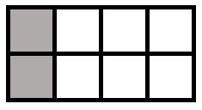
McKinley and Delaney had pizza for dinner. The image shows the fraction of a pizza that each girl ate.
McKinley’s Pizza Delaney’s Pizza

Part A
- How much pizza did McKinley eat?
- How much pizza did Delaney eat?

Enter the fraction of the pizza that each girl ate in the space provided.

Part B

Delaney stated that she ate more pizza than McKinley because she had two pieces and McKinley only had one.
Delaney is incorrect in her reasoning.
- Explain why Delaney’s reasoning is incorrect.
- Write a correct comparison that shows the amount of pizza both girls ate for dinner.

Enter your answer and your explanation in the space provided.

