Fractions On A Number Line

Part A
Which number line shows a point at $\frac{8}{6}$ ?
Circle the point on the number line that shows $\frac{8}{6}$.

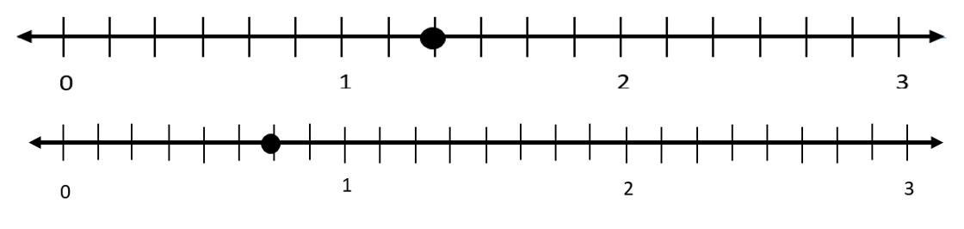

Part B
Explain how you know your selection is correct.

