Parts of a Pool

The county is building a new pool. The pool has a width of 11 meters. The length of the lap pool is 3 meters more than the diving and shallow areas.

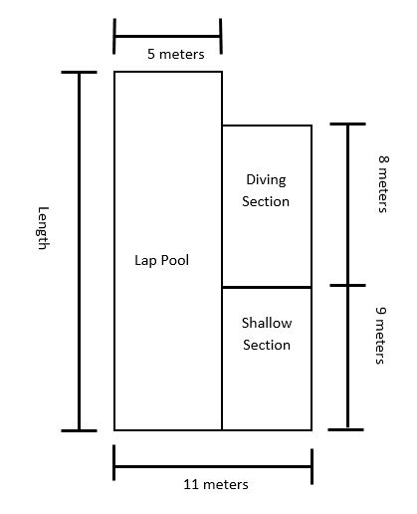
- What is the area of the lap area? Show your work.

- What is the area of the diving section? Show your work

- What is the area of the shallow section? Show your work.

- What is the total area of the pool? Show your work.

