Samantha’s Day

Part A
The analog clock shows the time school begins.
Plot the time school begins on the number line below.
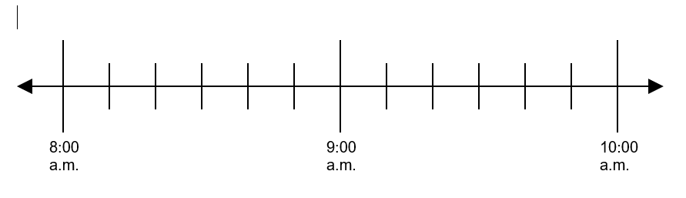

Part B
It takes Samantha twenty minutes to walk to school. At what time did Samantha leave her house to get to school on time? Use the number line to help explain your thinking.
Enter your answer and your explanation in the space provided.

Part C
Samantha attends an assembly as soon as school begins. The assembly is 40 minutes long. At what time is the assembly over? Use the number line to help explain your thinking.
Enter your answer and your explanation in the space provided.

