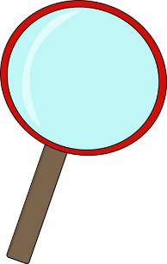Science 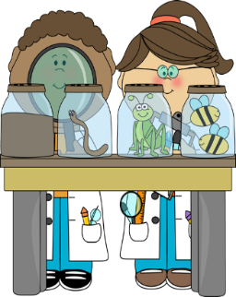

conclude
discover
explore
identify
investigate
observe
read
scientist
write

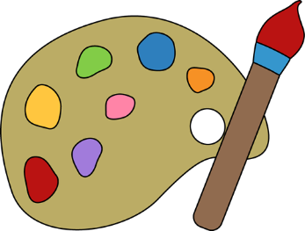Art 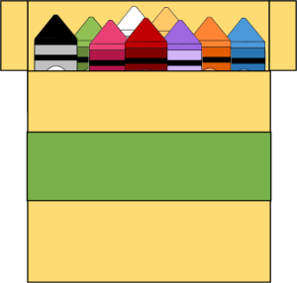

artist
artwork
build
construct
create
decorate
design
draw
illustrate
imagine
masterpiece
model

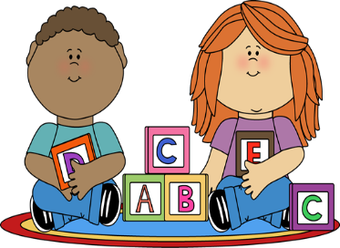Construction
assemble
build
create
construct
cooperate
design
imagine
plan
read
write

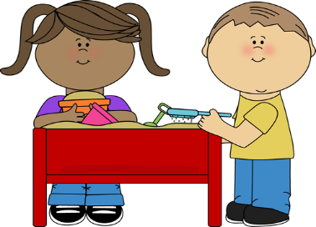Sensory

bumpy
damp
dull
feel
fluffy
feathery
hard
hear
rough
see
senses
shiny
smell
smooth
soft
spongy
taste
texture
touch

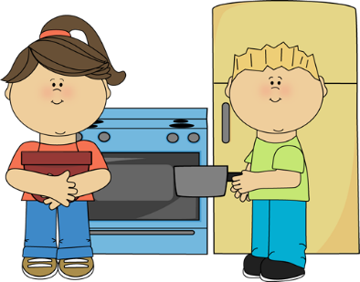Dramatic Play

baker
career
chef
cooperate
gather
groceries
ingredients
meal
prepare
pretend
read
recipe
responsible
select
write

Writing Center 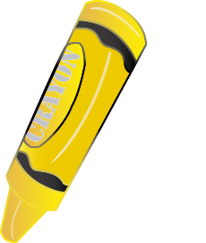

author
details
draft
draw
events
ideas
illustrate
publish
sentences
sequence
topic
words
write

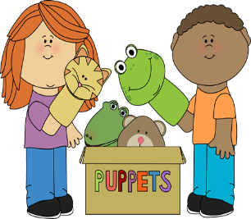Puppet Center

actor
actress
actions
baker
character
events
problem
role
scene
setting
solution
theater

Technology Center

app
cursor
icon
internet
mouse
search
type

