Library
At the library center I am:
* developing print awareness
* recognizing letters and sounds
* reinforcing high frequency words
* building my vocabulary
* retelling stories
Dramatic Play
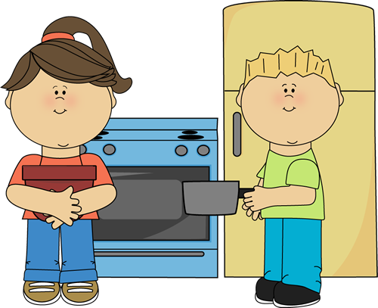
At the dramatic play center I am:
* recognizing that people make economic choices
* recognizing likeness and differences in self and families
* recognizing that resources are used to make products

Construction
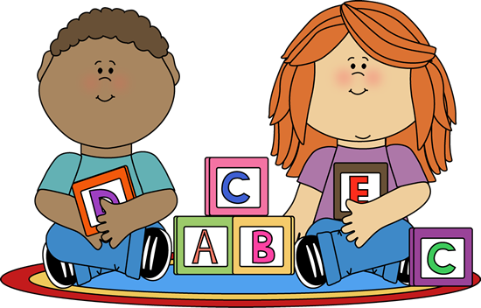
At the construction center I am:
* making a plan and following through
* practicing problem solving
* developing spatial concepts
* working collaboratively on projects
* improving language skills
Creation Station
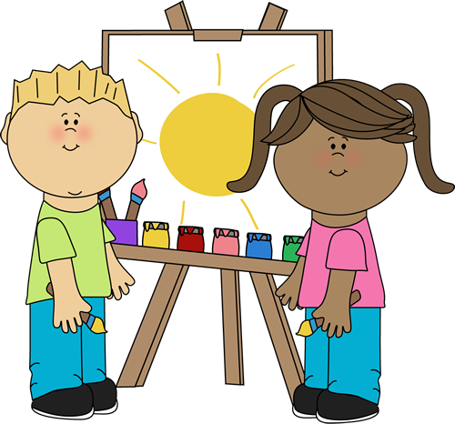
At the creation station center I am:
* developing fine motor skills
* engaging in creative expression
* improving hand eye coordination
* working collaboratively on projects
* communicating ideas
Science
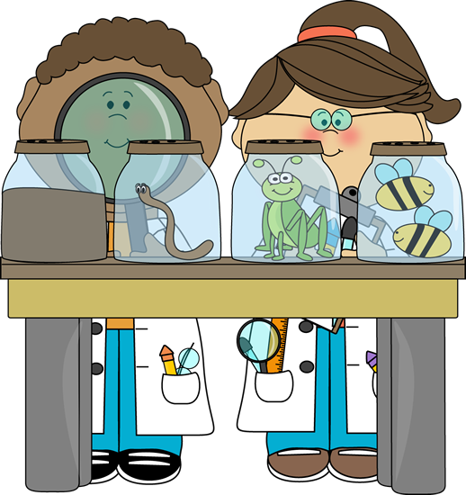
At the science center I am:
* asking and answering questions
* investigating using tools and equipment
* using senses to observe and describe
* comparing objects
Writing
At the writing center I am:
* engaging in creative expression
* developing fine motor skills
* developing sequential concepts
* working collaboratively on projects
* communicating ideas
Technology
At the technology center I am:
* recognizing letters and sounds
* practicing listening skills
* developing listening comprehension
* working on counting and numeracy
* practicing math concepts
* improving phonological awareness
Sensory
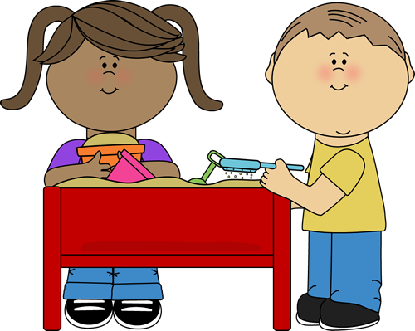
At the sensory table center I am:
* using my senses to describe
* sorting and classifying
* working collaboratively
* developing language skills
* investigating using tools
Puppets
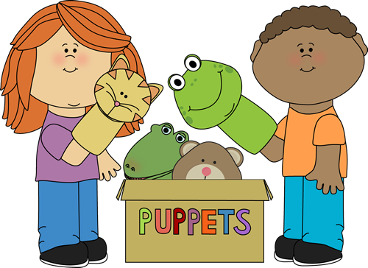
At the puppets center I am:
* practicing listening and speaking skills
* recognizing letters and sounds
* developing creativity
* working collaboratively
Math
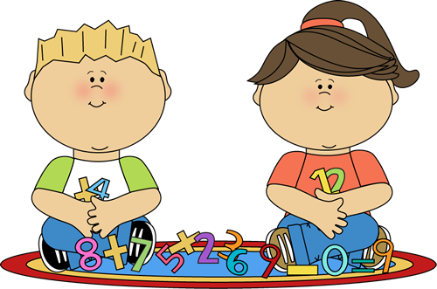
At the math center I am:
* developing numeracy
* sorting and classifying
* counting and creating sets
* exploring geometry
* identifying shapes
Literacy
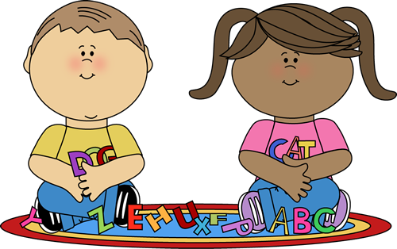
At the literacy center I am:
* identifying letter names
* producing letter sounds
* practicing phonological awareness skills
* working with words

