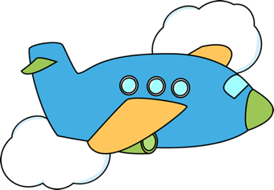

Fly Away Airport

Flight 123

Flight to: Orlando, Florida

Seat 1
Row 1

Thank you for flying
with us today!

Enjoy your flight!

Fly Away Airport

Flight 123

Flight to: Orlando, Florida

Seat 1
Row 1

Thank you for flying
with us today!

Enjoy your flight!

