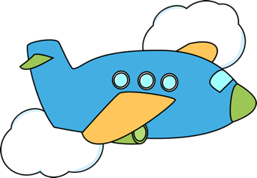Fly Away Airport

I want to fly to…
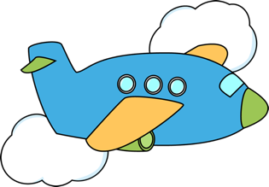Fly Away Airport

I want to fly to…

