Teacher: Michelle Tschantre |  | School: Eastern North Carolina School for the Deaf
Title of Unit: Continents, Oceans, Prime Meridian, Equator, Hemispheres
Grade Level: 6th | Estimated Class Time: 3 Days (9/30-10/2) |  |  | Objectives: 6.G.2.1
Materials and Resources:  - 3 pictures of the globe  - One 9x9 sheet of paper  - Continents, Oceans, Prime Meridian, Equator, Hemispheres PowerPoint  - Coloring Quick Check  - Cut and Paste Labeling Quick Check  - Hemisphere Quick Check  - Review Sheet  - Test |  |  | Lessons
Day 1:
- Do Now Vocabulary
- Set-up Journal using the 3 pictures of the globe and the 9x9 paper. Exemplar located in the teacher’s copy.
- Complete Oceans and continents in journal using the oceans and continents slides in PowerPoint
- Complete Coloring Quick Check
Overview:  - Student will have a pretest on maps to help show a baseline of understanding.  - Student will create a foldable to help in understanding of Continents, Oceans, Prime Meridian, Equator, Hemispheres  - Student will have a review activity  - Student will take a test |  |  | Day 2  - Do Now Vocabulary  - Complete prime meridian and equator section in journal using the prime meridian and equator and continents slides in PowerPoint  - Complete Cut and Paste Labeling Quick Check  - Complete hemisphere, prime meridian, and equator section in journal using the oceans and continents slides in PowerPoint  - Complete Hemisphere Quick Check
Do Now Words: Governor, Great Depression, Hydroelectricity, Immigration |  |  | Day 3  - Complete review work.  - Correct needed review questions  - Study  - Test
Do Now:  A PowerPoint will be up upon entering the classroom. Students will retrieve notebook from their cubby as they enter. Students will copy down the definition, and any other helpful information. They then will need to draw a picture representing the word. After 5 minutes, the teacher will sign the information for the students and prompt answers for the critical thinking question. After students should then go to their assigned cubby and switch out journals. |  |  | Vocabulary: Continents, Oceans, Prime Meridian, Equator, Hemispheres, Asia, Africa, North America, South America, Europe, Australia, Antarctica, Arctic Ocean, Atlantic Ocean, Indian Ocean, Pacific Ocean, Southern Ocean, Northern Hemispheres, Southern Hemispheres, Eastern Hemispheres, and Western Hemispheres.
Goals:  - Students will locate and label:  - The continents  - The oceans  - The equator  - The prime meridian.  - The hemispheres |  |  | Assessment:  - Completed Interactive Journal  - Completed Summative Quick Checks  - Review  - Summative Test
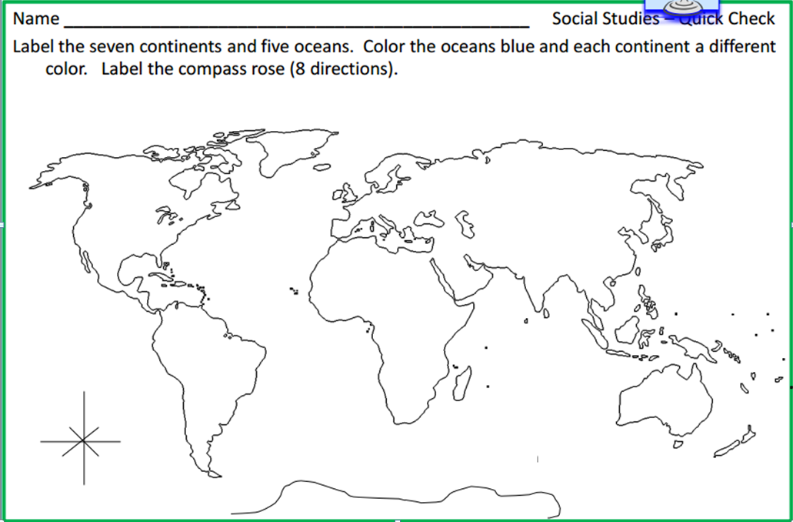
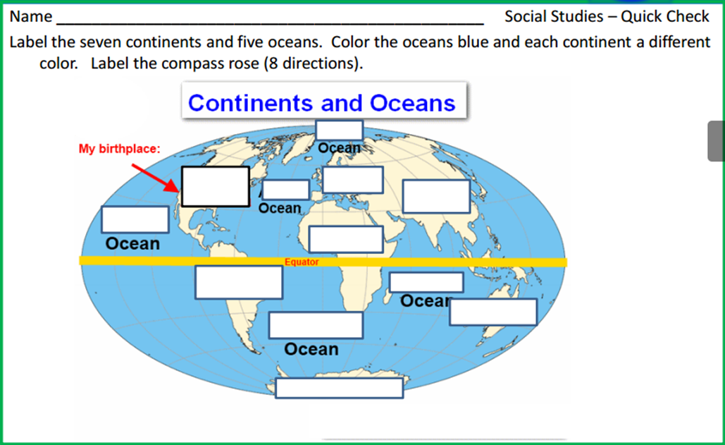
Word Box
Cut out the following words and paste them in their right places:
Asia Africa North America South America Europe Australia Antarctica Arctic Atlantic Indian Pacific Southern

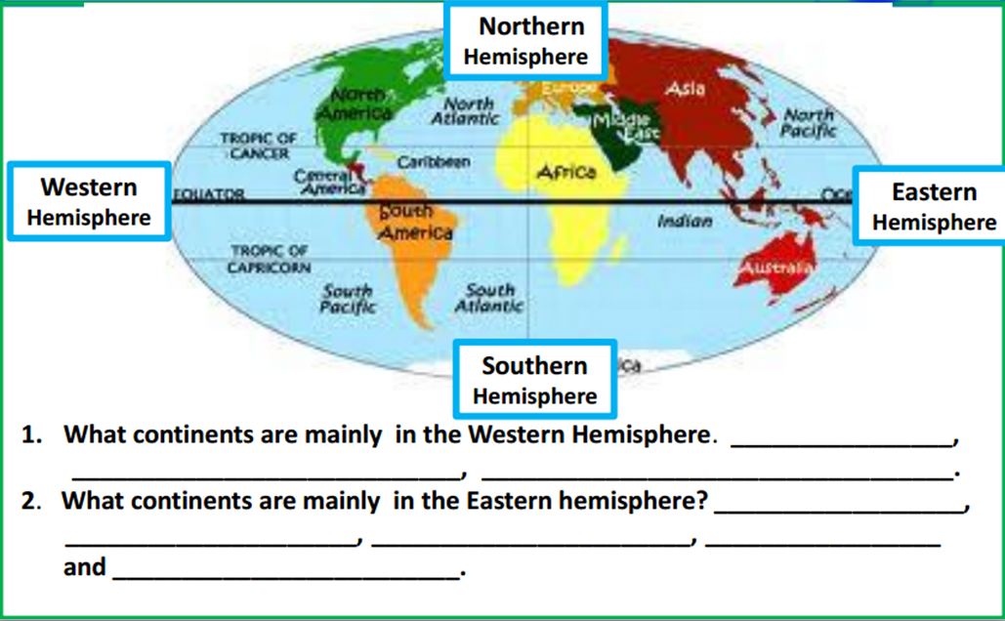
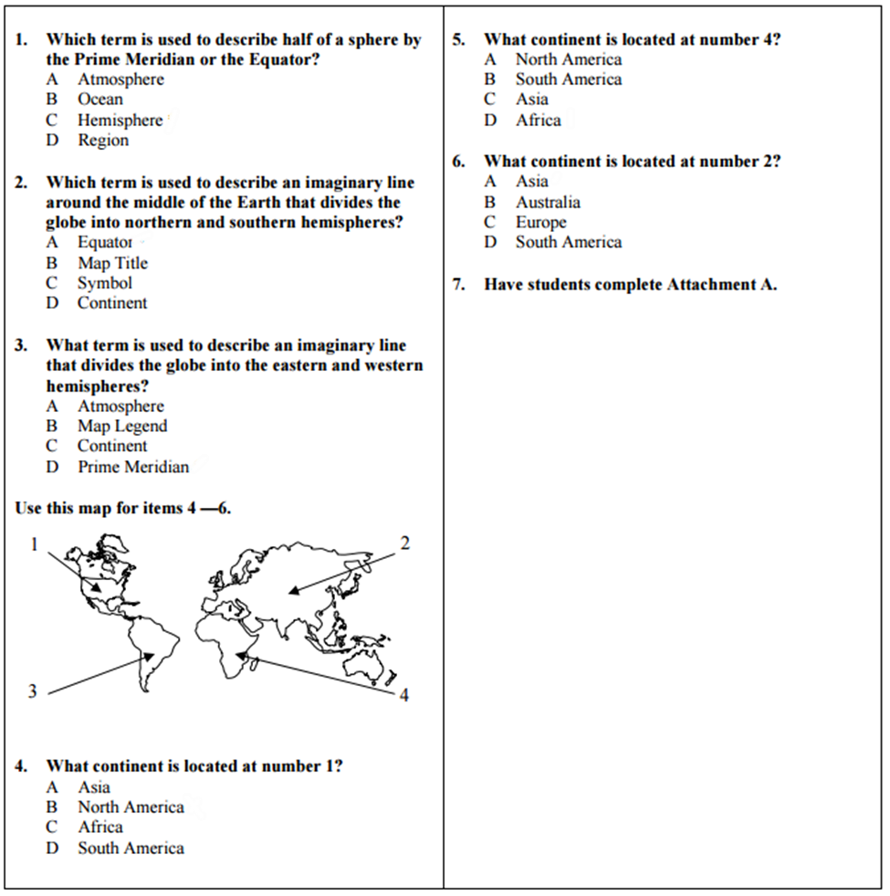
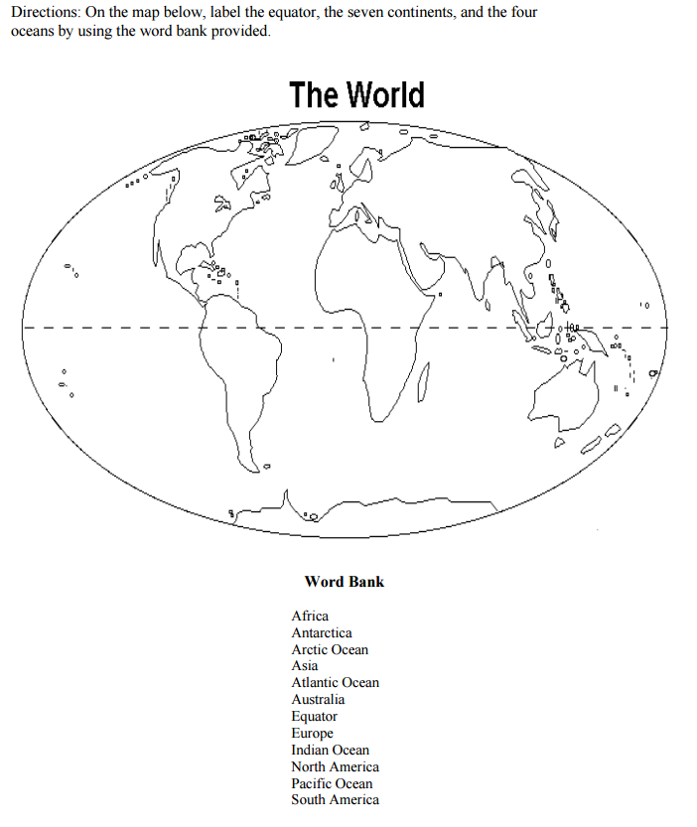

Name:____________________________________ Date:__________________ Period:_______
This is a pre-test and not for a grade. Do Your Best!
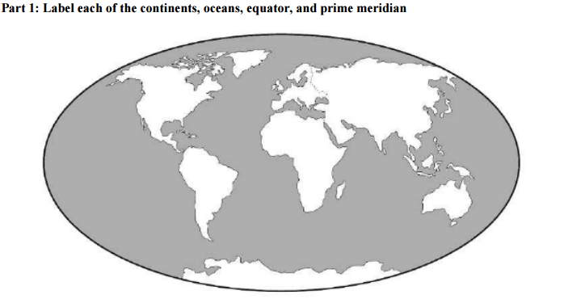
Word Bank:
- North America - South America - Europe - Asia - Australia - Antarctica - Africa - Atlantic Ocean
- Southern Ocean - Arctic Ocean - Indian Ocean - Equator - Pacific Ocean - Prime Meridian

