Results of the 2017 Science Survey

Education – Core Content Areas – Accountability Program

The following is a summary of the surveys of local school systems conducted pursuant to House Bill 1227: Education-Core Content Areas-Accountability Program. The information was gathered in the fall of 2017. The 2017 administration of the science survey contained edited questions to better reflect and inform the legislatively mandated areas of focus regarding the progress being made on the implementation of the Next Generation Science Standards (NGSS) within the Local Education Agencies (LEAs): instructional time for science, availability and use of appropriate instructional materials aligned to the NGSS, instructional technology, and teacher certification. Click here for more to learn about the how the survey was conducted.

The number of respondents to the surveys:

Grade Band | Teachers | Supervisors | Districts
Elementary | 4550 | 75
Middle | 1538 | 52
High | 1693 | 50
Total | 7678 | 94 | 24

2017 Summary:
The 2017 survey indicates an increase in the number of hours spent on content aligned to NGSS in the science classroom per week. There has also been an increase in resource availability aligned to NGSS. While there remains room for improvement, these indicators are encouraging regarding science instruction and NGSS implementation. Data regarding professional development indicates a continuing need across grade bands. Specific teacher comments suggest overall interest and increased comfort with NGSS for those who have experienced targeted professional development to support 3D instruction. Classes being taught by teachers out of their certification area are still problematic however substantially more classes are taught by teachers certified in the subject.

Summary of Science Teacher Survey

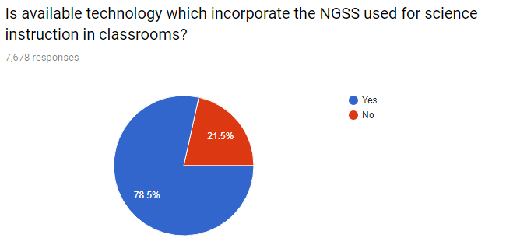

Summary of Science Supervisor Survey

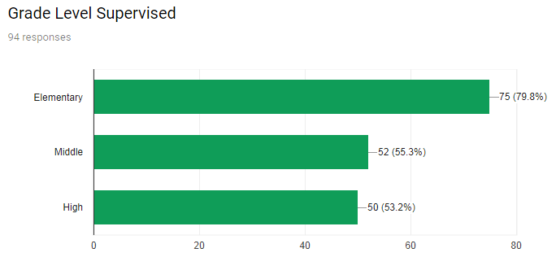
Conclusion
Educators continually improve their practice by learning from and with others and exploring proven and promising practices that leverage technology to improve student learning. Model and nurture creativity and creative expression to communicate ideas, knowledge or connections.

Note:

Mentiría si dijera que era del todo nuevo el sentimiento de que ya no iba a poder ser más que lo que era, que era un hombre que había envejecido más de lo que suponía, que había sospechado tener toda la vida por delante y había ido dejando pasar los años a la espera de que llegara su momento, y ahora la tenía a su espalda. La vida pospuesta para cuando las condiciones fueran favorables. Vivir en una suerte de provisionalidad que le había empujado a aplazarlo todo.

