If you are asking yourself what you can do to help students, we have the answers!
Help us Save Energy!!

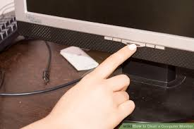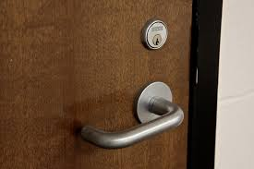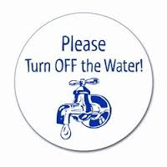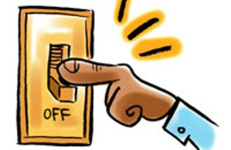

By making sure monitors are off when not in use, classroom doors are closed, faucets are turned off, and lights aren’t being used when not in the classroom

YOU can help our school conserve energy too!

