Online Psychology Course Activity – “Making Concept Connections Using Twitter”

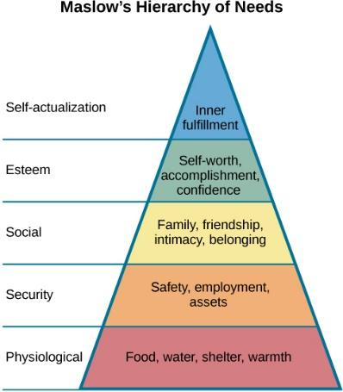
Created By: Dr. Sally B. Seraphin, University of Tennessee-Knoxville

Purpose:
- Students develop and demonstrate mastery on important topics in the discipline by drawing connections between important principles and terminology in the field.
- Students increase digital literacy through their academic use of social media.

Course Topic Addressed by Activity:
- Abraham Maslow’s Hierarchy of Needs

[Image Source - Figure 7: Openstax Psychology, Chapter 10]

Instructions:
- Read Section 10.1 of OpenStax Psychology
- Log-into or Set-Up a Twitter Account at https://twitter.com
- Using Abraham Maslow’s Hierarchy as a guide, find a Tweet that represents or expresses one of Maslow’s needs.
- Re-Tweet this post to our course’s Twitter feed (i.e., #PSYC320), including a 140 character statement on (1) how it relates to (2) one of the levels in Maslow’s Hierarchy.
- Check the Twitter feed on our course site (e.g., Canvas) and comment on the Maslow-related tweets from other students.

Example Submission (Tweet):
