Your Personal Zoo
Instructor Resources

This activity is designed to introduce students to the microbiome and common human conditions influenced by the microbiome. Students can work individually or in pairs/small groups (up to 4) and will produce a presentation as a result of their research. The presentations could be oral in class, a short video, or a Powerpoint presentation.

Learning Outcomes:
Students will understand the concepts of commensalism and symbiotic relationships and the effect of perturbing these communities on human health.

Learning Objectives:
Be able to describe the resident microbiota in selected locations of the human body.
Be able to explain the potential outcomes of disturbing the human microbiota.

Additional Resources:
Learn Genetics - The Human Microbiome Page
HHMI- I contain Multitudes Video Series
Science Friday--Scientist who tracked his gut microbiome daily for over a year
https://www.sciencefriday.com/segments/tracking-the-daily-rhythms-of-the-microbiome/

Your Personal Zoo
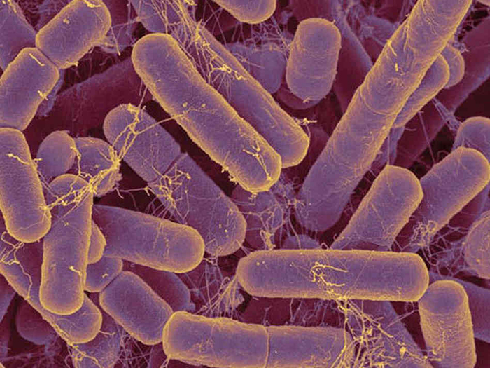
Instructions:
- Complete the reading below.
- Use the provided links to explore the basics of your microbiome.
- Prepare a presentation/activity to share with your classmates.

- Reading

From boiling thermal hot springs to deep beneath the Antarctic ice, microorganisms can be found almost everywhere on earth in great quantities. Microorganisms (or microbes, as they are also called) are small organisms. Most are so small that they cannot be seen without a microscope. Most microorganisms are harmless to humans and, in fact, many are helpful. They play fundamental roles in ecosystems everywhere on earth, forming the backbone of many food webs. People use them to make biofuels, medicines, and even foods. Without microbes, there would be no bread, cheese, or beer. Our bodies are filled with microbes, and our skin alone is home to trillions of them.¹ Some of them we can’t live without; others cause diseases that can make us sick or even kill us. Although much more is known today about microbial life than ever before, the vast majority of this invisible world remains unexplored. Microbiologists continue to identify new ways that microbes benefit and threaten humans.

Scientists have coined the term microbiome to refer to all prokaryotic and eukaryotic microorganisms that are associated with a certain organism or environment. Within the human microbiome, there are resident microbiota and transient microbiota. The resident microbiota consists of microorganisms that constantly live in or on our bodies. The term transient microbiota refers to microorganisms that are only temporarily found in the human body, and these may include pathogenic microorganisms. Hygiene and diet can alter both the resident and transient microbiota.

The resident microbiota is amazingly diverse, not only in terms of the variety of species but also in terms of the preference of different microorganisms for different areas of the human body. For example, in the human mouth, there are thousands of commensal or mutualistic species of bacteria. Some of these bacteria prefer to inhabit the surface of the tongue, whereas others prefer the internal surface of the cheeks, and yet others prefer the front or back teeth or gums. The inner surface of the cheek has the least diverse microbiota because of its exposure to oxygen. By contrast, the crypts of the tongue and the spaces between teeth are two sites with limited oxygen exposure, so these sites have more diverse microbiota, including bacteria living in the absence of oxygen (e.g., Bacteroides, Fusobacterium). Differences in the oral microbiota between randomly chosen human individuals are also significant. Studies have shown, for example, that the prevalence of such bacteria as Streptococcus, Haemophilus, Neisseria, and others was dramatically different when compared between individuals.¹

There are also significant differences between the microbiota of different sites of the same human body. The inner surface of the cheek has a predominance of Streptococcus, whereas in the throat, the palatine tonsil, and saliva, there are two to three times fewer Streptococcus, and several times more Fusobacterium. In the plaque removed from gums, the predominant bacteria belong to the genus Fusobacterium. However, in the intestine, both Streptococcus and Fusobacterium disappear, and the genus Bacteroides becomes predominant. Not only can the microbiota vary from one body site to another, the microbiome can also change over time within the same individual. Humans acquire their first inoculations of normal flora during natural birth and shortly after birth. Before birth, there is a rapid increase in the population of Lactobacillus spp. in the vagina, and this population serves as the first colonization of microbiota during natural birth. After birth, additional microbes are acquired from health-care providers, parents, other relatives, and individuals who come in contact with the baby. This process establishes a microbiome that will continue to evolve over the course of the individual’s life as new microbes colonize and are eliminated from the body. For example, it is estimated that within a 9-hour period, the microbiota of the small intestine can change so that half of the microbial inhabitants will be different.² The importance of the initial Lactobacillus colonization during vaginal child birth is highlighted by studies demonstrating a higher incidence of diseases in individuals born by cesarean section, compared to those born vaginally. Studies have shown that babies born vaginally are predominantly colonized by vaginal lactobacillus, whereas babies born by cesarean section are more frequently colonized by microbes of the normal skin microbiota, including common hospital-acquired pathogens.
Throughout the body, resident microbiotas are important for human health because they occupy niches that might be otherwise taken by pathogenic microorganisms. For instance, Lactobacillus spp. are the dominant bacterial species of the normal vaginal microbiota for most women.

1 J. Hulcr et al. “A Jungle in There: Bacteria in Belly Buttons are Highly Diverse, but Predictable.” PLoS ONE 7 no. 11 (2012): e47712. doi:10.1371/journal.pone.0047712.
2 E.M. Bik et al. “Bacterial Diversity in the Oral Cavity of 10 Healthy Individuals.” The ISME Journal 4 no. 8 (2010):962–974.
3 C.C. Booijink et al. “High Temporal and Intra-Individual Variation Detected in the Human Ileal Microbiota.” Environmental Microbiology 12 no. 12 (2010):3213–3227.

OpenStax Microbiology, Microbiology . OpenStax CNX. Apr 4, 2018 http://cnx.org/contents/e42bd376-624b-4c0f-972f-e0c57998e765@4.50.

Download for free at http://cnx.org/contents/e42bd376-624b-4c0f-972f-e0c57998e765@4.50.

Note: Recall that when writing a taxonomic name, the Genus is capitalized, the species is lowercase, and that both are either italicized or underlined, as you can see in the reading above.

2. Provided Links
Your Changing Microbiome
Your Microbial Friends

3. Presentation Assignment: Follow your instructor’s directions about selecting one topic from the list below. Each of these topics has a link to the microbiome. Prepare a one-minute presentation addressing the relationship between this condition and the microbiome.

Topics you can research:

Antibiotics
Use of hand sanitizers
C-sections vs. vaginal births
Breast feeding
Obesity
Autoimmune diseases
Autism
Childhood malnutrition
Food poisoning
Probiotics
Acne
Asthma
Allergies
Cancer
Dental cavities
Depression and anxiety
Diabetes
Eczema
Gastric ulcers
Hardening of the arteries
Inflammatory bowel diseases

Rubric for student presentation:

Topic | 1 point | 3 points | 5 points
Set up the problem | Either problem not explained well or context not provided | Problem well explained, but no context provided | Problem well explained, context provided
Bacteria involved in that area of the microbiome | Genus and species not properly written or only provided for 1 or fewer bacteria | Genus and species properly written for 2 or more bacteria involved | Genus and species properly written for 3 or more bacteria involved
What changes in the microbiome | Changes not clearly explained | One change clearly explained | Two or more changes clearly explained
Treatment/solution options | Treatment not fully explained | Treatment explained; timeline not fully explained | Treatment and timeline for recovery fully explained
Conclusion in your own words | Summary does not represent findings | Findings not clearly summarized | Conclusion clearly summarizes the findings

