Energy Transfer: Calorimetry and Chemical Reactions

Learning Objectives
- Explain the technique of calorimetry
- Calculate and interpret heat and related properties using typical calorimetry data
- Write and balance thermochemical equations
- Calculate enthalpy changes for various chemical reactions

Why?

Chemical reactions and/or phase transitions absorb and release energy; we can calculate the amount of energy that chemical reactions and/or phase transitions absorb and release using a technique called calorimetry. Calculating the amount of energy absorbed or release can give us valuable insights into the properties of specific chemical processes and/or chemical reactions.

What?

Calorimetry is used to measure amounts of heat transferred to or from a substance. To do so, the heat is exchanged with a calibrated object (calorimeter). The change in temperature of the measuring part of the calorimeter is converted into the amount of heat. Calorimetry is based on the heat absorbed based on a certain amount of temperature change. Recall that the equation below describes the relationship of heat absorbed or released based on the temperature change and mass.

$$q=mc∆T$$

If we perform a chemical reaction in an isolated environment, like a calorimeter, we can use the equation above to calculate the energy released or absorbed by a chemical reaction. In chemical reactions, energy is either absorbed or released. Work is usually done by the system or on the system by the surroundings. Energy is required to pull apart atoms and break bonds. When bonds are formed, energy is released. Imagine reactions that involves both bond formation and breaking; determining whether the overall reaction is endothermic or exothermic depends on whether there is more energy used in breaking the bonds of the reactants or more energy released in the formation of product bonds. The energy transferred in a reaction under constant pressure conditions is called the enthalpy of reaction ($∆H_{r}^{°}$).

Instructions:
Your instructor will do the gummy bear sacrifice demonstration. The reactions are written below; use them to answer the following questions.

2KClO₃ (s) 2KCl (s) + 3O₂ (g)

C₁₂H₂₂O₁₁ (s) + 12O₂ (g) 12CO₂ (g) + 11H₂O (l)

Observations:
- What forms of energy do you observe during the chemical reaction?

- Do you think the reaction is absorbing or releasing energy from or into the surroundings? Would it be endothermic or exothermic?

Questions:

- Imagine the demo were performed in a calorimeter, like the one below. If the reaction releases heat, what component of the calorimeter would be absorbing that heat?

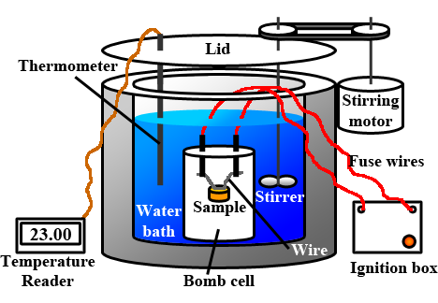

- If the calorimeter contains 150.0 kg of water and the water temperature increases from 23.0°C to 31.9°C during the combustion of sucrose, did the water bath absorb or release energy?

- Calculate the amount of energy the water absorbed or released in question 3.

- What would be the enthalpy of combustion for sucrose (C₁₂H₂₂O₁₁) in the reaction below?

C₁₂H₂₂O₁₁ (s) + 12O₂ (g) 12CO₂ (g) + 11H₂O (l)

- What would be the enthalpy of combustion if 1 mol of sucrose were combusted? If 171.2 g of sucrose were combusted?

- Using the enthalpies of formation ($∆H_{f}^{°}$) of the products and reactants from the table at the end of your book, what would be the $∆H_{r}^{°}$ of the reaction:

2KClO₃ (s) 2KCl (s) + 3O₂ (g)?

- Now that you determined the $∆H_{r}^{°}$ of the two following equations:

2KClO₃ (s) 2KCl (s) + 3O₂ (g) $∆H_{r}^{°}= ________________$
C₁₂H₂₂O₁₁ (s) + 12O₂ (g) 12CO₂ (g) 11H₂O (l) $∆H_{r}^{°}= __________________$

Calculate the enthalpy of reaction for the following reaction.

C₁₂H₂₂O₁₁ (s) + 9O₂ (g) + 2KClO₃ (l) 12CO₂ (g) + 11H₂O (l) + 2KCl (s)

References
- OpenStax Chemistry: Section 5.2 and 5.3
- Calorimeter diagram: https://commons.wikimedia.org/wiki/File:Bomb_Calorimeter_Diagram.png

