STEAM Day Morning Meeting Activity

STEAM Day Schedule
7:30-8:00 CPR
8:00-8:30 STEAM Day Home Room Challenge: Stacking Cups
8:30-9:40 Session 1
9:45-10:55 Session 2
11:00-11:30 Lunch on Team

Stacking Cups Activity

Groups:
4 students will work together to stack the cups
If you need to, you can make groups of 5. Better to have 5 students working to stack cups then 3.

Materials per group:
6 Plastic Cups
1 STEAM Day Logo Mat.
1 STEAM Day Bullseye
1 4-legged Octopus (a cup with a rubber band around it and 4 strings tied to the rubberband.)

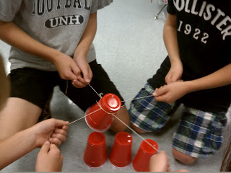
Student using the 4-legged Octopus

Part 1: Stacking the Cups

Objective:
The objective in part one is to stack the 6 plastic cups onto the STEAM Day Bullseye as quickly as possible.

----------------------->

Set Up the Competition:
Teacher: Set up your homeroom groups into a Round Robin. You will have two teams competing against each other to see who can stack the cups on the bullseye the fastest. The top two teams from the Round Robin will go head to head in Part 2: Creating a 3-2-1 Pyramid.

Set Up the Cups:
Have each group of students take a STEAM Day Logo Mat and place it on a flat surface. Place the STEAM Day Bullseye sheet next to the Logo Mat so that two of the long sides of the papers are touching. The students now may place the 6 plastic cups face down anywhere on STEAM Day Logo Mat as long as they are touching the word STEAM. The group of students will then circle around their mats each holding one string of the 4 legged-octopus.

Stacking the Cups:
Give the groups of students 5 minutes of practice time and develop their team work before the competition. Once you begin the competition the students must make a stack of cups on the STEAM Day Bullseye as fast as the can only using the 4 Legged Octopus. If one of the plastic cups tips over, the students must place all the cups back on the STEAM Day logo and start from the beginning.

Part 2: 3-2-1 Pyramid
Once you have your top two teams from your Round Robin you will have them go head to head to see who can stack the cups into a 3-2-1 pyramid anywhere on the STEAM DAY Bullseye mat. As before place the STEAM Day Bullseye sheet next to the Logo Mat so that two of the long sides of the papers are touching. The students now may place the 6 plastic cups face down anywhere on STEAM Day Logo Mat as long as they are touching the word STEAM. The group of students will then circle around their mats each holding one string of the 4 legged-octopus.

