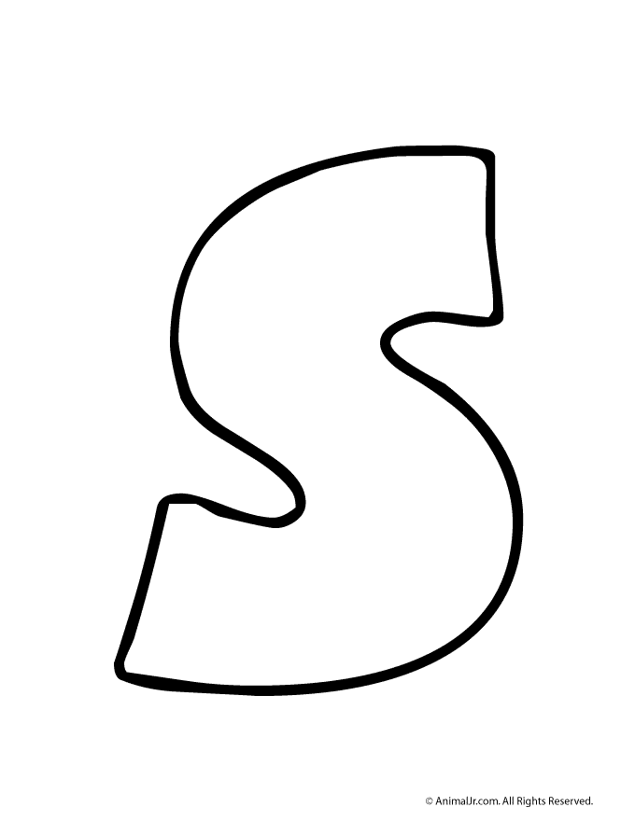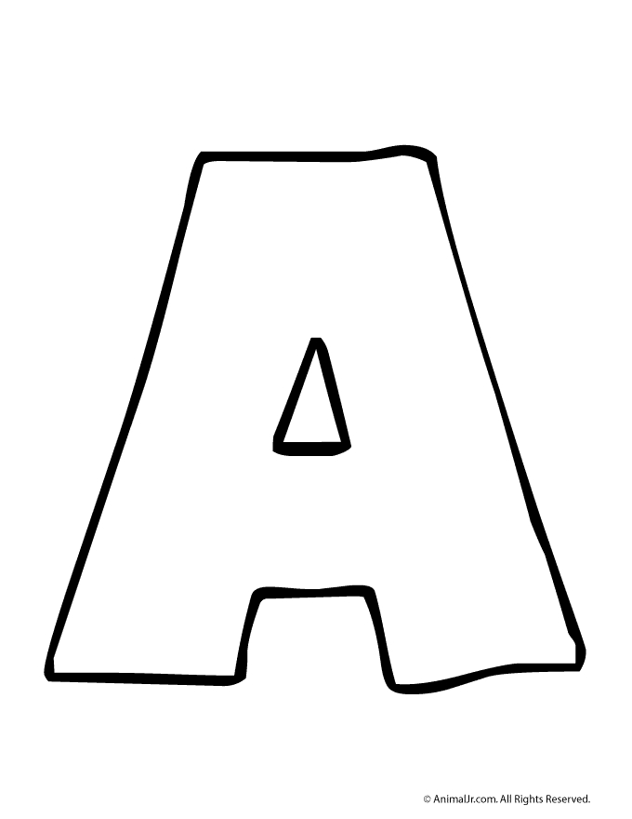

STEAM Day logo design challenge!

This year EMS will be holding the 2nd annual STEAM day to give students an opportunity to explore activities in Science, Technology, Engineering, Art, and Mathematics, but we need your help!

We are running a design challenge from January 8th until January 23rd! Submit your STEAM logo design and be in the running to have your design chosen for our banner!

Contest rules:
This contest is open to all 6th, 7th, and 8th graders.
You must include the 5 letters of STEAM in your design.
You can use the template provided or you may design your own.
Size and paper layout requirements: Landscape set up:
See your science teacher with any questions!

Final designs due to your grade level science teacher by the end of the school day on Tuesday, January 23rd

