Demo4a
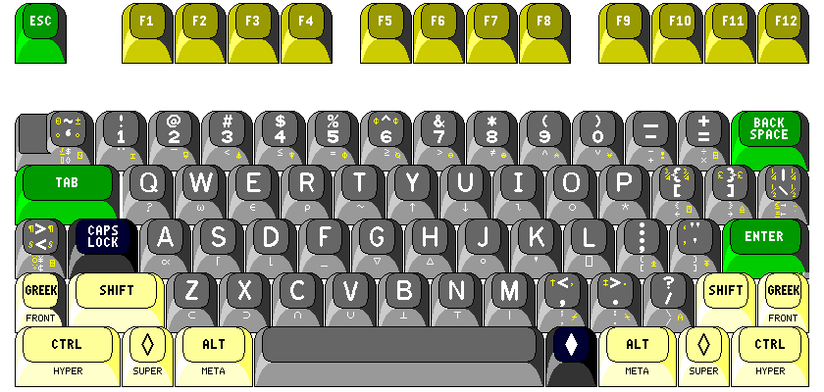
GED Computer Skills

Instructions: In this practice task, you will be using features of the keyboard (shift, delete, enter, backspace, and spacebar) to correct the text below.
Look at the text and complete the following tasks:
- Using the shift key, capitalize the first letter in sentence one.
- Using the spacebar, separate the 3 joined words.
- Using the delete key, delete one of the words ‘taking’
- Using the return key put your cursor between the period (.) after etc and the next sentence. Put that sentence on next line below.
GED Computer Skills
the new GED test series iscomputerbased and has is taken at an approved GED testing center. Some of the most important computer skills when taking taking the essay writing part is the ability to use the mouse skills: click, drag, scroll and word-processing skills involving: basic keyboarding, copy and paste, cut and paste, insert, enter, space etc.These are the same skills that employers look for when hiring the best qualified candidates.

