|  |
| --- |
| **Intersecting lines** |
| ( 0 , 1 ) |
| **Parallel lines** |
| $$( 1 , 2 )$$ |
| **Coincident lines** |
| **( -2 , 3 )** |
| No points |
| $$( 2 , -1 )$$ |
| $$infinite number$$ $$of points$$ |
| **( 1 , 1 )** |

Choose the definition of these cards:

9.3.1

These lines are called ………….

These lines are called ……………



The point of intersection of the 2 lines is …………………….

These lines are called ………….

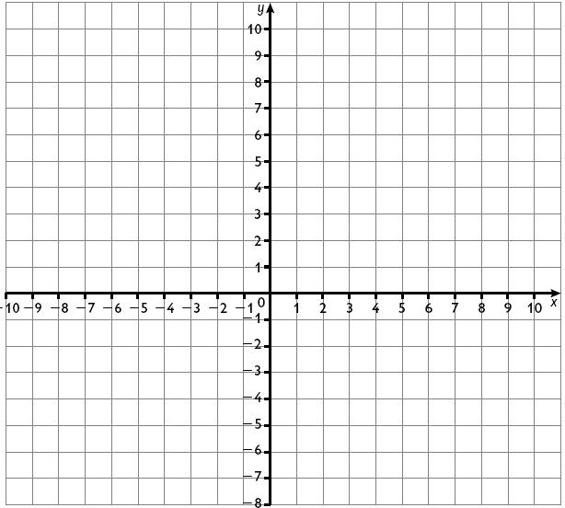



The point of intersection of the 2 lines is …………………

The point of intersection of the

2 lines is ……………………….





The point of intersection of the 2 lines is …………………..

The point of intersection of the 2 lines is …………………………





The point of intersection of the 2 lines is ………………………

The point of intersection of the

2 lines is ………………..



|  |
| --- |
|  |
|  |
|  |
|  |
|  |
|  |
|  |
|  |
|  |
|  |

Choose the definition of these cards:

9.3.1

These lines are called ………….

These lines are called ……………



These lines are called ………….

The point of intersection of the 2 lines is …………………….





The point of intersection of the 2 lines is …………………

The point of intersection of the 2 lines is …………………





The point of intersection of the 2 lines is …………………

The point of intersection of the 2 lines is …………………





The point of intersection of the 2 lines is …………………

The point of intersection of the 2 lines is …………………

