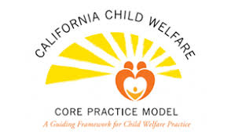 | Trainer/Presenter Guide for  Core Practice Model Overview

Attached is a brief Core Practice Model (CPM) Overview presentation that you can customize in your county. As written, the training takes approximately 1.5 to 2 hours. To modify the training for your county, you may want to have a small working group made up of staff, supervisors, trainers, managers and community, depending on how you organize training in your county.

Following are items you may want or need to prepare for the overview:

Materials:
- PowerPoint slides, projector and screen
- Flip charts for the room and/or each table
- Post-it sticky notes and pens for each table
- Handouts of the slides
- Handouts of the CPM overview and practice behaviors

Setup:
- Setup is small group, as there is a group activity
- Suggest having table rounds that can hold 5-8 people at each table

Sample Agenda (post on flip chart in room):
- Welcome & Introductions
- Icebreaker or Centering Activity (see attached example activity)
- Purpose: Provide an overview of the CPM
- Objectives:
- Say the practice behaviors out loud and identify the ways in which we are already using these in our everyday interactions
- Identify one practice area to work on
- Content – Overview of CPM
- Next Steps
- Plus/Delta

Sample Icebreaker:
There are two ways to approach this activity:
- Make a copy for every participant, then have them go around the room and ask another person to answer one; or
- If time is short or the group is large, pick 2-3 and write on a board or flop chart, and then ask participants to answer one of them.

