Development of the cell theory
Create a timeline that illustrates the contributing cell theory scientists.
CATEGORY | DESCRIPTION
Overall Presentation  (4 points) | The title represents the content well and is neat and easy to read. 2 pts  Poster is neat, accurate and attractive.
4 illustrations  (2 points) | 4 illustrations are included  2 pts |  | Each illustration enhances the timeline  2 pts
Janssen  (2 points) | Produced first compound micro | Dutch lens grinder (spectacle maker) | Made a telescope
Hooke  (3 points) | Thin slices of cork | Coined the term cells | Feud with Newton | Documented work in Micrographia
Leeuwenhoek  (3 points) | Viewed unicellular organisms | “Animalcules” | Dutch lens maker | Pond scum, teeth scrapings
Brown  (2 points) | English botanist | Discovered nucleus | Crucial part of living things
Schleiden  (3 points) | All plants composed of cells | German | Built on work of Dutrochet | Believed in free cell formation
Schwann  (2 points) | All animals composed of cells | German | Built on work of Dutrochet
Virchow  (3 points) | All cells come from cells | Jewish/German | Borrowed from Remak | Experimented with diseases
Overall  (8 points) | All 3 statements of cell theory are included and accurate.  All dates and names included and accurate (0.25/each)

Development of the cell theory
Create a timeline that illustrates the contributing cell theory scientists.
CATEGORY | DESCRIPTION
Overall Presentation  (4 points) | The title represents the content well and is neat and easy to read. 2 pts  Poster is neat, accurate and attractive.
4 illustrations  (2 points) | 4 illustrations are included  2 pts |  | Each illustration enhances the timeline  2 pts
Janssen  (2 points) | Produced first compound micro | Dutch lens grinder (spectacle maker) | Made a telescope
Hooke  (3 points) | Thin slices of cork | Coined the term cells | Feud with Newton | Documented work in Micrographia
Leeuwenhoek  (3 points) | Viewed unicellular organisms | “Animalcules” | Dutch lens maker | Pond scum, teeth scrapings
Brown  (2 points) | English botanist | Discovered nucleus | Crucial part of living things
Schleiden  (3 points) | All plants composed of cells | German | Built on work of Dutrochet | Believed in free cell formation
Schwann  (2 points) | All animals composed of cells | German | Built on work of Dutrochet
Virchow  (3 points) | All cells come from cells | Jewish/German | Borrowed from Remak | Experimented with diseases
Overall  (8 points) | All 3 statements of cell theory are included and accurate.  All dates and names included and accurate (0.25/each)

Cell Theory Summarizer
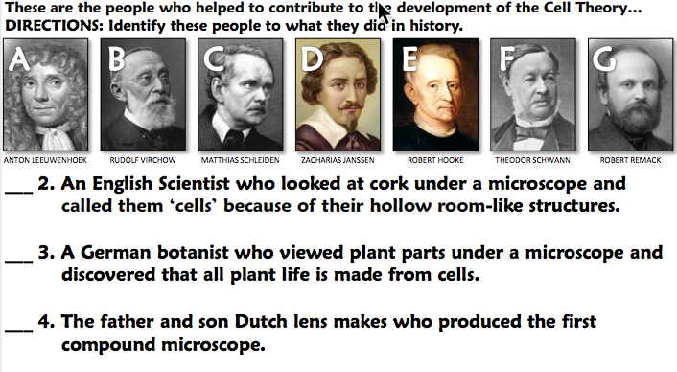
1. In your own words, describe a cell:

