Types of Radioactive Decay - Reading Guide

*Sections 21.1–21.3 in OpenStax*

**Nuclear Structure and Stability (Section 21.1)**

A **nuclide** refers to ________________________________________________________.

Complete the following table:

|  |  |  |
| --- | --- | --- |
|  | *symbol* | *definition* |
| Mass number |  | #protons + # neutrons |
| Atomic number | Z |  |

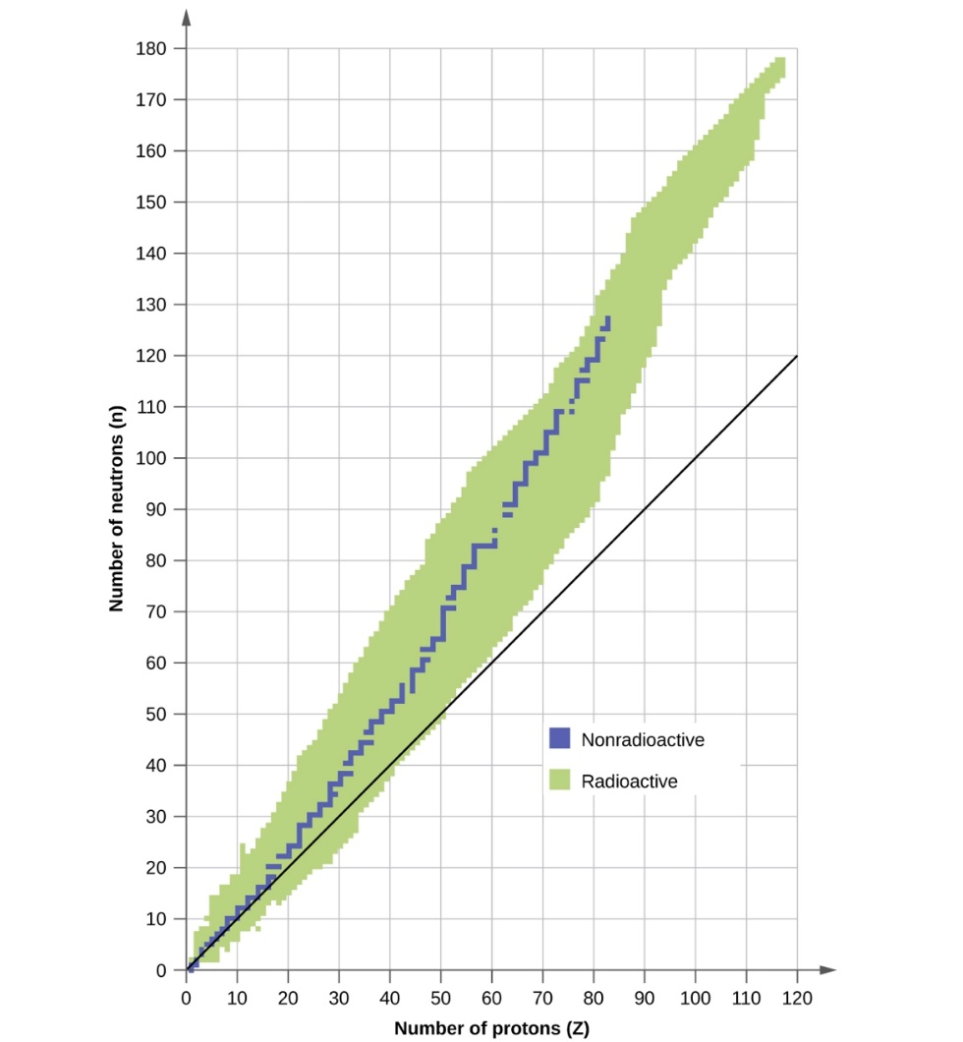In the graph below (Figure 21.2 in OpenStax), the blue data points represent stable nuclides. The straight line represents a 1:1 neutron:proton ratio.

Figure 21.2 from OpenStax

Heavy nuclides need a ______________ *(higher/lower)* ratio of neutrons to protons to be stable.

Are even or odd numbers of protons and neutrons more likely to be stable? _____________

What are **magic numbers**?

**Nuclear Equations (Section 21.2)**

Use Figure 21.4 to complete the following table.

|  |  |  |
| --- | --- | --- |
| **Species involved in nuclear reaction** | **Symbol** | **Description** |
| Alpha particle |  |  |
|  | $${}_{–1}^{0}β$$ |  |
|  |  | Very high energy electromagnetic radiation |
| Positron |  |  |
| Electron |  | Nuclei of hydrogen atoms |
|  | $${}_{1}^{0}n$$ |  |

**Radioactive decay (Section 21.3)**

|  |  |  |  |
| --- | --- | --- | --- |
| **Radiation** | **Example** | **Change in mass number (A)** | **Change in atomic number (Z)** |
|  |  | Decrease by 4 | Decrease by 2 |
| Beta decay |  |  |  |
|  |  | Unchanged | Unchanged |
| Positron emission |  |  |  |
| Electron capture |  |  |  |

Which type of radioactive decay changes the mass number AND the atomic number?

Which type of radioactive decay has NO EFFECT on the mass number AND the atomic number?

Refer back to Figure 21.2 on the first page and consider which of the radioactive **decay** processes are likely to occur in order to reach stability in the following scenarios.

* If the nuclide is **above** the valley of stability, the n/Z ratio is too _____________ *(high/low)* and it will undergo _________________ decay to reach the valley of stability.
* If the nuclide is **below** the valley of stability, the n/Z ratio is too _____________ *(high/low)* and it will undergo _______________________ decay or _______________________decay to reach the valley of stability.

Balancethe following nuclear equations:

+ ______ 

______ 

Pd-103 undergoes electron capture:

Tl-207 undergoes beta decay:

**End of Chapter 21 Practice Problems**

#3, 5, 9a–d, 13

For detailed solutions to these problems, go to the [OpenStax website](https://openstaxcollege.org/textbooks/chemistry/resources) and download the “Student Answer and Solution Guide.”