Reaction Mechanisms - Reading Guide
sections 12.6 and 12.7 in OpenStax

Reaction Mechanisms (section 12.6)
A reaction mechanism is ___________________________________________________________________.
Each step in a reaction mechanism is an ___________________________.

A reaction intermediate is ______________ in one elementary step and _______________ in another.

Elementary steps are characterized by their molecularity.
Define molecularity:

Complete the following table to characterize each elementary step.

Elementary Step | Molecularity | Rate Law
A products
A + B products
2 A products
3 A products
2 A + B products

The rate-determining step is the _____________________________________________________________.

The rate law for the overall reaction is determined from ______________________ and is used to deduce the _____________________.

For a proposed reaction mechanism to be valid, two conditions must be met:

1. The elementary steps in the mechanism must sum to the __________________________________.

2. The rate law predicted by the mechanism must be consistent with the ________________________.

Catalysts (section 12.7)

A catalyst is ____________________________________________________________________.

The energy diagram below shows the uncatalyzed pathway for a reaction. Sketch a curve that could represent a catalyzed pathway that has a two-step mechanism with the slow step being the first step.

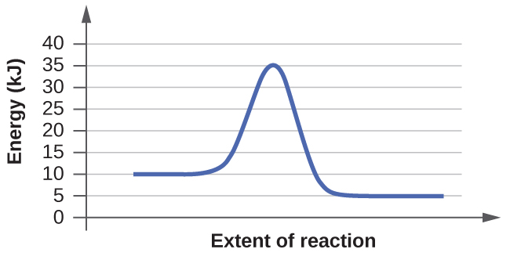

In a homogeneous catalysis, the catalysis exists in the ______________ phase as reactants.

In a heterogeneous catalysis, the catalysis exists in a ______________ phase than the reactants.

End of Chapter Practice Problems

#69, 71, 73, 81
For detailed solutions to these problems, go to the OpenStax website and download the “Student Answer and Solution Guide.”

