Reaction Rates - Reading Guide
section 12.1 in OpenStax

Rates of Chemical Reactions

Rate = change in ____________________________ divided by change in ___________________.

The general unit for rate is ________________.

As time progresses, the concentration of the reactants ________________________ (decreases/increases).

As time progresses, the concentration of the products ________________________ (decreases/increases).

For the following reaction, express the rate with respect to A, B and C. The first one, A, is done for you.
3A + 2B → 4C
$Rate= – \frac{1}{3} \frac{∆[A]}{∆t}$

What does t represent in the above equations? ________________________

What do the brackets represent in the above equation? ___________________________________

If the concentration of A decreases from 0.010 M to 0.005 M over a period of 100.0 seconds, show how you would calculate the average rate of disappearance of A.

(ans. 5.0 × 10^{–5} M/s)

Use your answer above to show how you would calculate the average rate of appearance of C.

(ans. 6.7 × 10^{–5} M/s)

Instantaneous Rates
The instantaneous rate of a reaction is the ______________________________________________________.

How is the instantaneous rate different from the average rate of a reaction?

Show how you would calculate the instantaneous rate at 10.0 hours using the graph below.
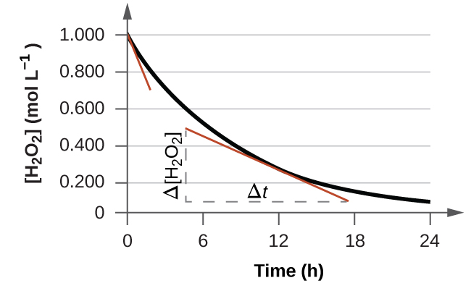

(ans. 8.3× 10^{–3} M/h)

End of 12 Chapter Practice Problems

#3, 5a
For detailed solutions to these problems, go to the OpenStax website and download the “Student Answer and Solution Guide.”

