5.6 – Rational Functions

Suppose we know that the cost of making a product is dependent on the number of items, x, produced. This is given by the equation C(x)=15,000x−0.1x2+1000.If we want to know the average cost for producing x items, we would divide the cost function by the number of items, x.
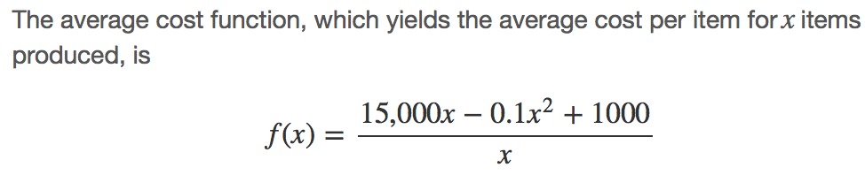
Many other application problems require finding an average value in a similar way, giving us variables in the denominator. Written without a variable in the denominator, this function will contain a negative integer power. In the last few sections, we have worked with polynomial functions, which are functions with non-negative integers for exponents. In this section, we explore rational functions, which have variables in the denominator.

Using Arrow Notation
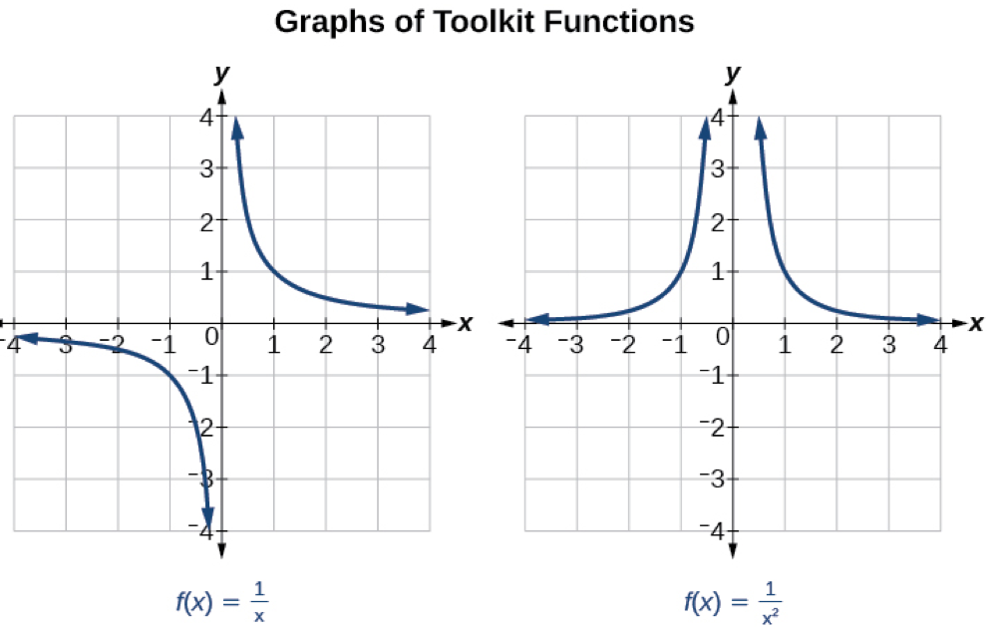
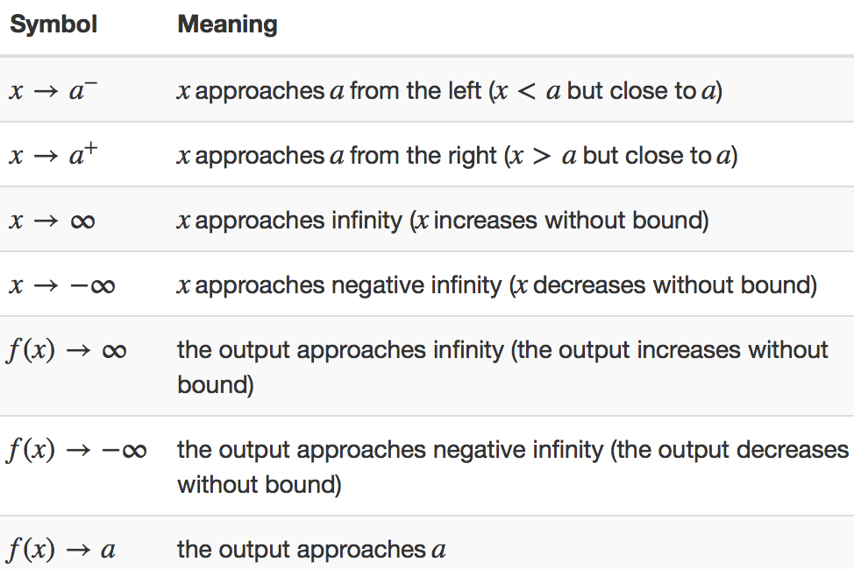
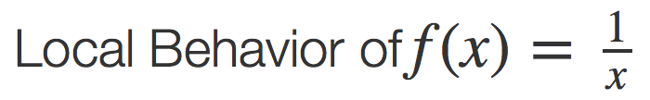 & 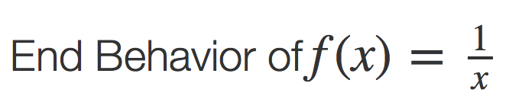

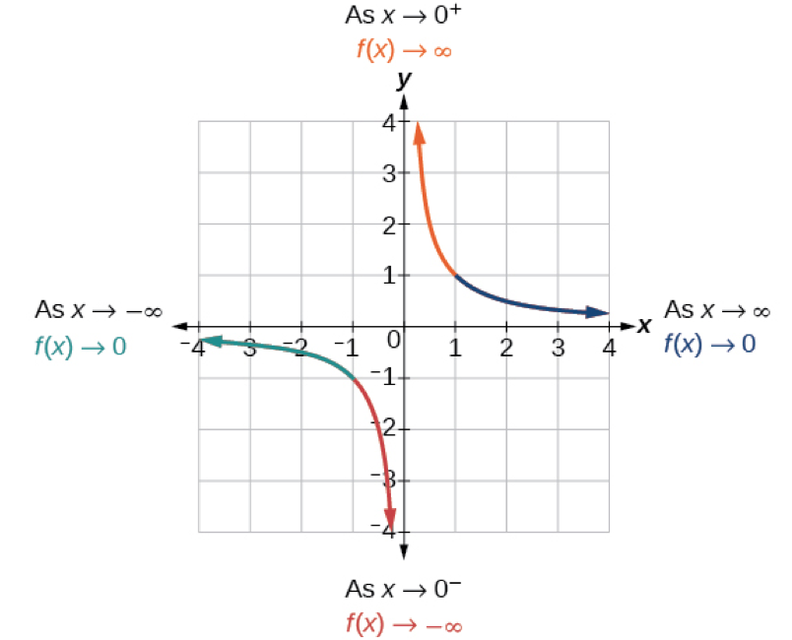
Based on this overall behavior and the graph, we can see that the function approaches 0 but never actually reaches 0; it seems to level off as the inputs become large. This behavior creates a ________________________ asymptote, a horizontal line that the graph approaches as the input increases or decreases without bound. In this case, the graph is approaching the horizontal line y=0.

This behavior creates a vertical ________________________, which is a vertical line that the graph approaches but never crosses. In this case, the graph is approaching the vertical line x=0as the input becomes close to zero.

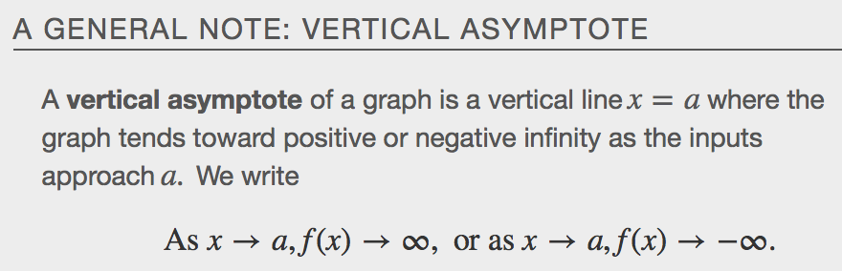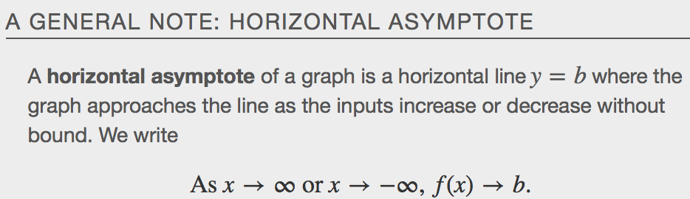

Examples
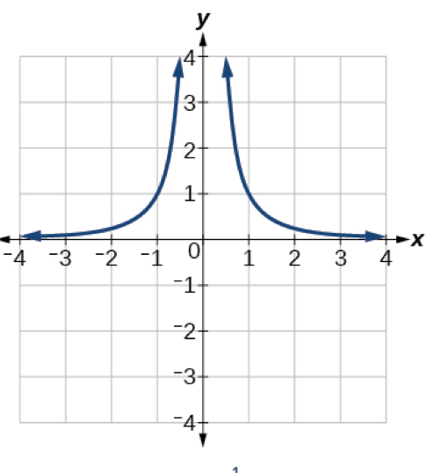
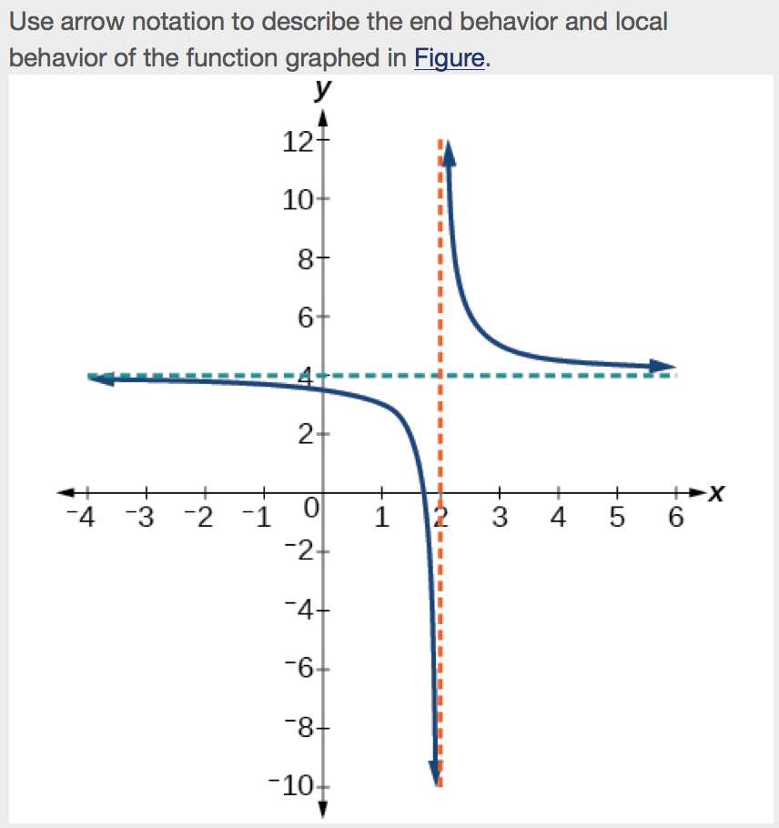

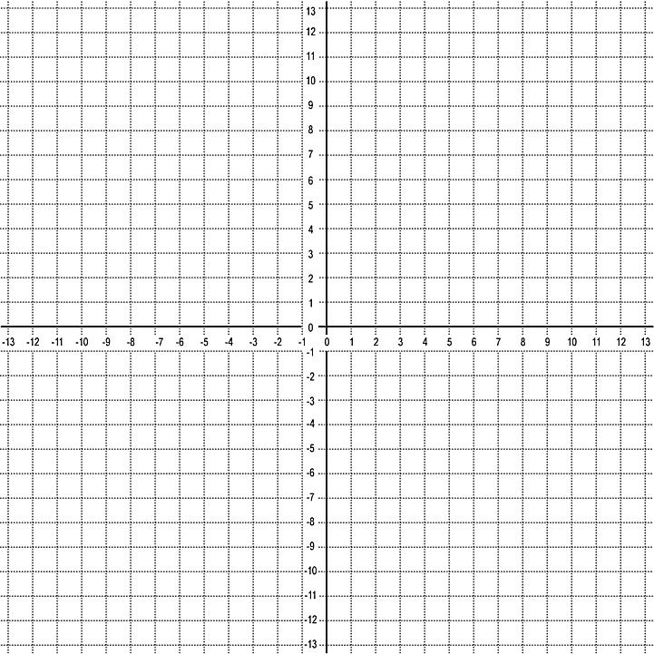

Solving Applied Problems Involving Rational Functions
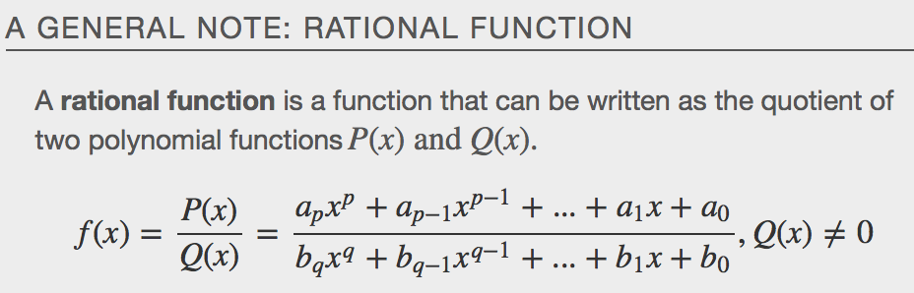
Examples
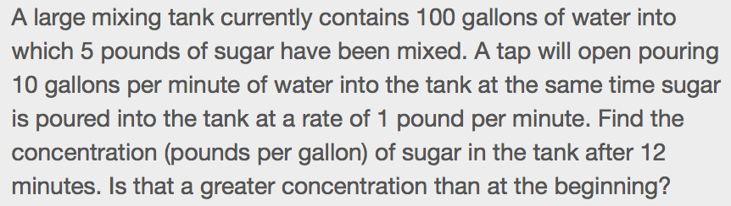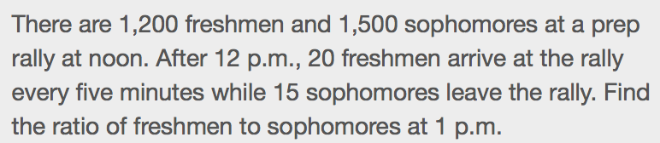

Finding the Domains of Rational Functions
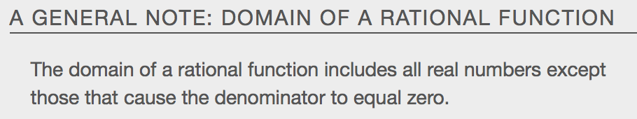

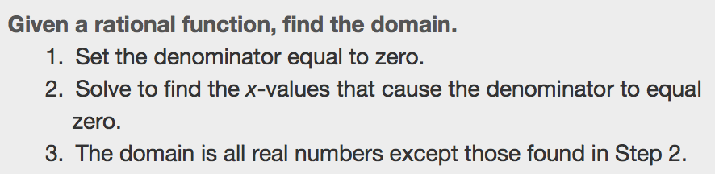

Examples
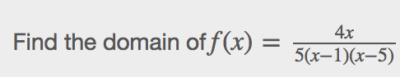

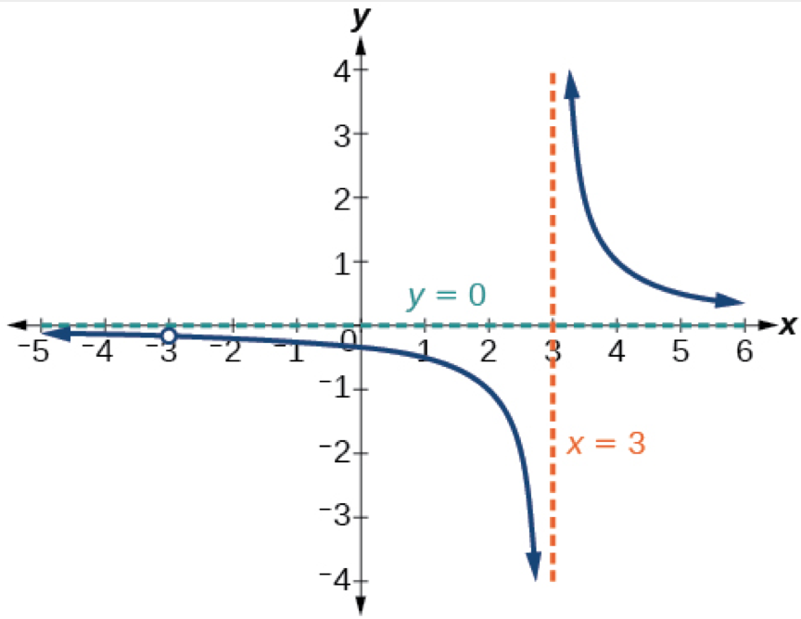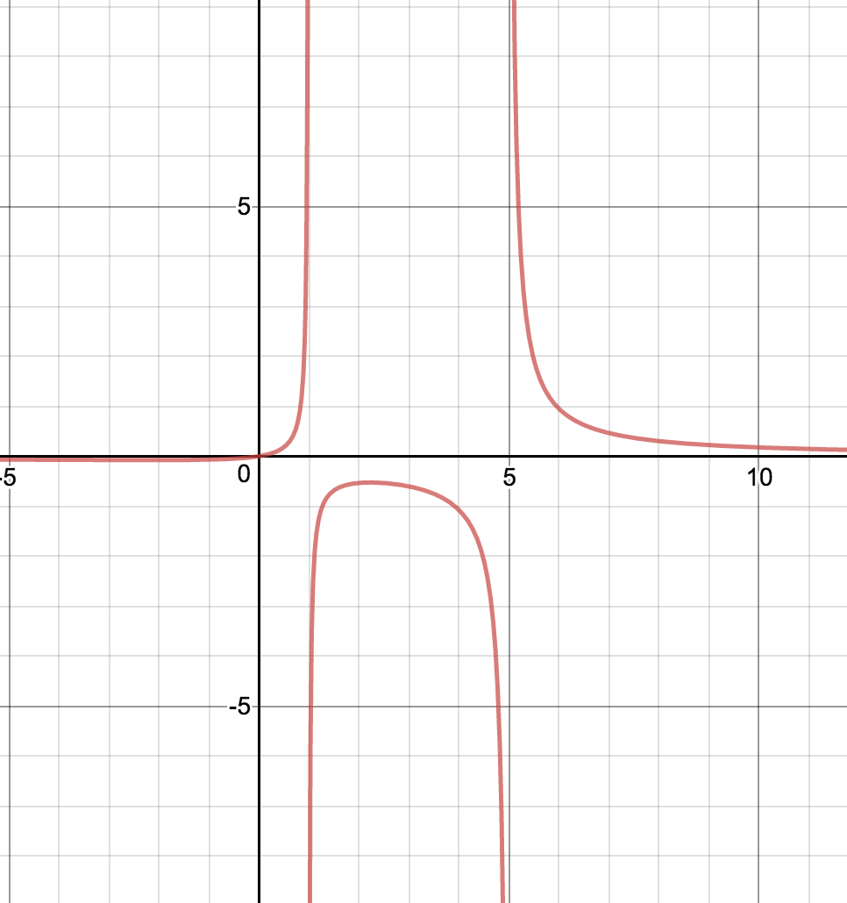
Identifying Vertical Asymptotes of Rational Functions
The vertical asymptotes of a rational function may be found by examining the factors of the denominator that are not common to the factors in the numerator. Vertical asymptotes occur at the zeros of such factors.
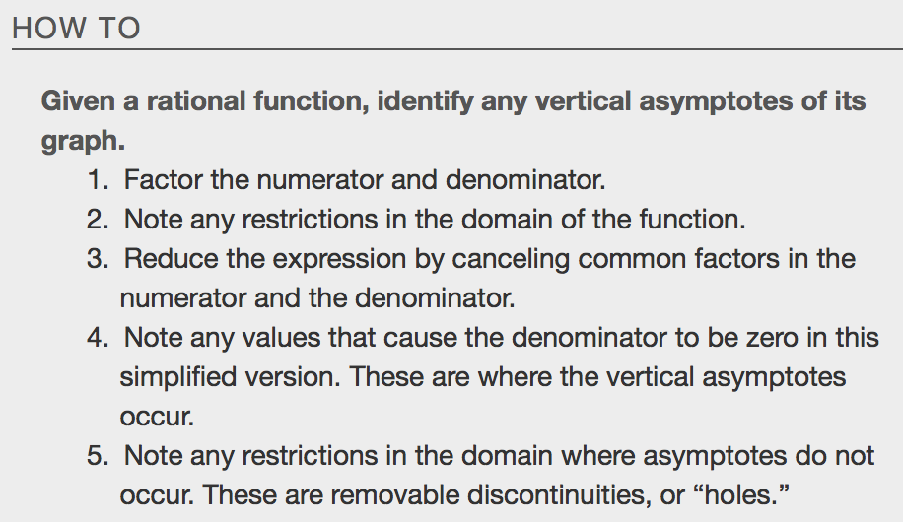
Example

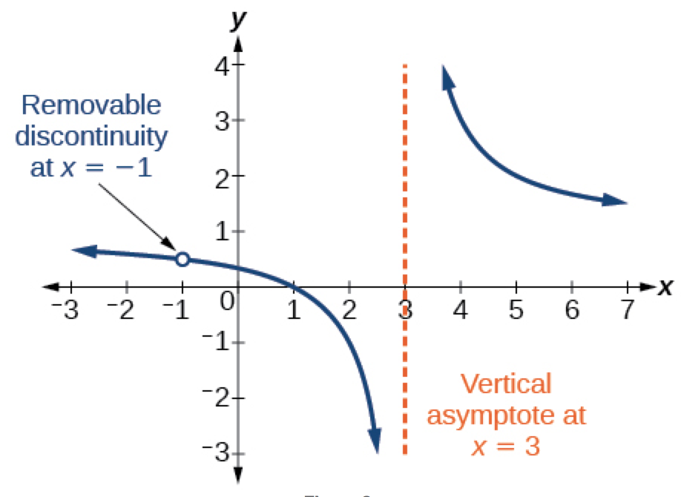

Removable Discontinuities
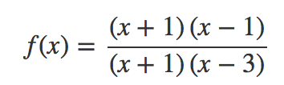

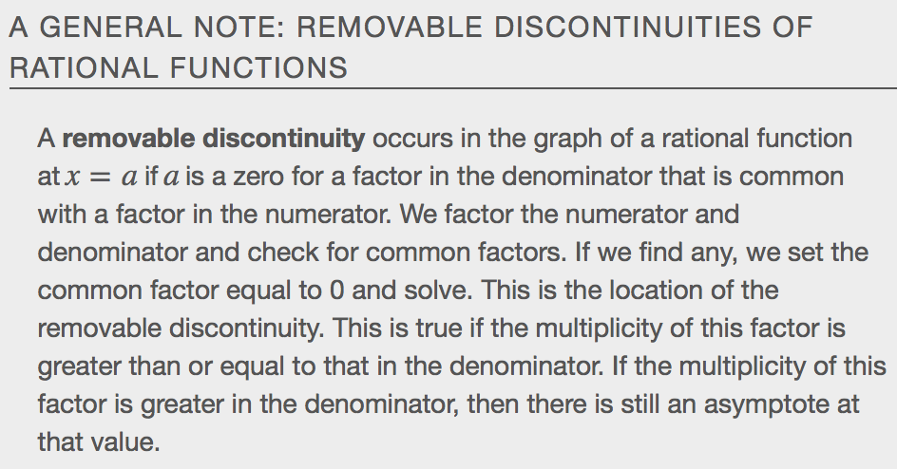
Examples

Identifying Horizontal Asymptotes of Rational Functions
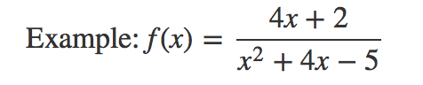
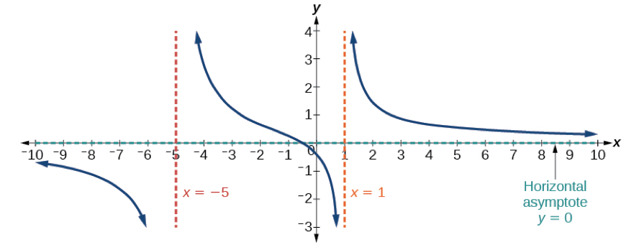

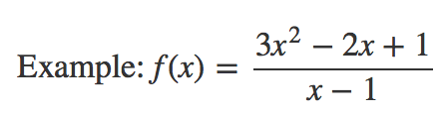
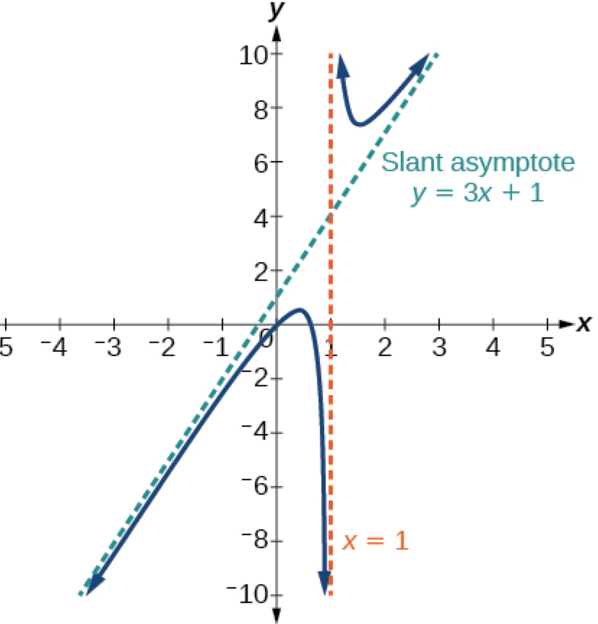

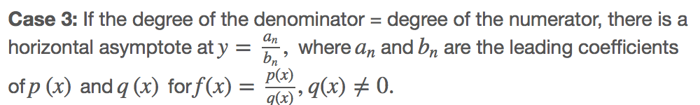
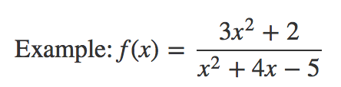
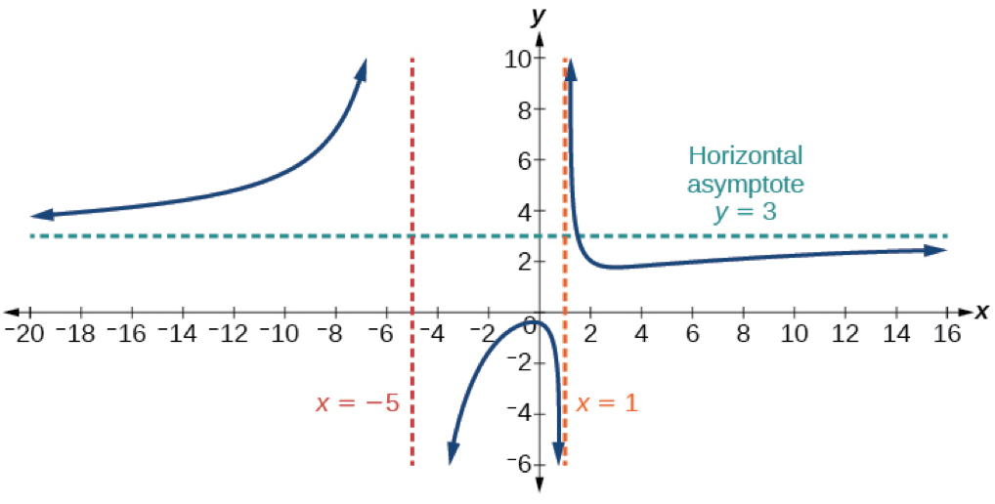

Notice that, while the graph of a rational function will never cross a vertical asymptote, the graph may or may not cross a horizontal or slant asymptote. Also, although the graph of a rational function may have many vertical asymptotes, the graph will have at most one horizontal (or slant) asymptote. It should be noted that, if the degree of the numerator is larger than the degree of the denominator by more than one, the end behavior of the graph will mimic the behavior of the reduced end behavior fraction.
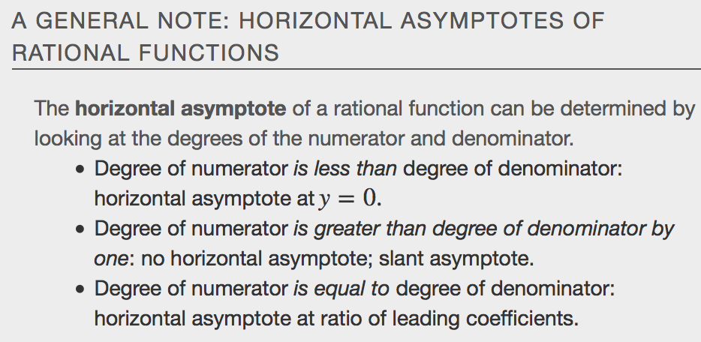
Examples
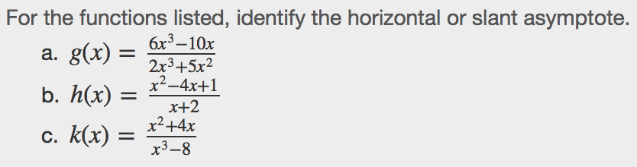

Intercepts of Rational Functions
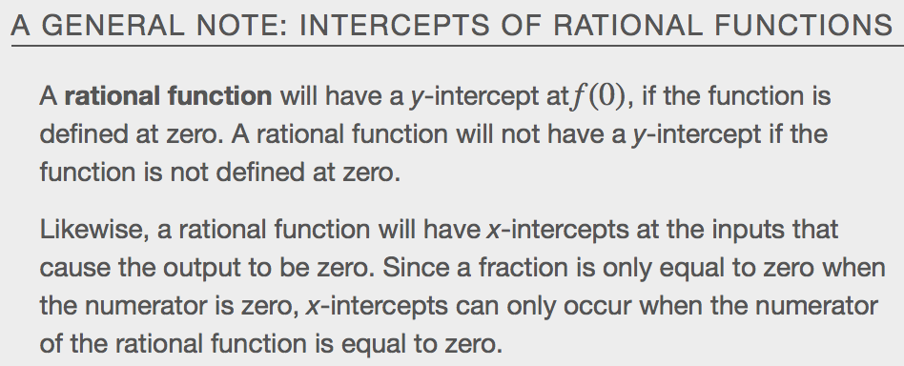
Examples

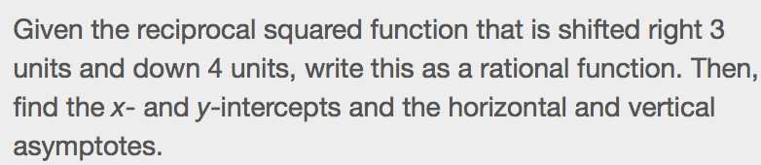

Graphing Rational Functions
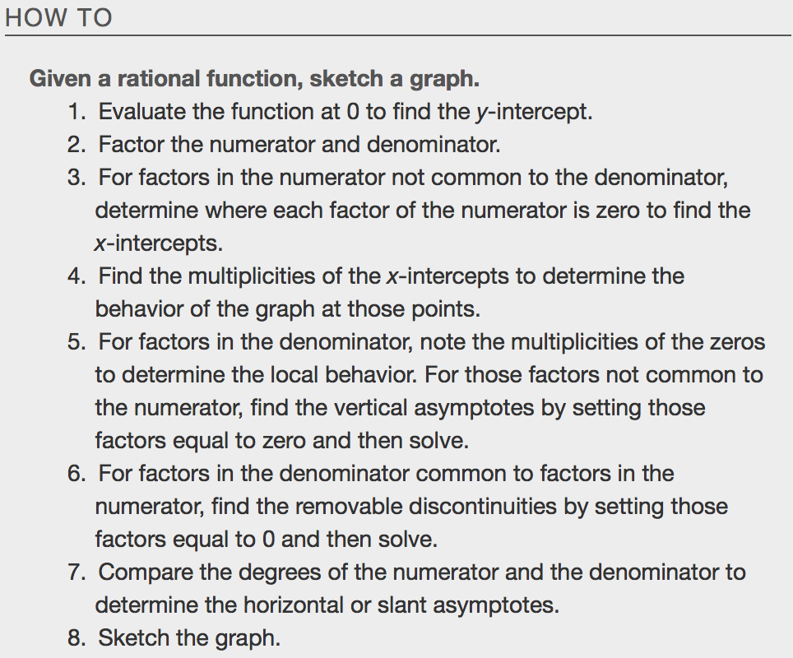
Examples
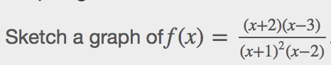

Writing Rational Functions
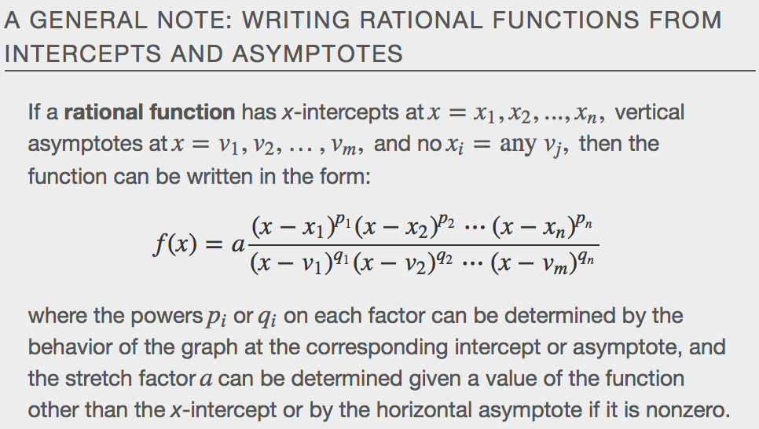

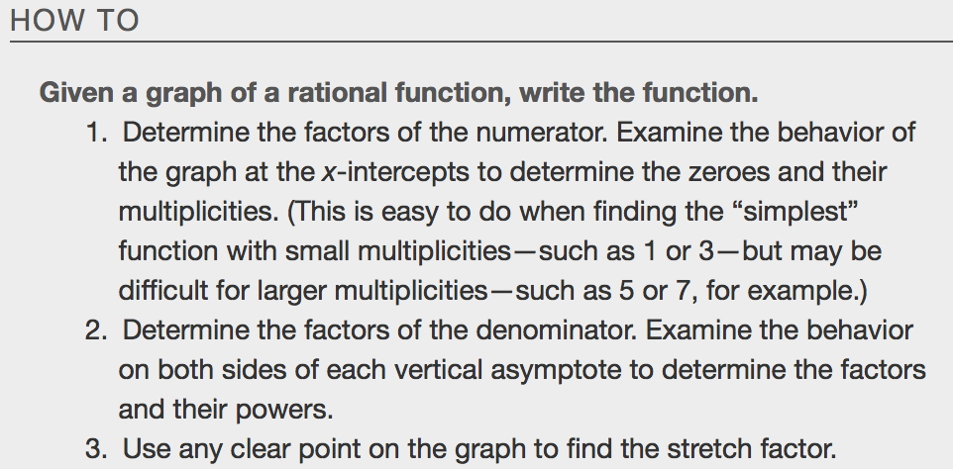
Examples
