10.3 – Polar Coordinates

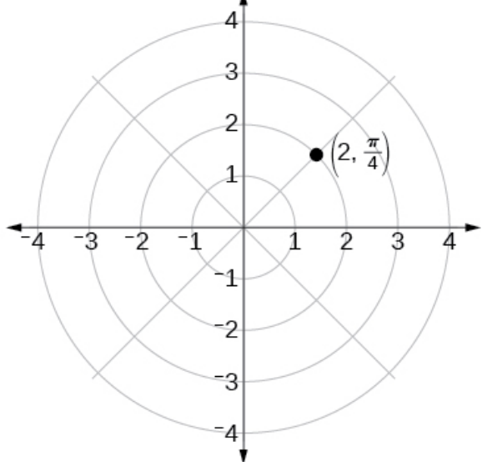
In this section, we introduce to polar coordinates, which are points labeled ( , ) and plotted on a polar grid. The polar grid is represented as a series of concentric circles radiating out from the pole, or the origin of the coordinate plane.

The polar grid is scaled as the unit circle with the positive ____-axis now viewed as the _____________ axis and the origin as the pole. The first coordinate r is the __________________ or length of the directed line segment from the pole. The angle θ, measured in radians, indicates the ____________________ of r. We move counterclockwise from the polar axis by an angle of θ, and measure a directed line segment the length of r in the direction of θ. Even though we measure θ first and then r, the polar point is written with the r-coordinate first.

Examples
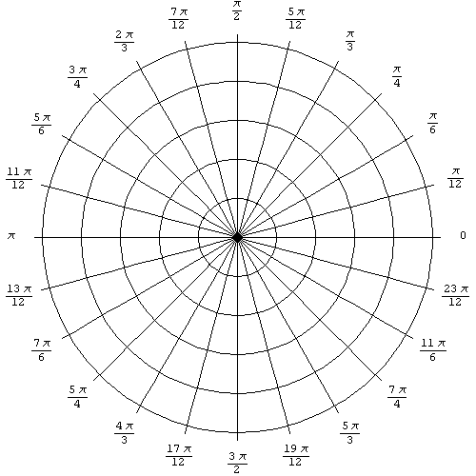

Converting from Polar Coordinates to Rectangular Coordinate
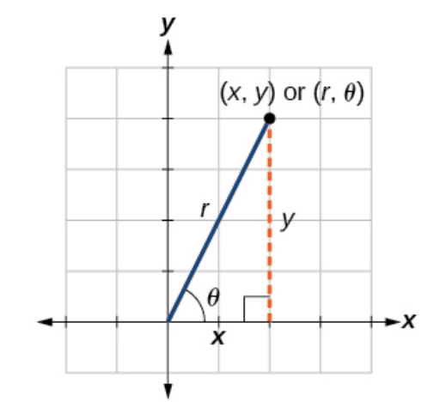
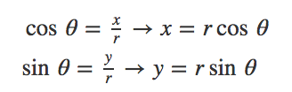

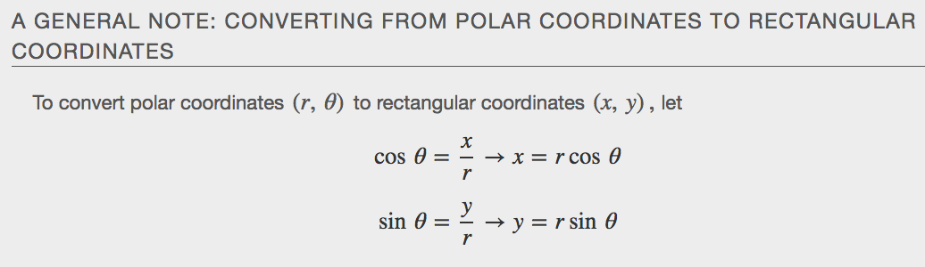
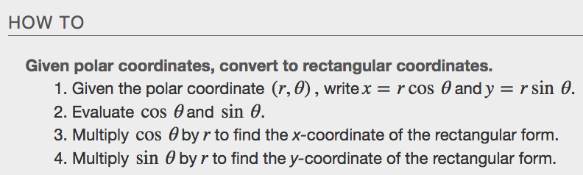
Examples

Converting from Rectangular Coordinates to Polar Coordinates
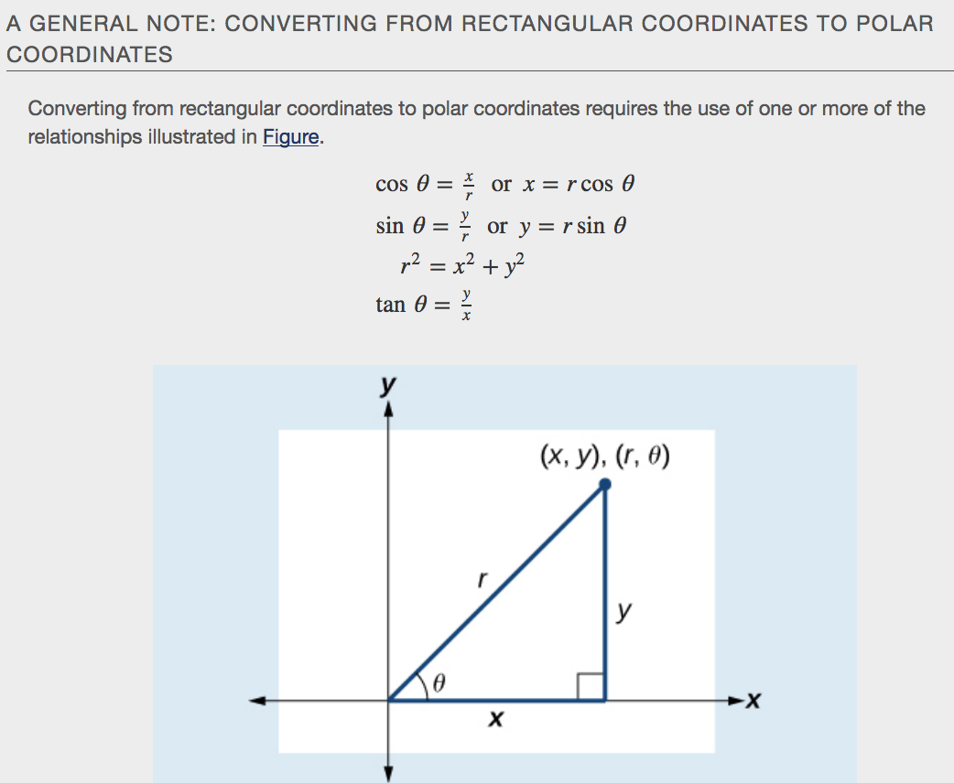
Example

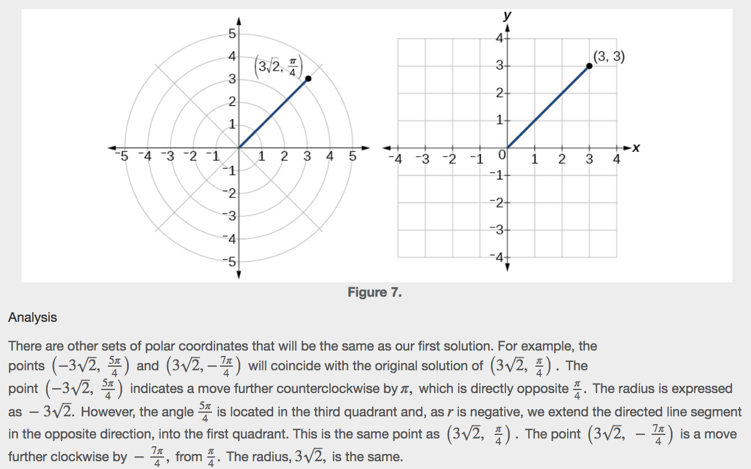
Transforming Equations between Polar and Rectangular Forms

Examples

Identify and Graph Polar Equations by Converting to Rectangular Equations

Examples

