10.2 – Non-Right Triangles: Law of Cosines

Using the Law of Cosines to Solve Oblique Triangles
Understanding how the Law of Cosines is derived will be helpful in using the formulas. The derivation begins with the Generalized Pythagorean Theorem, which is an extension of the Pythagorean Theorem to non-right triangles. Here is how it works: An arbitrary non-right triangle ABC is placed in the coordinate plane with vertex A at the origin, side c drawn along the x-axis, and vertex C located at some point(x,y)in the plane, as illustrated in Figure. Generally, triangles exist anywhere in the plane, but for this explanation we will place the triangle as noted.
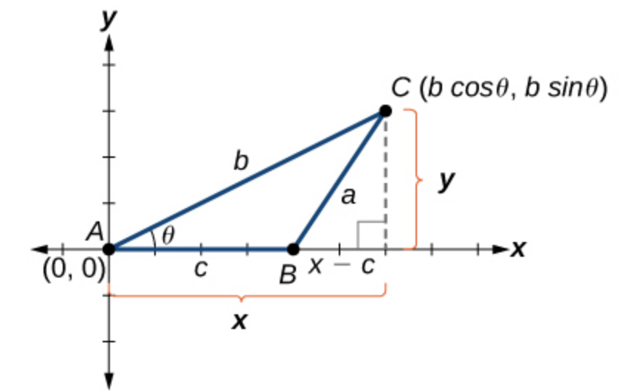
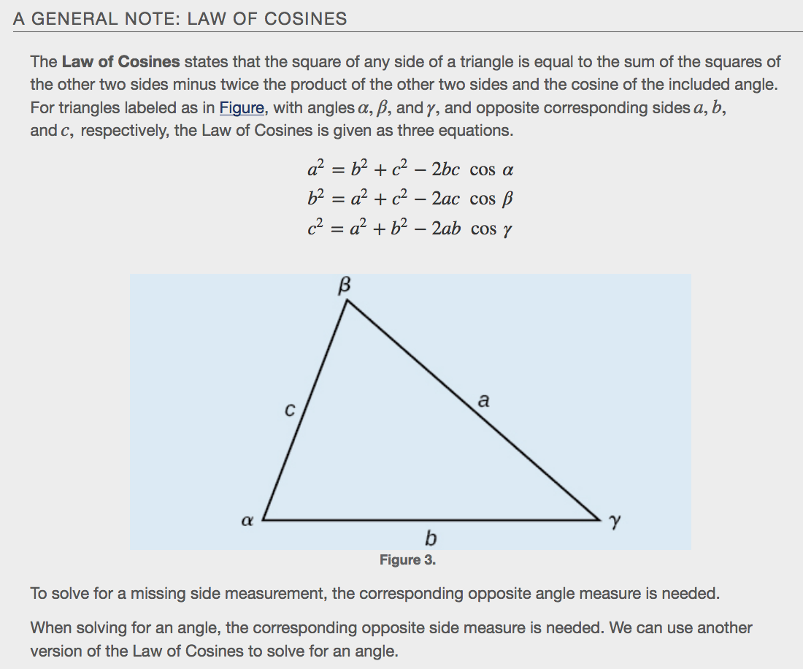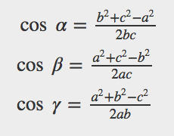
Examples

Suppose a boat leaves port, travels 10 miles, turns 20 degrees, and travels another 8 miles as shown in Figure. How far from port is the boat?
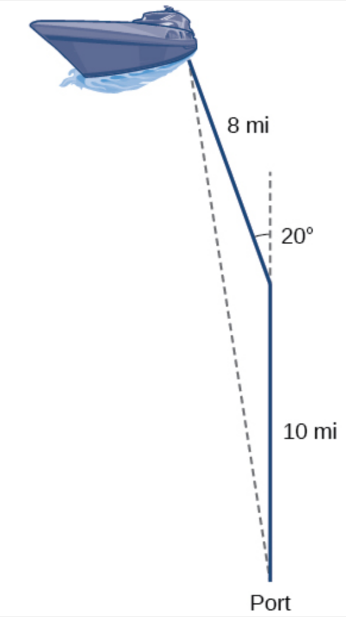
Using Heron’s Formula to Find the Area of a Triangle
We already learned how to find the area of an oblique triangle when we know two sides and an angle. We also know the formula to find the area of a triangle using the base and the height. When we know the three sides, however, we can use Heron’s formula instead of finding the height.
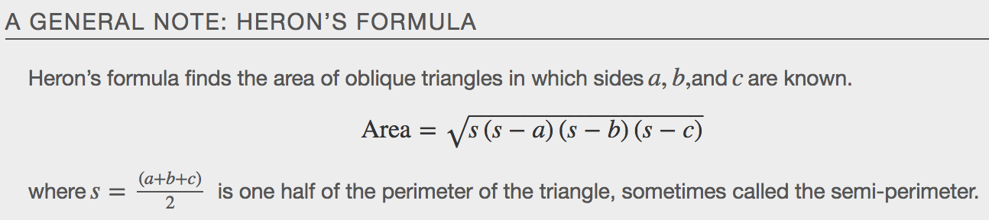
Example
