10.1 – Non-Right Triangles: The Law of Sines

Using Law of Sines to Solve Oblique Triangles
Any triangle that is not a right triangle is an _______________________ triangle. Solving an oblique triangle means finding the measurements of all three angles and all three sides. To do so, we need to start with at least three of these values, including at least one of the sides. We will investigate three possible oblique triangle problem situations:

- ASA (angle-side-angle) We know the measurements of two angles and the included side.

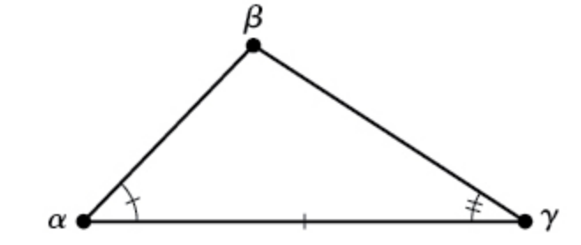
- AAS (angle-angle-side) We know the measurements of two angles and a side that is not between the known angles.

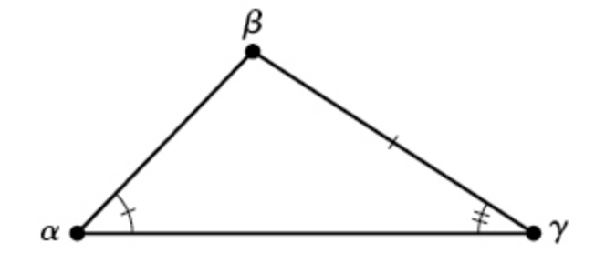
- SSA (side-side-angle) We know the measurements of two sides and an angle that is not between the known sides.

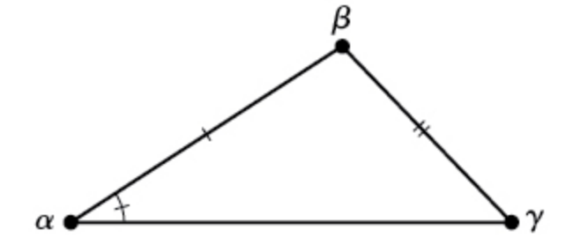

How do right triangle relationships set up the Law of Sines?
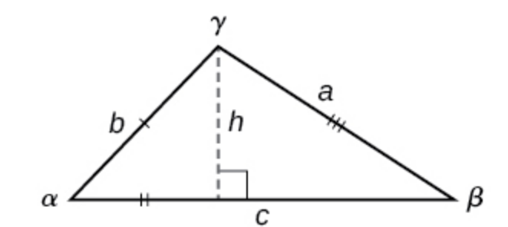

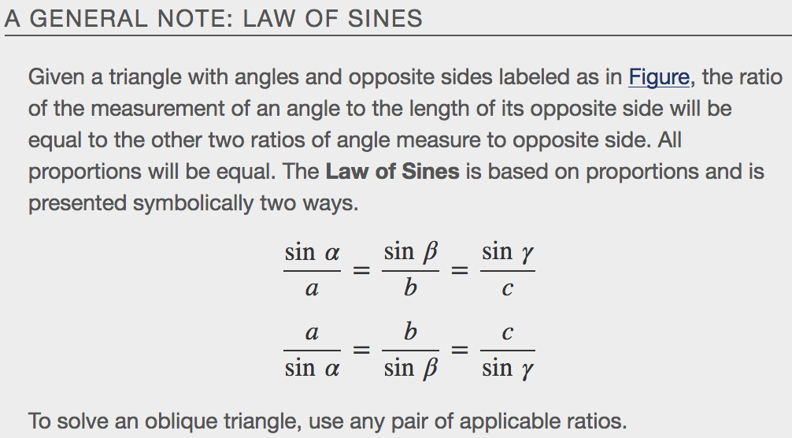
Examples
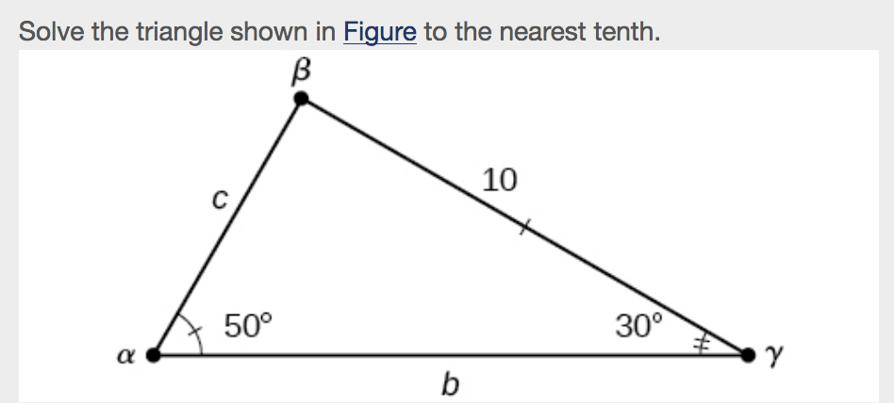

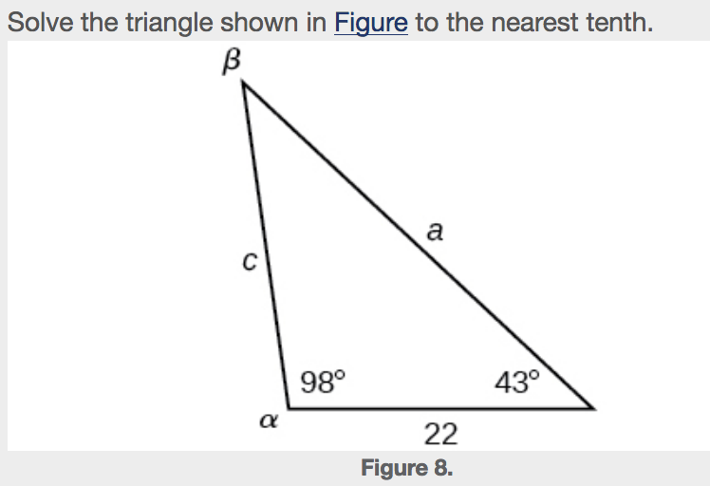

Using the Law of Sines to Solve SSA Triangles
We can use the Law of Sines to solve any oblique triangle, but some solutions may not be straightforward. In some cases, more than one triangle may satisfy the given criteria, which we describe as an ___________________________________ case. Triangles classified as SSA, those in which we know the lengths of two sides and the measurement of the angle opposite one of the given sides, may result in one or two solutions, or even no solution.
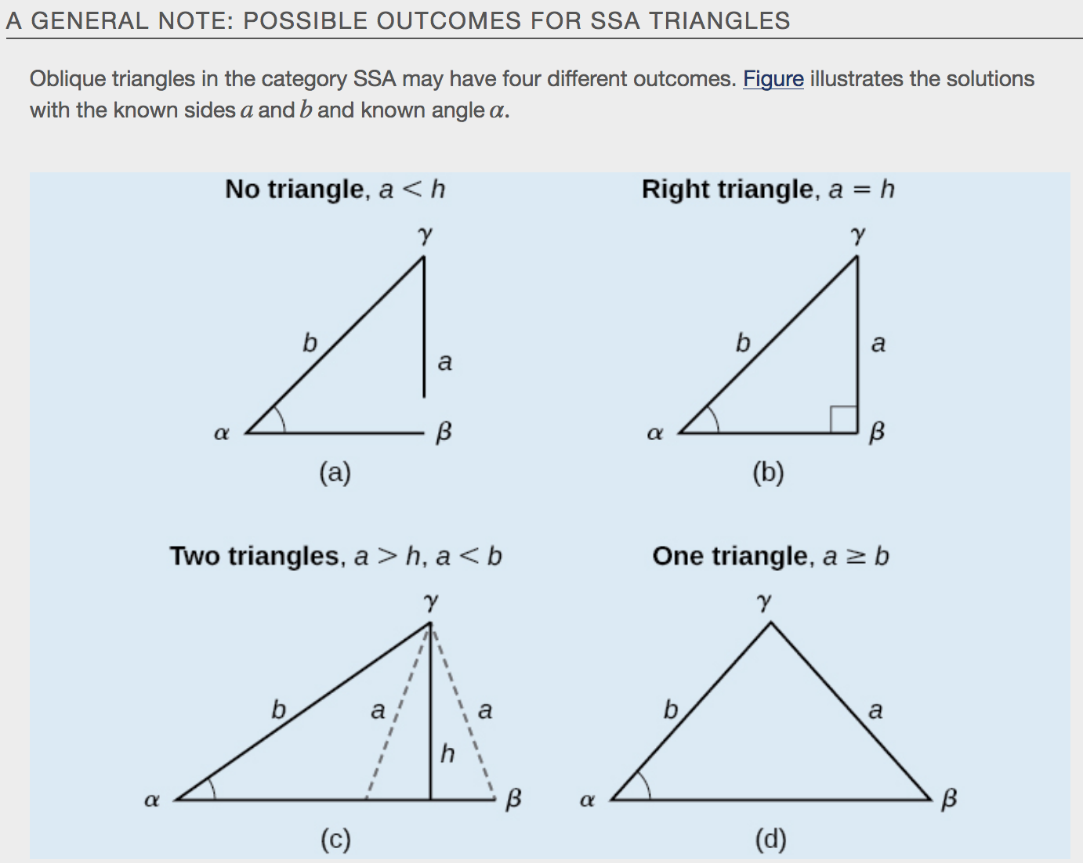
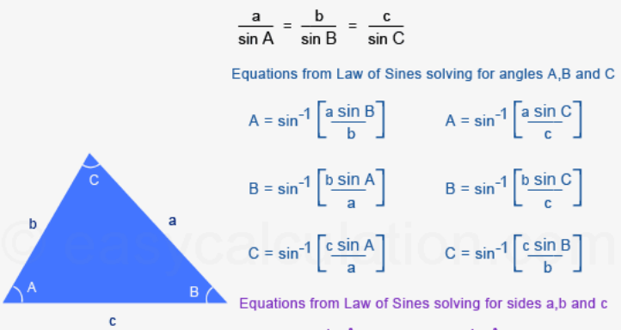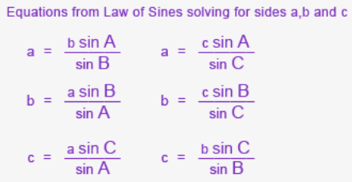
Examples
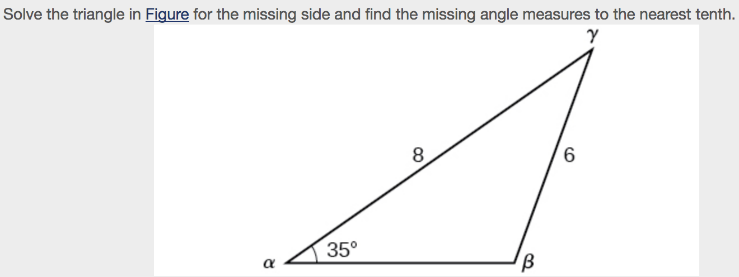

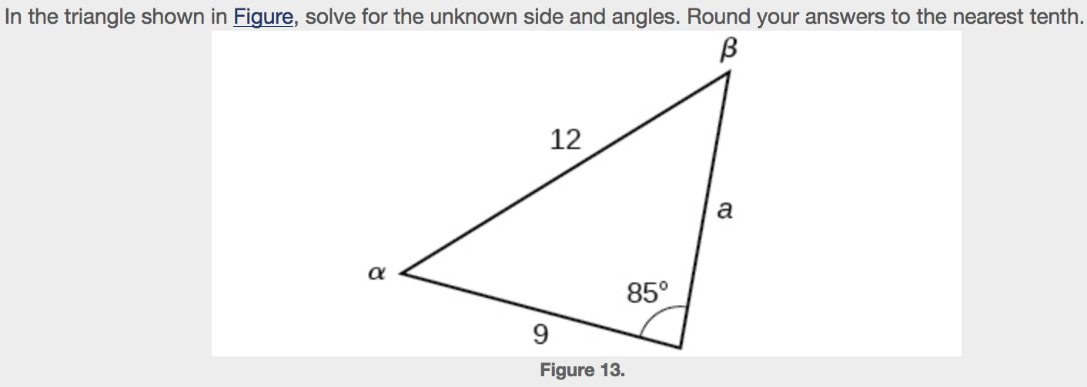

Finding the Area of an Oblique Triangle Using the Sine Function
Recall that the area formula for a triangle is given as $Area=\frac{1}{2}bh$, where b is base and h is height. For oblique triangles, we must find h before we can use the area formula. Observing the two triangles in Figure, one acute and one obtuse, we can drop a perpendicular to represent the height and then apply the trigonometric property $\sin{α}=\frac{opposite}{hypotenuse}$ to write an equation for area in oblique triangles. In the acute triangle, we have $sinα=\frac{h}{c}$ or $c\sin{α=h}$.However, in the obtuse triangle, we drop the perpendicular outside the triangle and extend the base b to form a right triangle. The angle used in calculation is α′, or180−α.
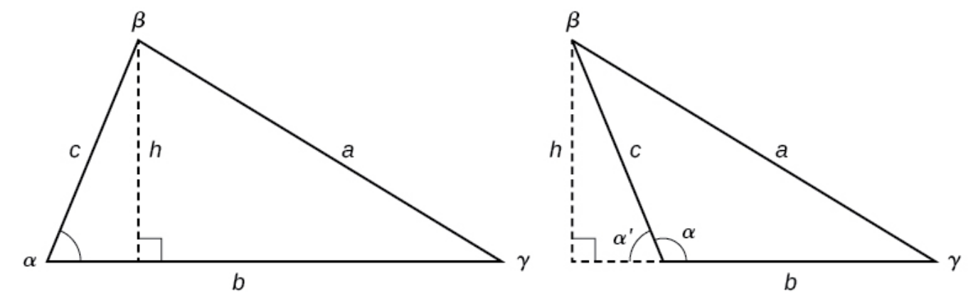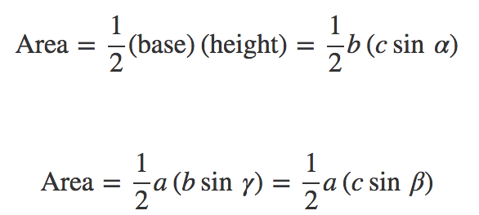
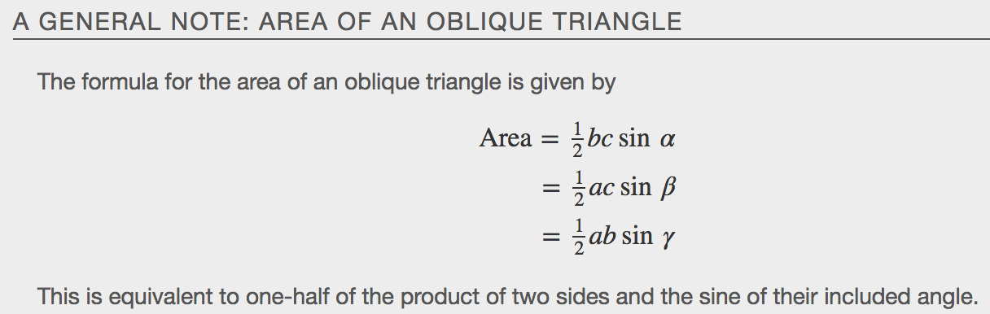
Examples
