9.5 – Solving Trigonometric Equations

Solving Trigonometric Equations in Sine and Cosine
The period of both the sine function and the cosine function is 2π. In other words, every 2π units, the y-values repeat. If we need to find all possible solutions, then we must add ________,where k is an integer, to the initial solution.

Examples

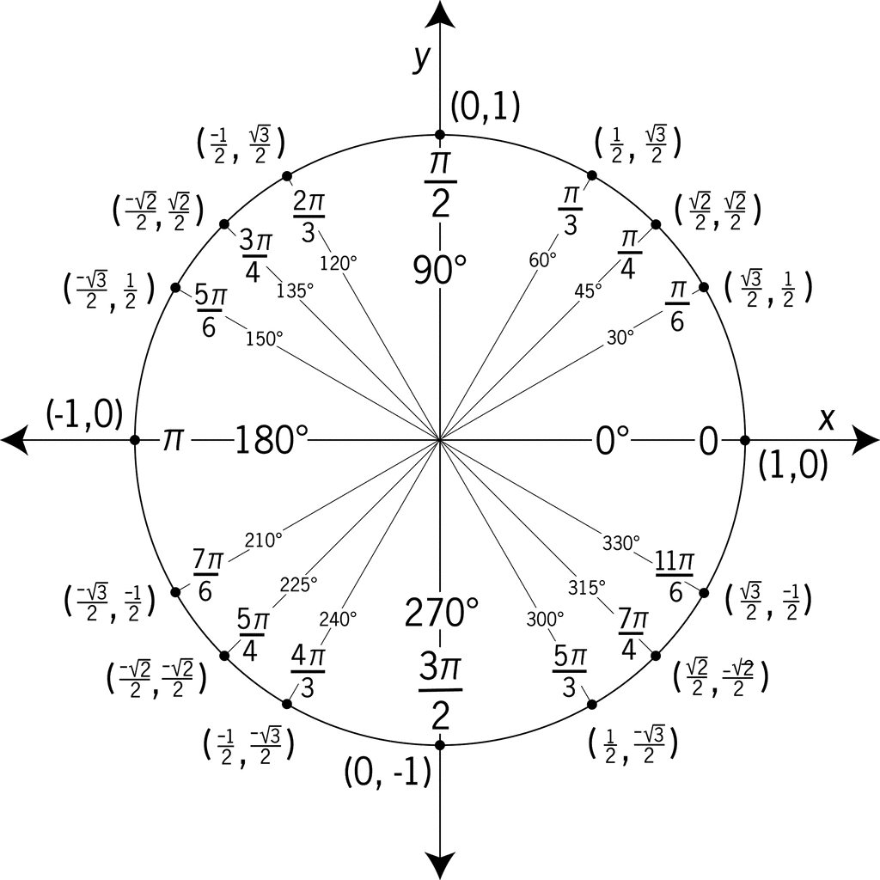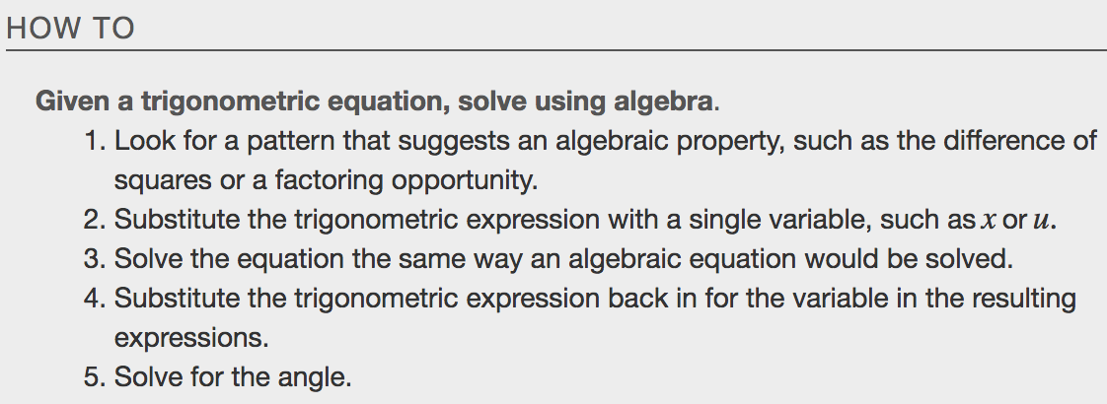
Examples
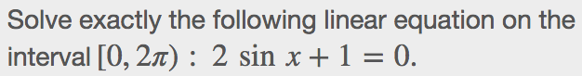

Solving Equations Involving Single Trigonometric Functions
We need to make several considerations when the equation involves trigonometric functions other than sine and cosine. Problems involving the reciprocals of the primary trigonometric functions need to be viewed from an algebraic perspective. In other words, we will write the reciprocal function, and solve for the angles using the function.

Examples

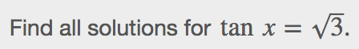

Solve Trigonometric Equations Using a Calculator
Not all functions can be solved exactly using only the unit circle. When we must solve an equation involving an angle other than one of the special angles, we will need to use a calculator. Make sure it is set to the proper mode, either degrees or radians, depending on the criteria of the given problem.

Examples
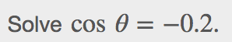

Solving Trigonometric Equations in Quadratic Form
If there is only one function represented and one of the terms is squared, think about the standard form of a quadratic. Replace the trigonometric function with a variable such asxoru.If substitution makes the equation look like a quadratic equation, then we can use the same methods for solving quadratics to solve the trigonometric equations.

Examples

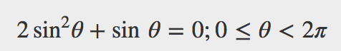

Solving Trigonometric Equations
Remember that the techniques we use for solving are not the same as those for verifying identities. The basic rules of algebra apply here, as opposed to rewriting one side of the identity to match the other side. In the next example, we use two identities to simplify the equation.

Examples
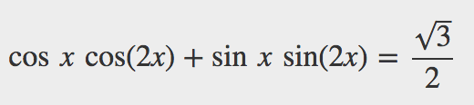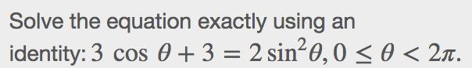

Solving Trigonometric Equations with Multiple Angles
Sometimes it is not possible to solve a trigonometric equation with identities that have a multiple angle, such as sin(2x) or cos(3x).When confronted with these equations, recall that y=sin(2x)is a horizontal compression by a factor of 2 of the function y=sinx. On an interval of 2π, we can graph two periods of y=sin(2x),as opposed to one cycle of y=sinx. This compression of the graph leads us to believe there may be twice as many x-intercepts or solutions to sin(2x)=0compared to sinx=0.This information will help us solve the equation.

Example
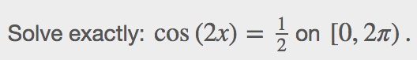

Solving Right Triangle Problems
We can now use all of the methods we have learned to solve problems that involve applying the properties of right triangles and the Pythagorean Theorem. We begin with the familiar Pythagorean Theorem, a²+b²=c², and model an equation to fit a situation.

Example
OSHA safety regulations require that the base of a ladder be placed 1 foot from the wall for every 4 feet of ladder length. Find the angle that a ladder of any length forms with the ground and the height at which the ladder touches the wall.

