9.4 – Sum-to-Product and Product-to-Sum
Expressing Products as Sums for Cosine
We can derive the product-to-sum formula from the sum and difference identities for cosine. If we add the two equations, we get:
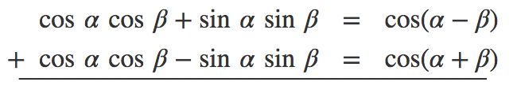

Examples

Expressing the Product of Sine and Cosine as a Sum
Next, we will derive the product-to-sum formula for sine and cosine from the sum and difference formulas for sine. If we add the sum and difference identities, we get:
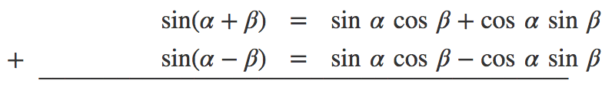

Examples

Expressing Products of Sines in Terms of Cosine
Expressing the product of sines in terms of cosine is also derived from the sum and difference identities for cosine. In this case, we will first subtract the two cosine formulas:
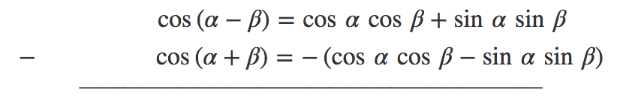

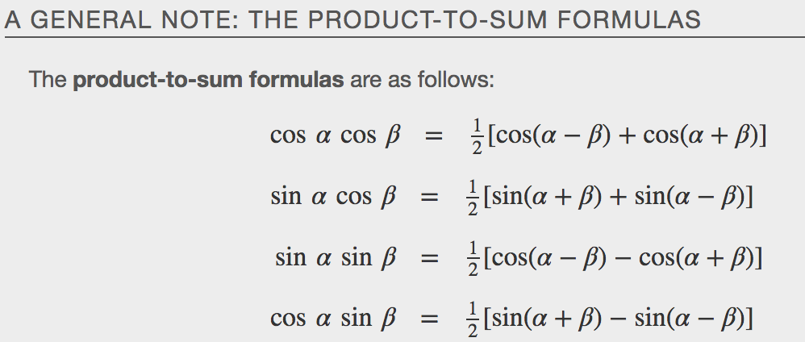
Examples

Expressing Sums as Products
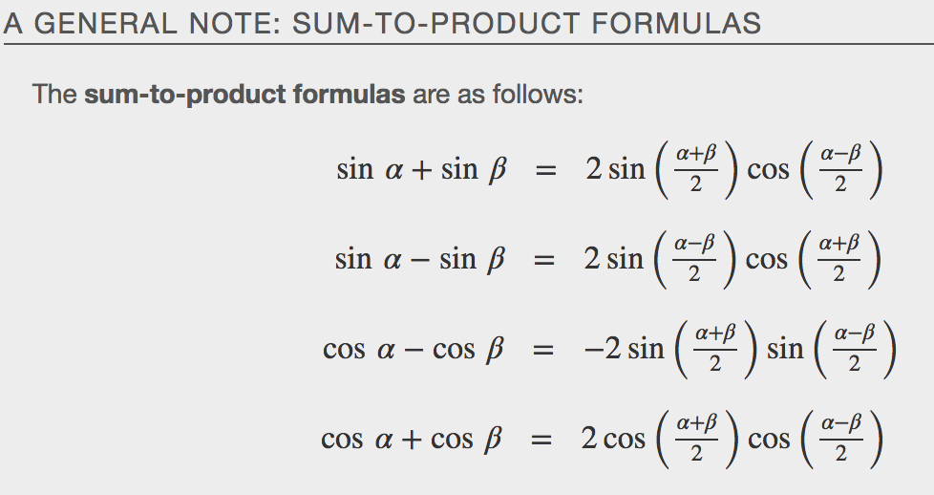
Examples

