9.3 – Double-Angle, Half-Angle, and Reduction Formulas

The _________________ ______________formulas are a special case of the sum formulas, where α=β. Deriving the double-angle formula for sine begins with the sum formula.
sin(α+β)=sinα cosβ+cosα sinβ

cos(α+β)=cosα cosβ−sinα sinβ

Using the Pythagorean properties, we can expand this double-angle formula for cosine and get two more variations. The first variation is:
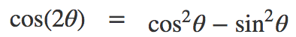

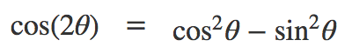

Similarly, to derive the double-angle formula for tangent, replacing α=β=θ in the sum formula gives
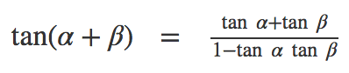

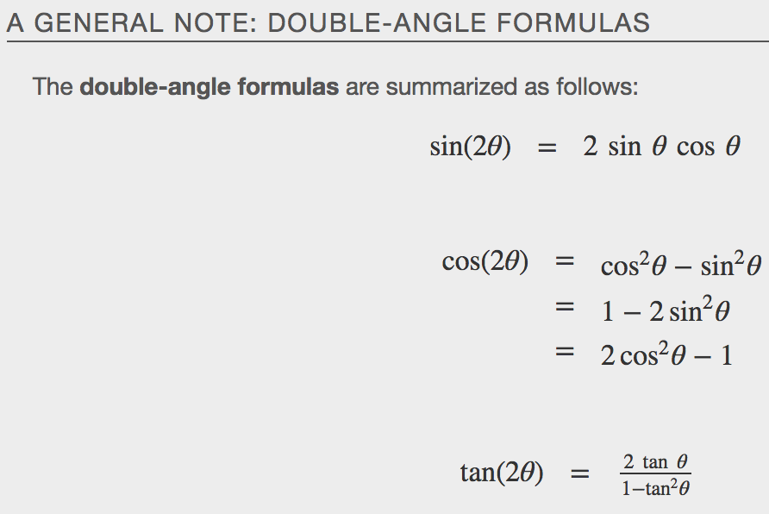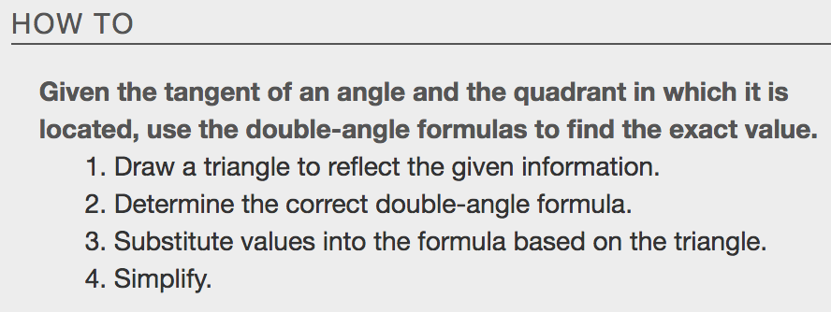
Example

Use Reduction Formulas to Simplify an Expression
The __________________ ________________ formulas can be used to derive the reduction formulas, which are formulas we can use to reduce the power of a given expression involving even powers of sine or cosine. They allow us to rewrite the even powers of sine or cosine in terms of the first power of cosine. These formulas are especially important in higher-level math courses, calculus in particular. Also called the power-reducing formulas, three identities are included and are easily derived from the double-angle formulas.

We can use two of the three double-angle formulas for cosine to derive the reduction formulas for sine and cosine.

Solve for sin²θ Solve for cos²θ
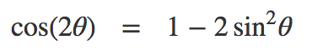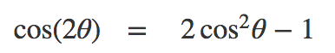

The last reduction formula is derived by writing tangent in terms of sine and cosine:
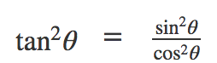

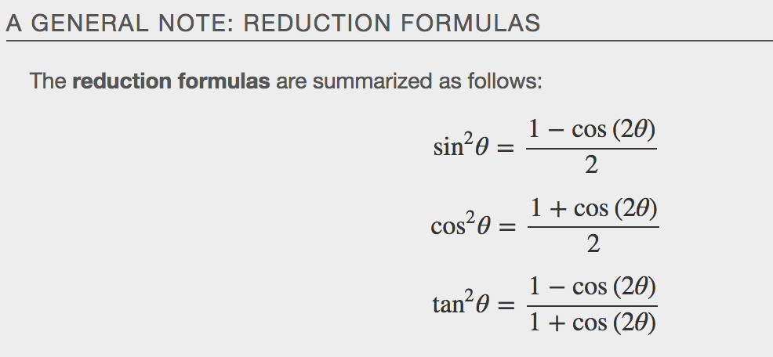
Examples
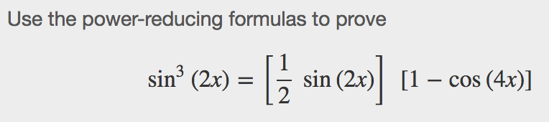

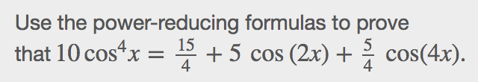

Using Half-Angle Formulas to Find Exact Values
The next set of identities is the set of __________ _______________ formulas, which can be derived from the reduction formulas and we can use when we have an angle that is half the size of a special angle. If we replace $θ$with $\frac{a}{2}$,the half-angle formula for sine is found by simplifying the equation and solving for sin($\frac{a}{2}$).Note that the half-angle formulas are preceded by a ± sign. This does not mean that both the positive and negative expressions are valid. Rather, it depends on the quadrant in whichα2terminates.

The half-angle formula for sine is derived as follows: To derive the half-angle formula for cosine:
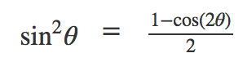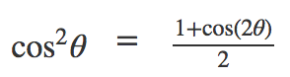

For the tangent identity, we have
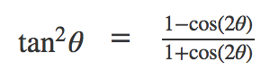

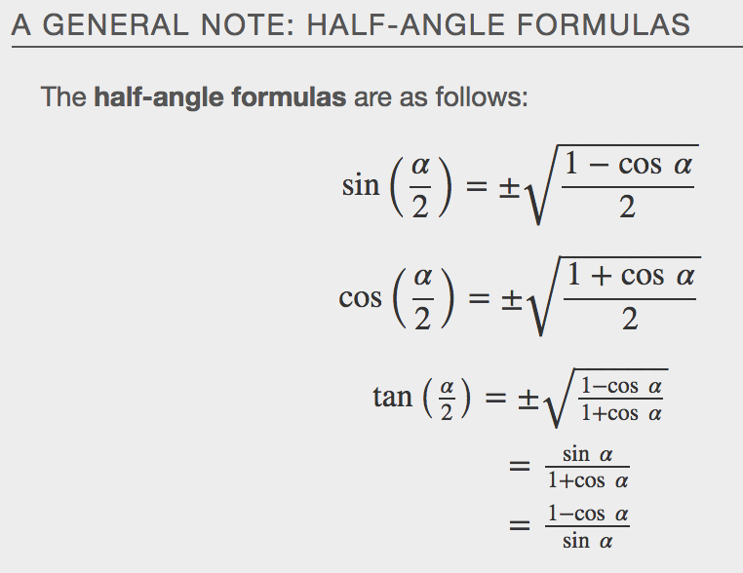
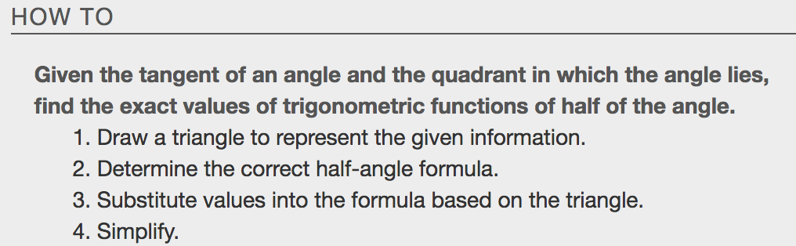
Examples
