9.2 - Sum and Difference Identities
Proof of the Difference Formula for Cosines
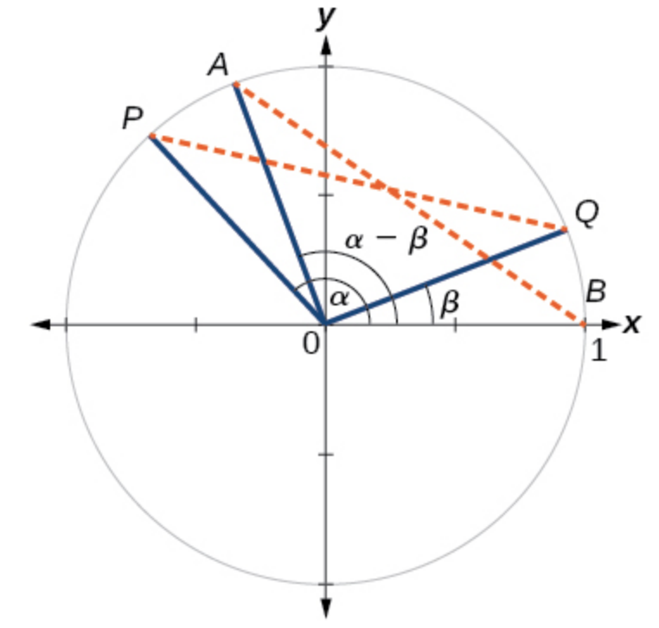
Point P is at an angle α from the positive x-axis with coordinates (cosα, sinα) and point Q is at an angle of β from the positive x-axis with coordinates(cosβ,sinβ).Note the measure of angle POQ is α−β.

Label two more points: A at an angle of (α−β) from the positive x-axis with coordinates(cos(α−β), sin(α−β)); and point B with coordinates(1,0).Triangle POQ is a rotation of triangle AOB and thus the distance from P to Q is the same as the distance from A to B.

We can find the distance from P to Q using the distance formula.
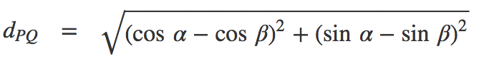

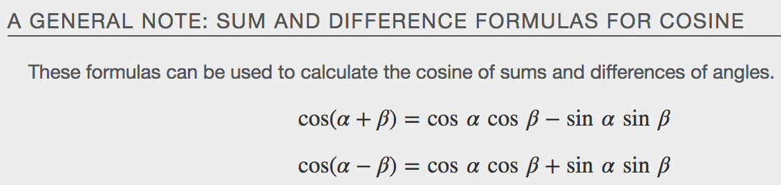
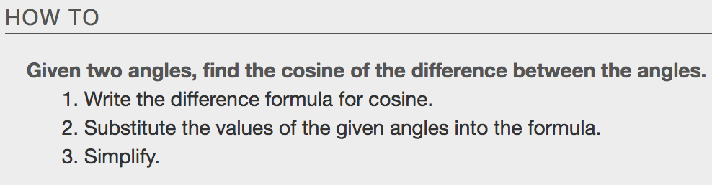
Example
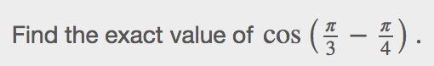

Using the Sum and Difference Formulas for Sine
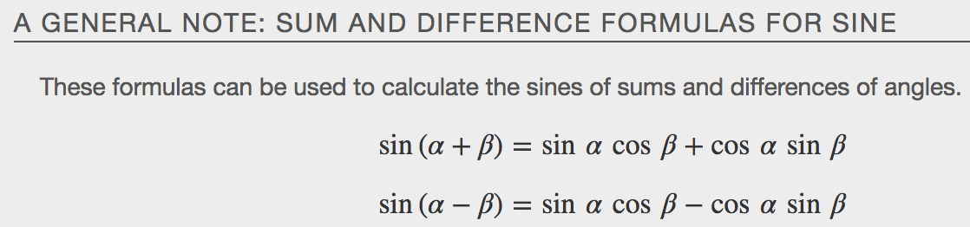
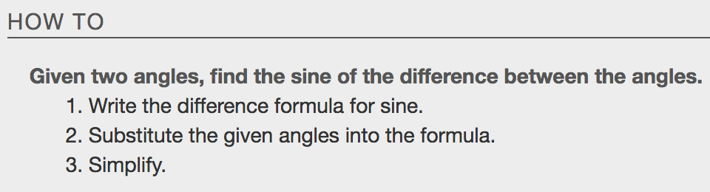
Examples
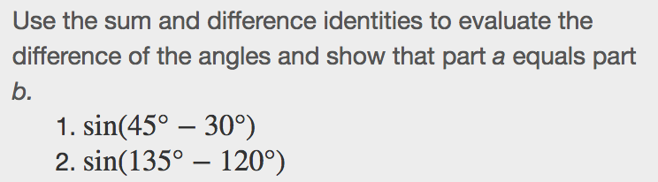

Using the Sum and Difference Formulas for Tangent
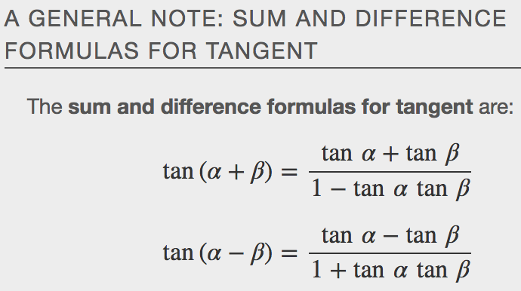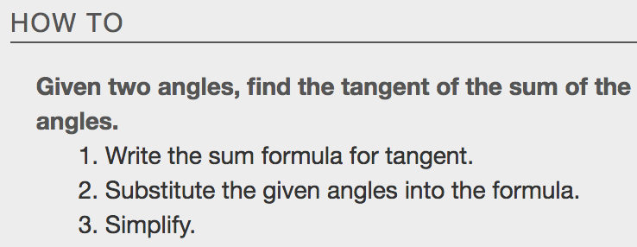
Examples
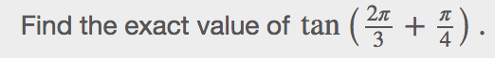

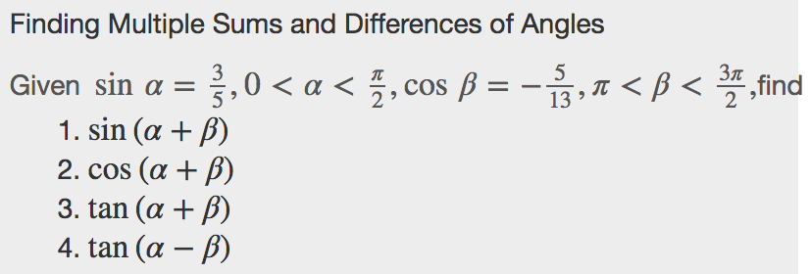

Using the Sum and Difference Formulas for Cofunctions
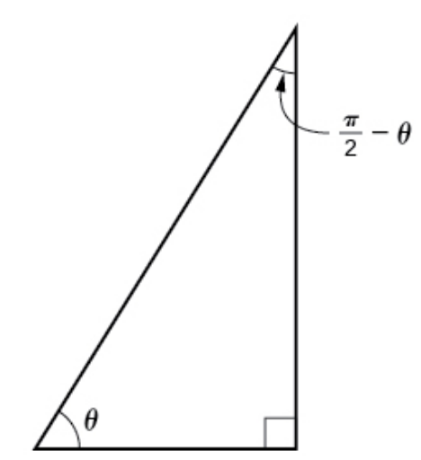
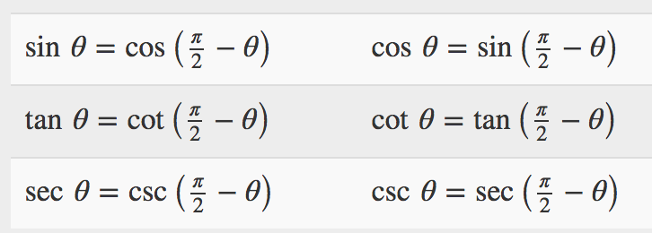

Examples

Using the Sum and Difference Formulas to Verify Identities
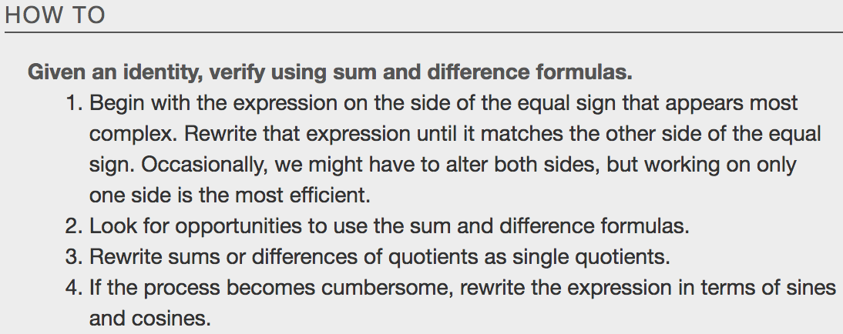
Example

