8.3 – Inverse Trigonometric Functions

Understanding and Using Inverse Sine, Cosine, and Tangent Functions
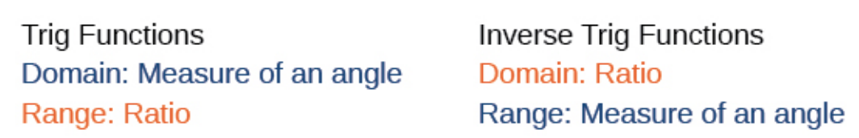
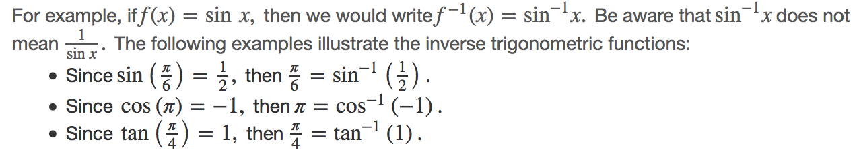

Recall that, for a one-to-one function, if f(a)=b, then an inverse function would satisfy f⁻¹( )= . Bear in mind that the sine, cosine, and tangent functions are not one-to-one functions. The graph of each function would fail the horizontal line test. In fact, no periodic function can be one-to-one because each output in its range corresponds to at least one input in every period, and there are an infinite number of periods. As with other functions that are not one-to-one, we will need to restrict the ____________________ of each function to yield a new function that is one-to-one. We choose a domain for each function that includes the number 0.
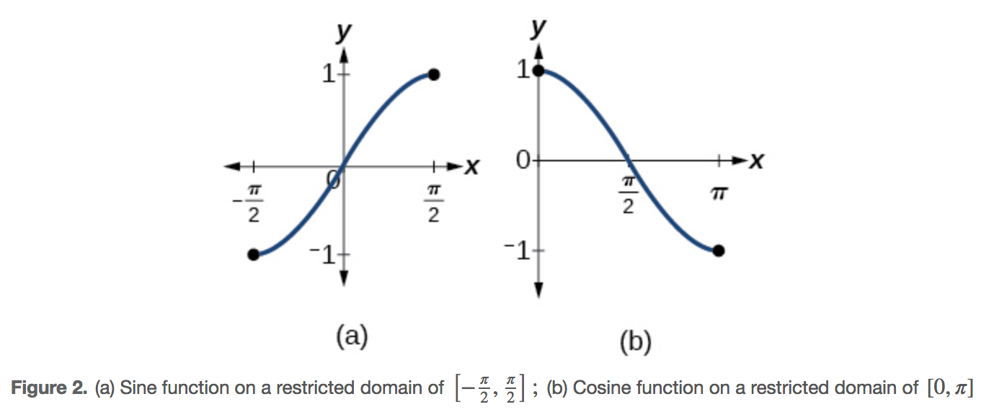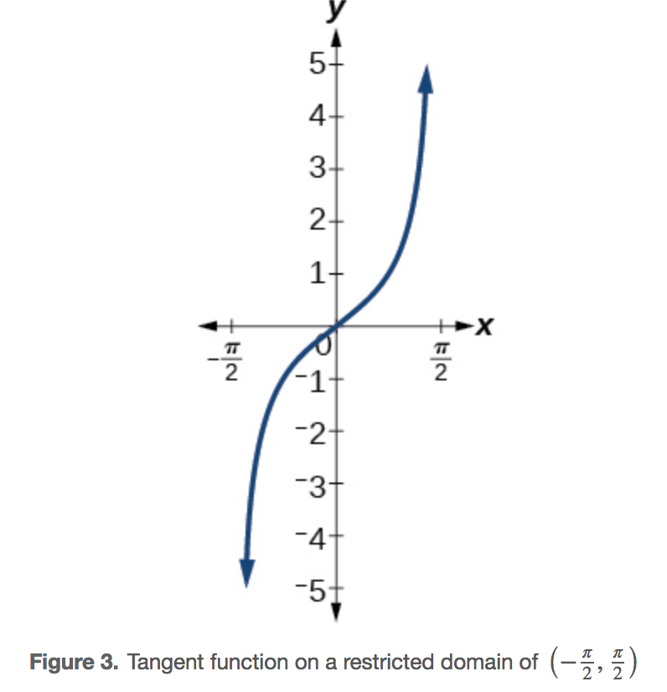
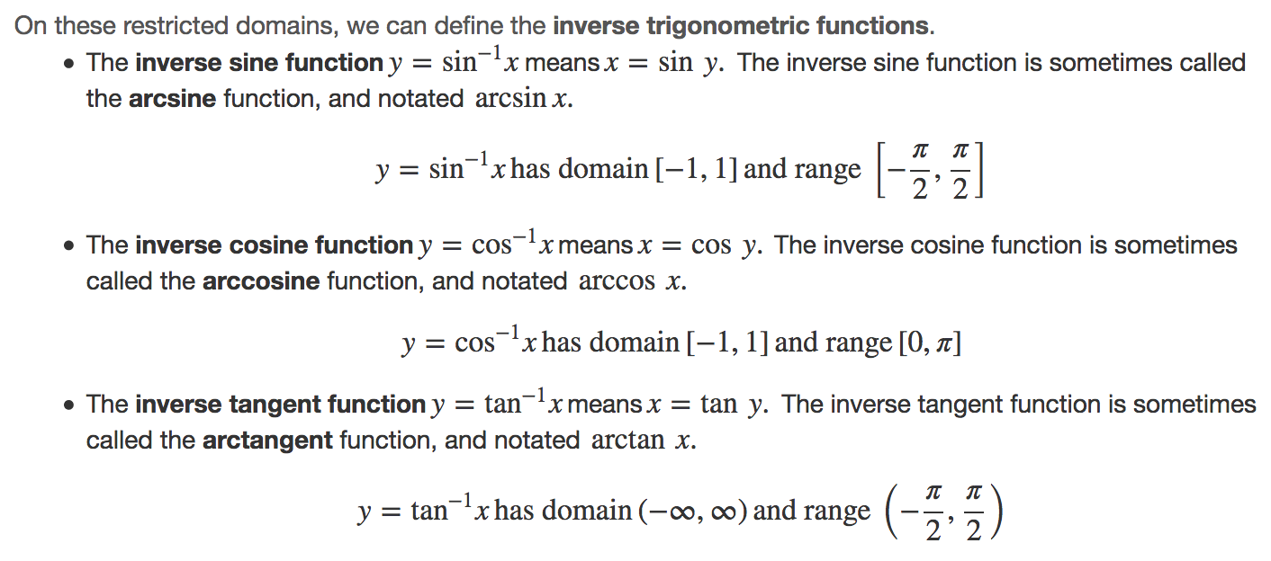
To find the domain and range of inverse trigonometric functions, _______________ the domain and range of the original functions. Each graph of the inverse trigonometric function is a reflection of the graph of the original function about the line y=x.
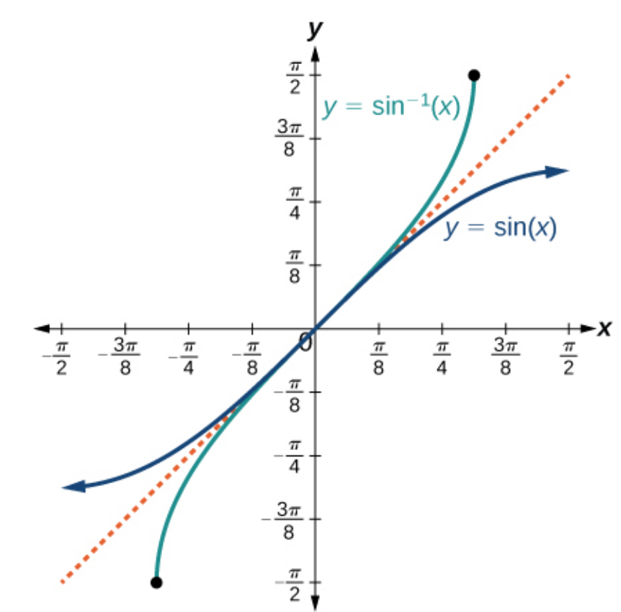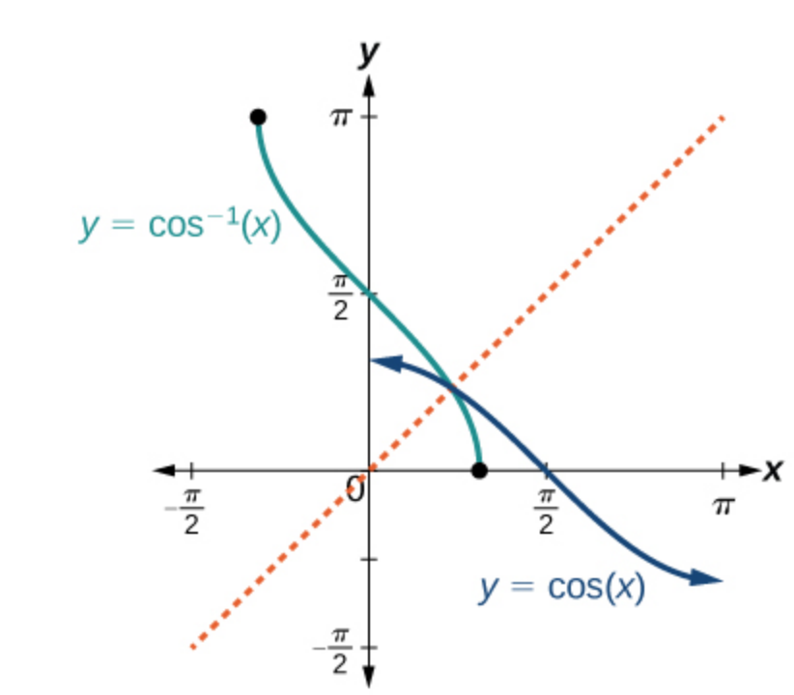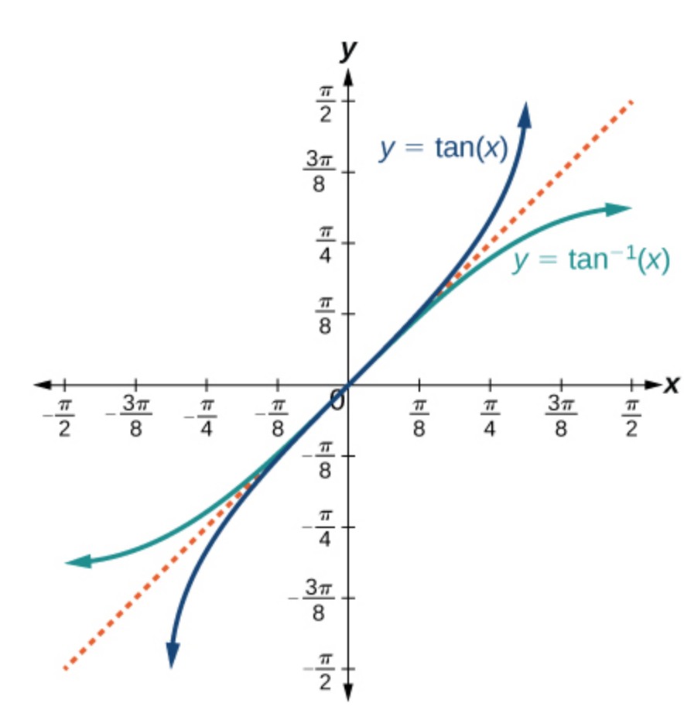
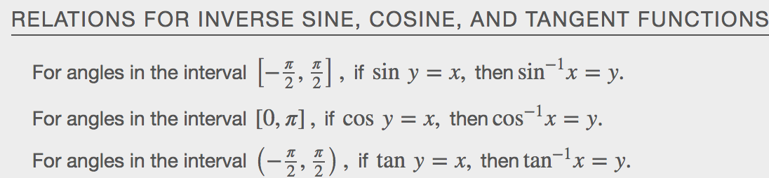
Examples

Finding the Exact Value of Expressions Involving the Inverse Sine, Cosine, and Tangent Functions
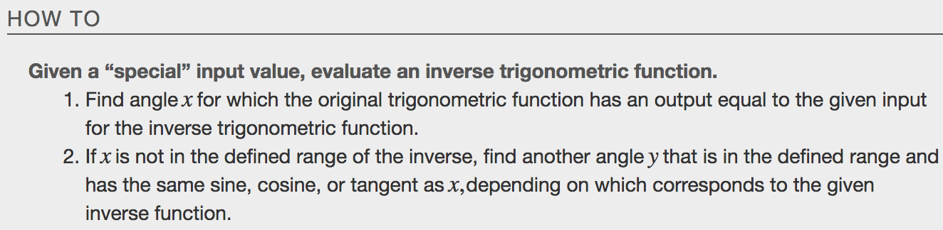
Examples
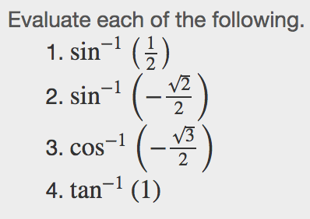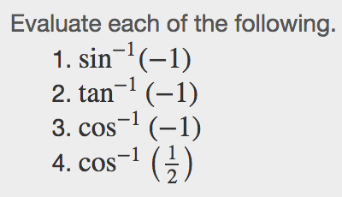

Using a Calculator to Evaluate Inverse Trigonometric Functions
To evaluate inverse trigonometric functions that do not involve the special angles discussed previously, we will need to use a calculator or other type of technology. Most scientific calculators and calculator-emulating applications have specific keys or buttons for the inverse sine, cosine, and tangent functions. These may be labeled, for example, SIN-1, ARCSIN, or ASIN.
Examples - RADIANS!!!!!!
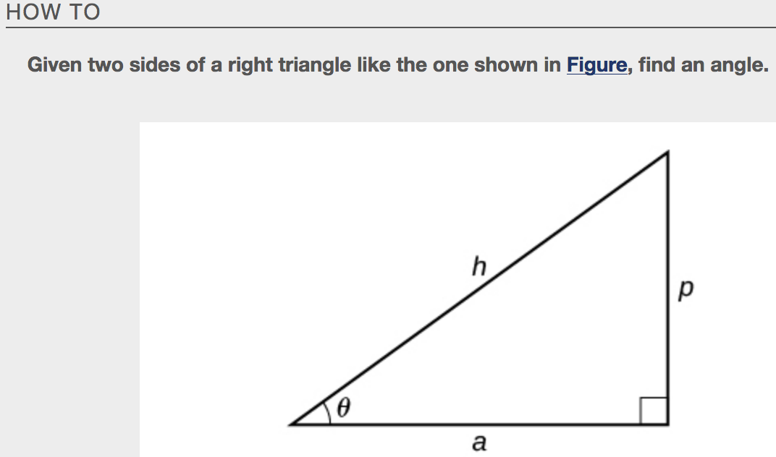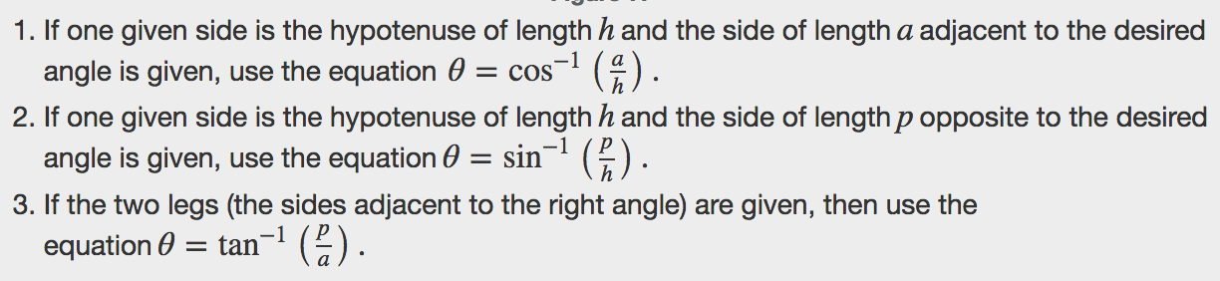

Examples
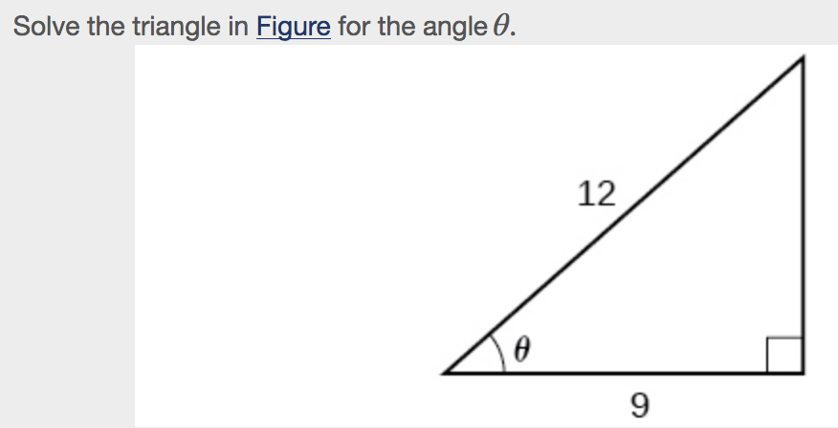

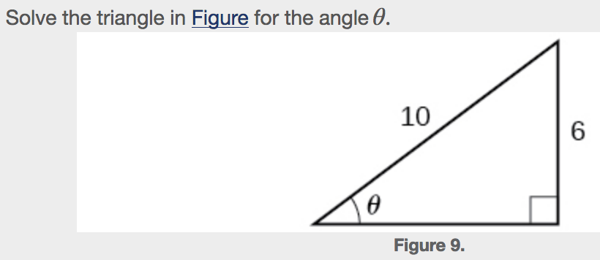

Finding Exact Values of Composite Functions with Inverse Trigonometric Functions
For any trigonometric function, f(f−1(y))=y for all y in the proper domain for the given function. This follows from the definition of the inverse and from the fact that the range of f was defined to be identical to the domain of f⁻¹.However, we have to be a little more careful with expressions of the form f⁻¹(f(x)).
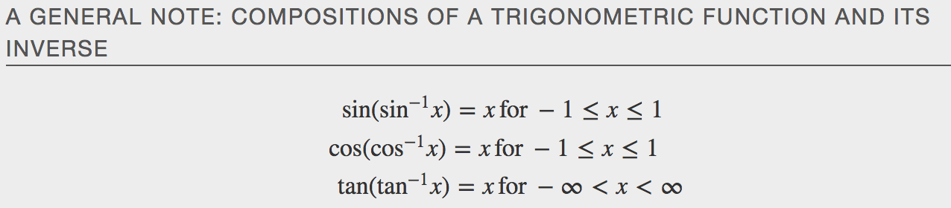
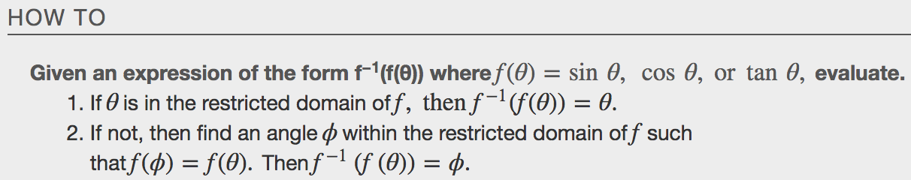
Examples
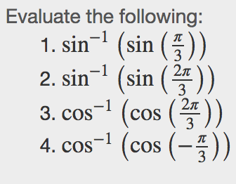
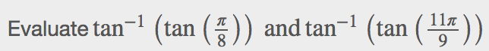

Evaluating Compositions of the Form $f^{-1}(g\left(x\right))$
For special values of x, we can exactly evaluate the inner function and then the outer, inverse function. However, we can find a more general approach by considering the relation between the two acute angles of a right triangle where one is θ, making the other $\frac{π}{2}= θ$.Consider the sine and cosine of each angle of the right triangle in Figure.
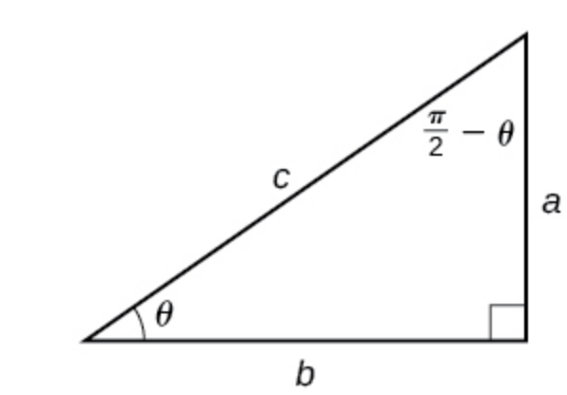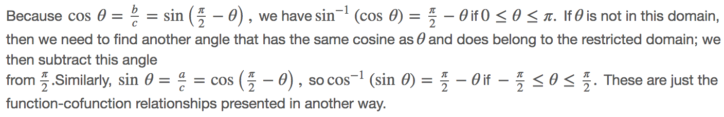
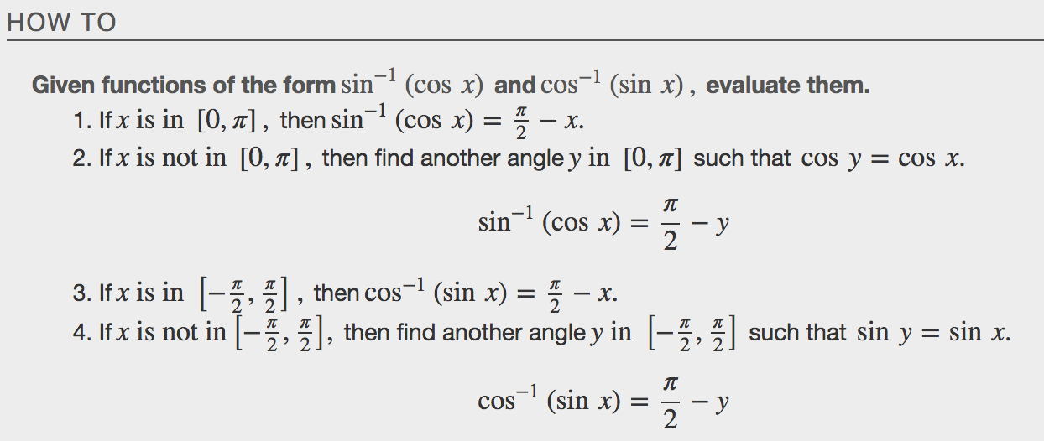
Examples
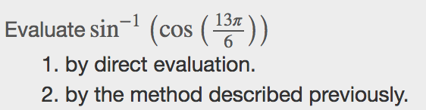

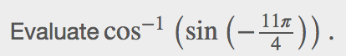

Evaluating Composition of the Form $f(g^{-1}\left(x\right))$
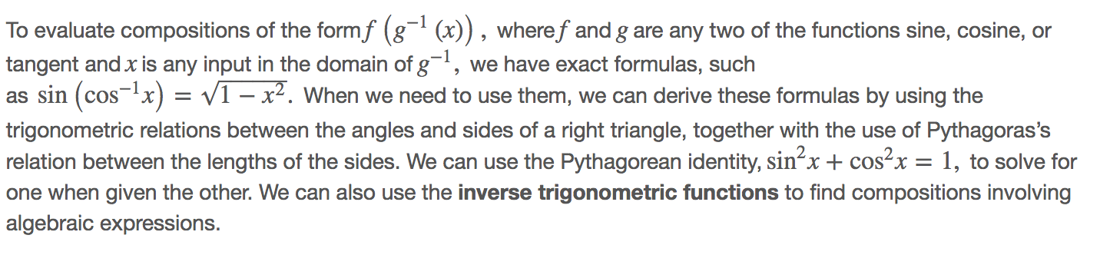
Examples
