8.2 – Graphs and Other Trig Functions
Analyzing the Graph of $y=\tan{x}$
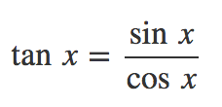
x | 0 | $$\frac{π}{6}$$ | $$\frac{π}{4}$$ | $$\frac{π}{3}$$ | $$\frac{π}{2}$$ | $$\frac{2π}{3}$$ | $$\frac{3π}{4}$$ | $$\frac{5π}{6}$$ | $$π$$
sin (x) | 0 | $$\frac{1}{2}$$ | $$\frac{\sqrt{2}}{2}$$ | $$\frac{\sqrt{3}}{2}$$ | 1 | $$\frac{\sqrt{3}}{2}$$ | $$\frac{\sqrt{2}}{2}$$ | $$\frac{1}{2}$$ | 0
cos (x) | 1 | $$\frac{\sqrt{3}}{2}$$ | $$\frac{\sqrt{2}}{2}$$ | $$\frac{1}{2}$$ | 0 | $$-\frac{1}{2}$$ | $$-\frac{\sqrt{2}}{2}$$ | $$-\frac{\sqrt{3}}{2}$$ | -1
tan (x)

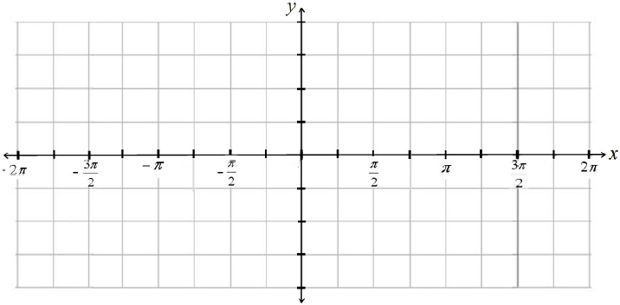
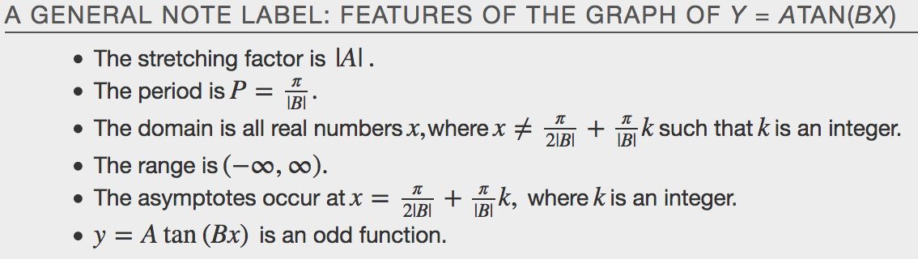
Graphing Variations of $y=\tan{x}$
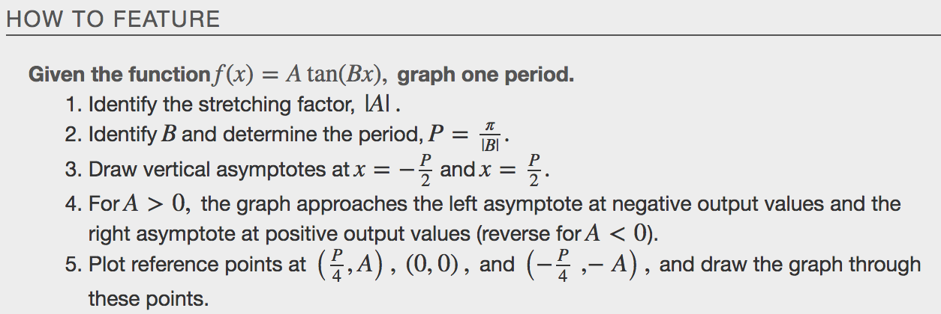
Examples
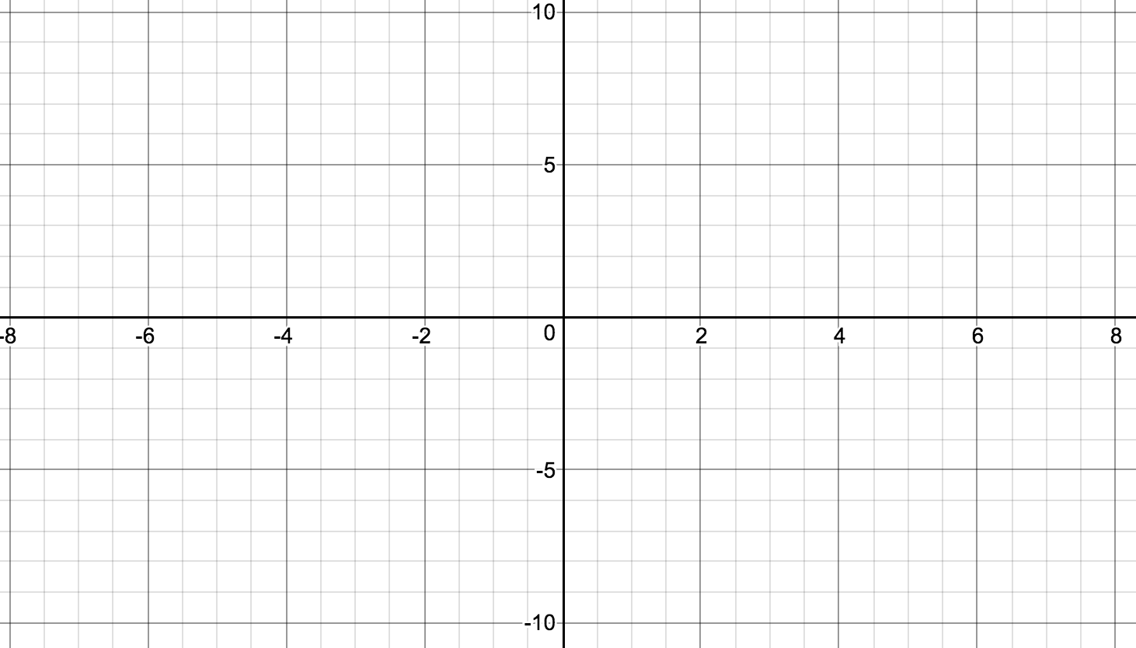

Graphing One Period of a Shifted Tangent Function
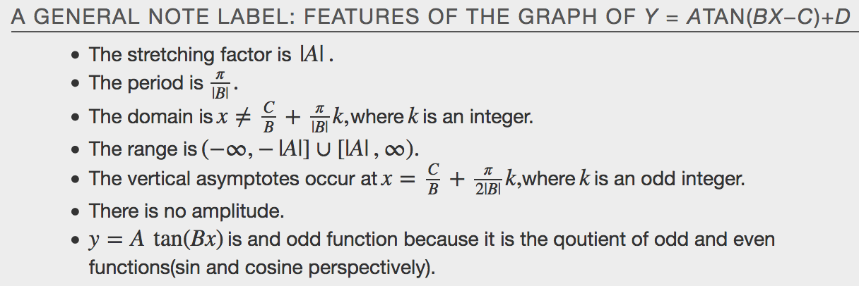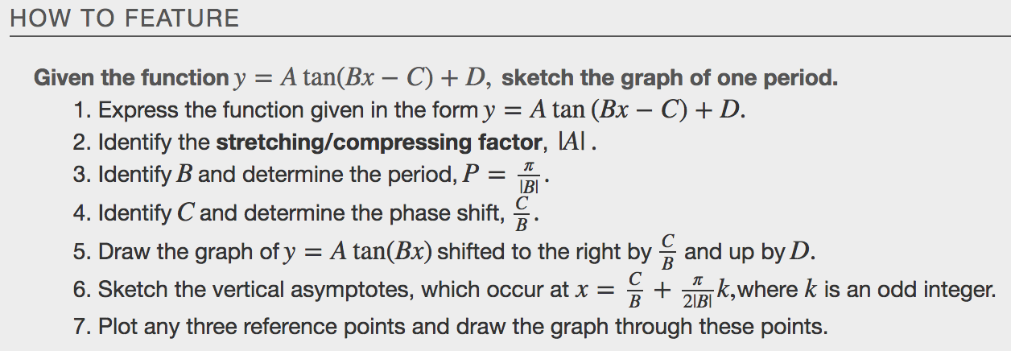
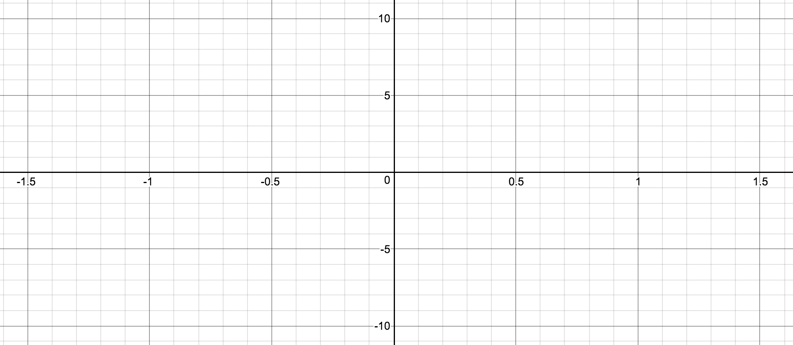

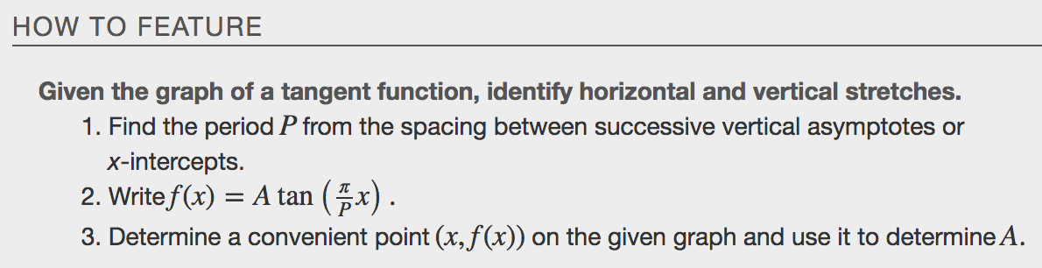
Example
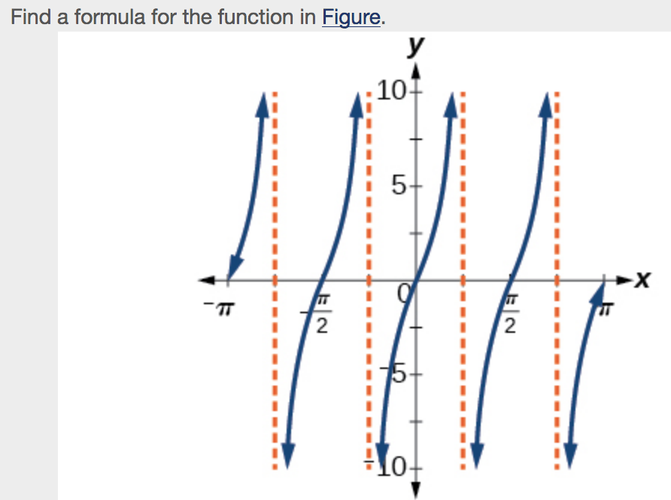
Analyzing the Graph of $y=\sec{x}$ and $y=\csc{x}$
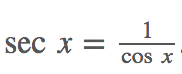
x | 0 | $$\frac{π}{6}$$ | $$\frac{π}{4}$$ | $$\frac{π}{3}$$ | $$\frac{π}{2}$$ | $$\frac{2π}{3}$$ | $$\frac{3π}{4}$$ | $$\frac{5π}{6}$$ | $$π$$
cos (x) | 1 | $$\frac{\sqrt{3}}{2}$$ | $$\frac{\sqrt{2}}{2}$$ | $$\frac{1}{2}$$ | 0 | $$-\frac{1}{2}$$ | $$-\frac{\sqrt{2}}{2}$$ | $$-\frac{\sqrt{3}}{2}$$ | -1
sec (x)

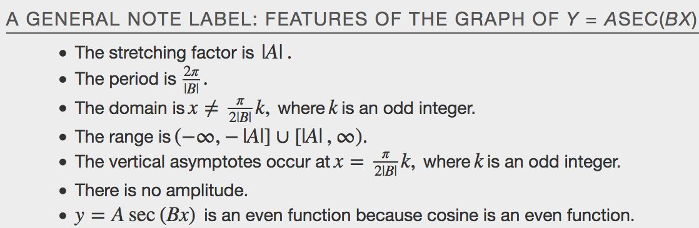
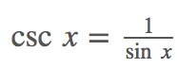
x | 0 | $$\frac{π}{6}$$ | $$\frac{π}{4}$$ | $$\frac{π}{3}$$ | $$\frac{π}{2}$$ | $$\frac{2π}{3}$$ | $$\frac{3π}{4}$$ | $$\frac{5π}{6}$$ | $$π$$
sin (x) | 0 | $$\frac{1}{2}$$ | $$\frac{\sqrt{2}}{2}$$ | $$\frac{\sqrt{3}}{2}$$ | 1 | $$\frac{\sqrt{3}}{2}$$ | $$\frac{\sqrt{2}}{2}$$ | $$\frac{1}{2}$$ | 0
csc (x)

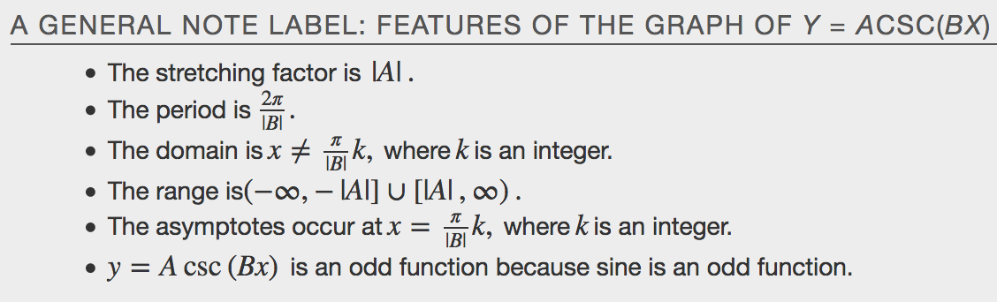
Graphing Variations of $y=\sec{x}$
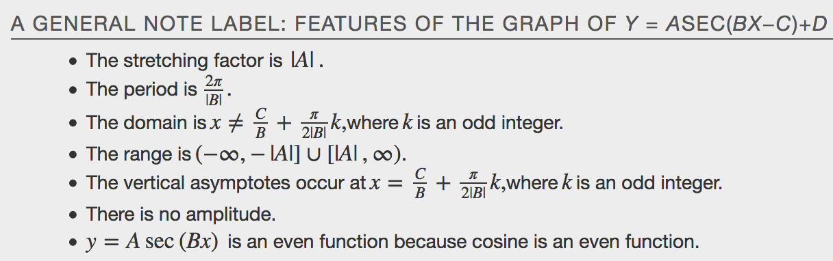
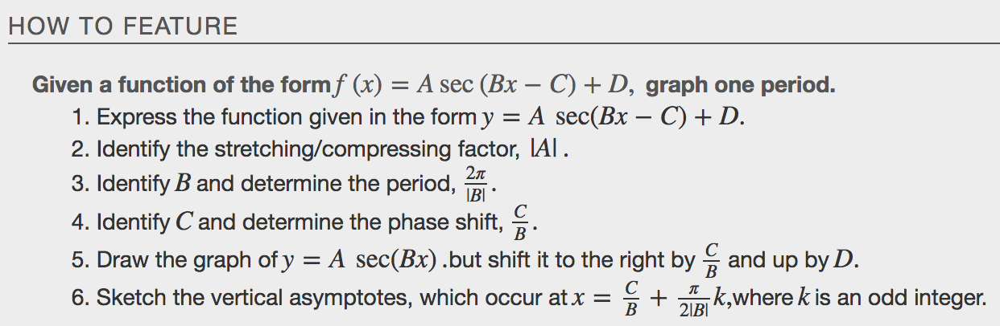
Example
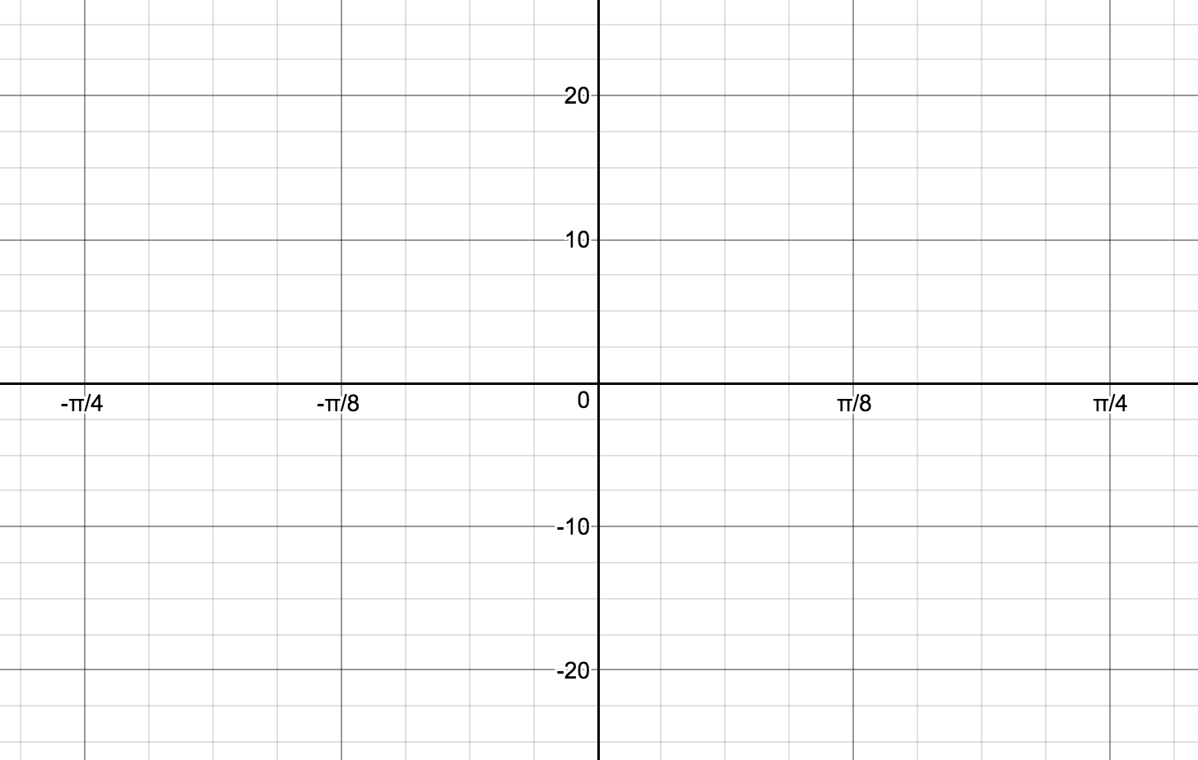

Graphing Variations of $y=\csc{x}$
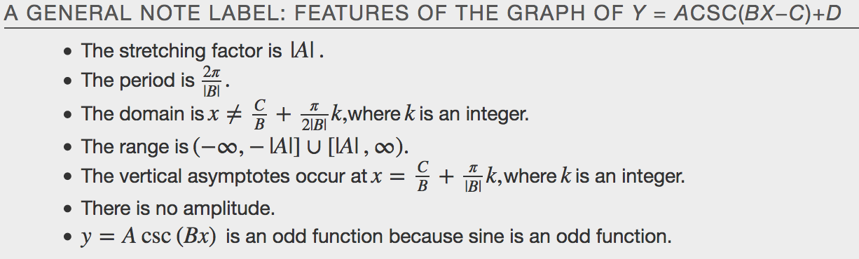
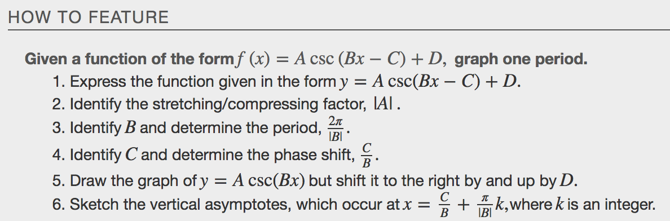
Example
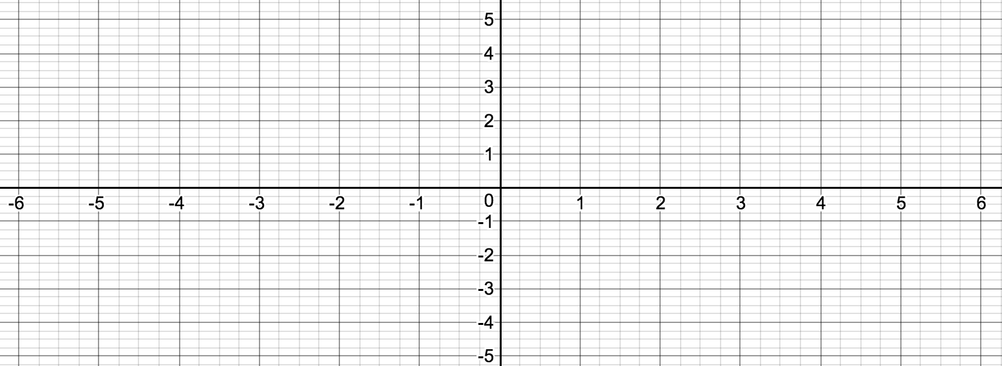

Analyzing the Graph of $y=\cot{x}$
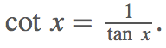
x | 0 | $$\frac{π}{6}$$ | $$\frac{π}{4}$$ | $$\frac{π}{3}$$ | $$\frac{π}{2}$$ | $$\frac{2π}{3}$$ | $$\frac{3π}{4}$$ | $$\frac{5π}{6}$$ | $$π$$
cos (x) | 1 | $$\frac{\sqrt{3}}{2}$$ | $$\frac{\sqrt{2}}{2}$$ | $$\frac{1}{2}$$ | 0 | $$-\frac{1}{2}$$ | $$-\frac{\sqrt{2}}{2}$$ | $$-\frac{\sqrt{3}}{2}$$ | -1
sin (x) | 0 | $$\frac{1}{2}$$ | $$\frac{\sqrt{2}}{2}$$ | $$\frac{\sqrt{3}}{2}$$ | 1 | $$\frac{\sqrt{3}}{2}$$ | $$\frac{\sqrt{2}}{2}$$ | $$\frac{1}{2}$$ | 0
cot (x)

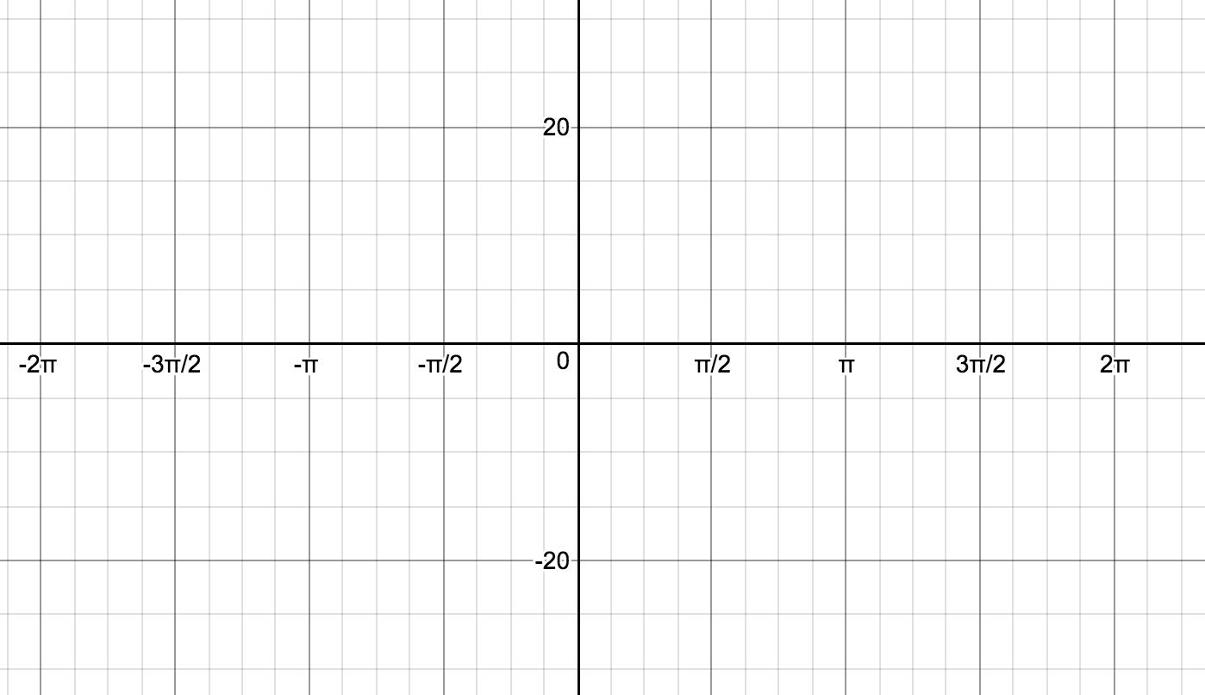
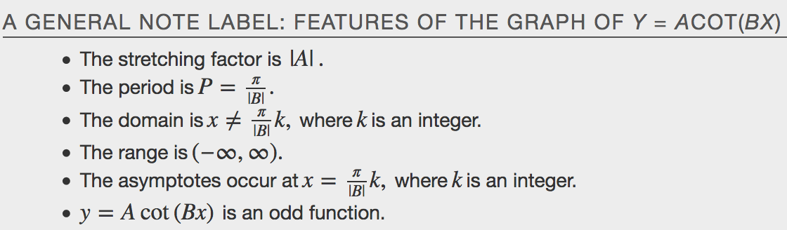
Graphing Variations of $y=\cot{x}$
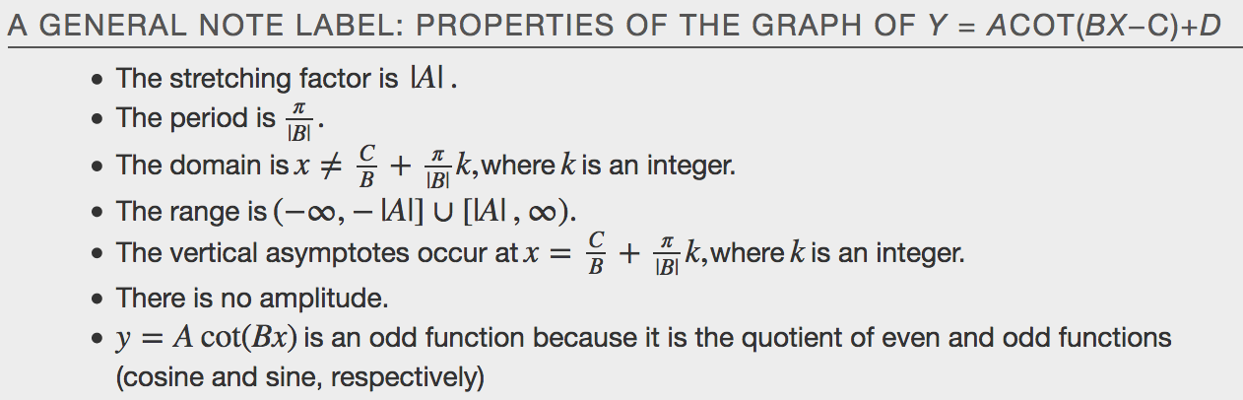
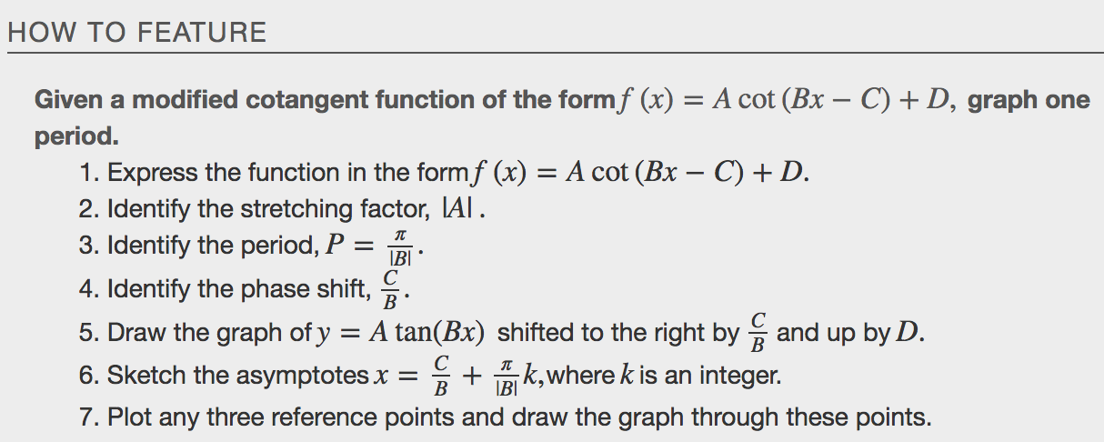
Example
