8.1 – Graphs of Sine and Cosine Functions
The Graph of $y=sin\left(x\right)$
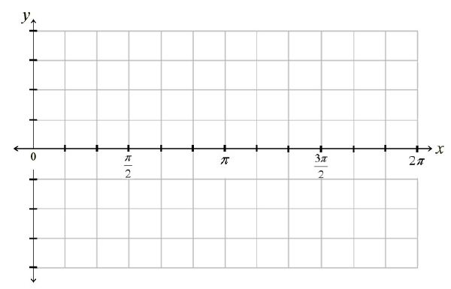
x | y

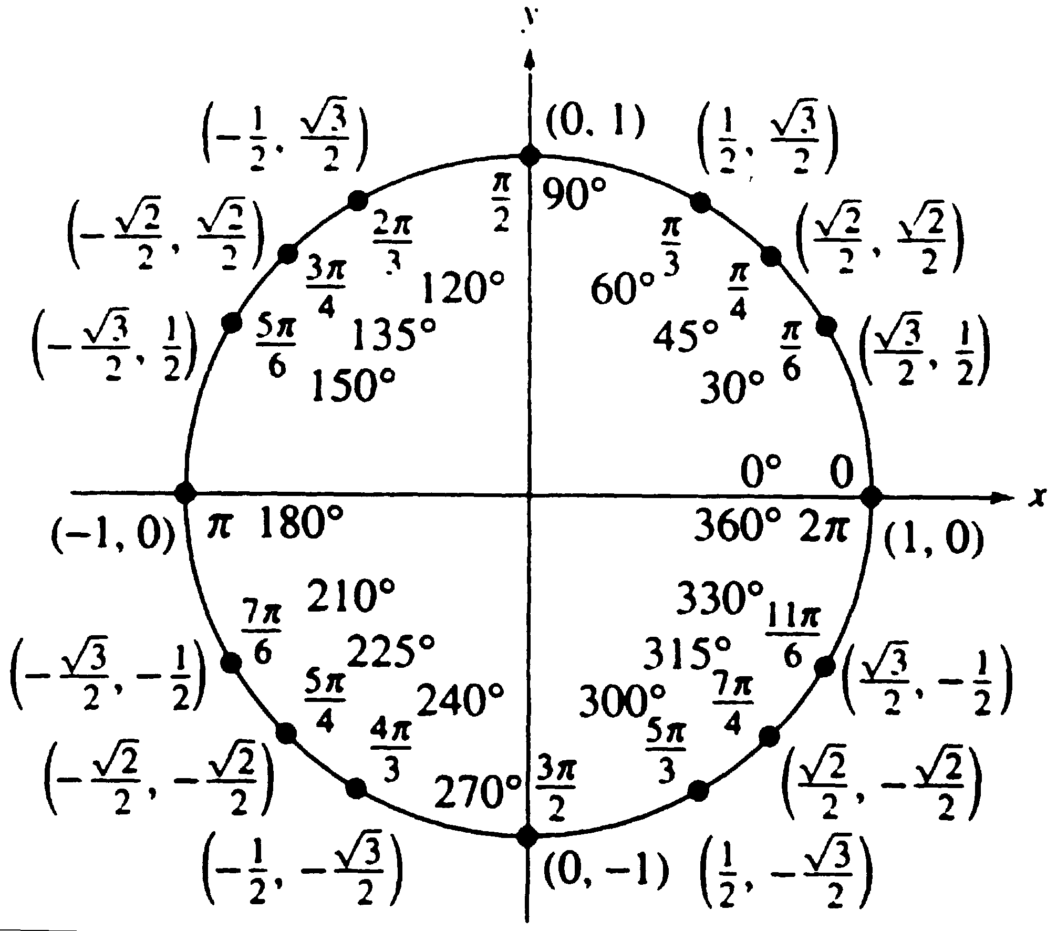
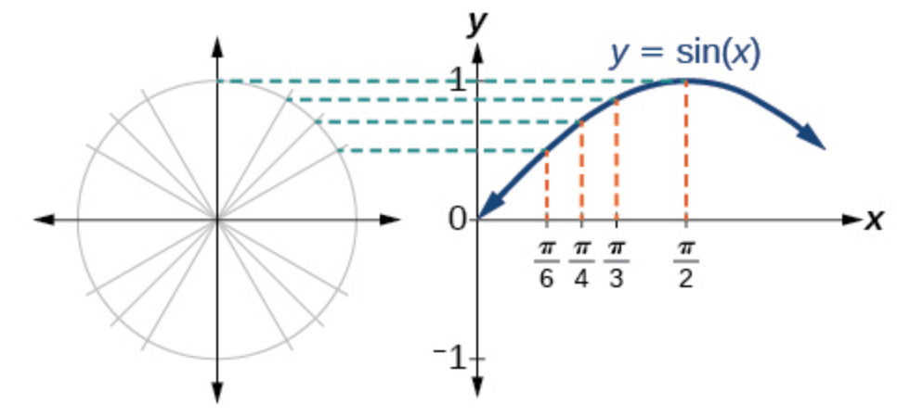

The graph of $y=cos\left(x\right)$
x | y

In both graphs, the shape of the graph repeats after 2π, which means the functions are periodic with a period of 2π. A periodic function is a function for which a specific horizontal shift, P, results in a function equal to the original function: f(x+P)=f(x)for all values of x in the domain of f. When this occurs, we call the smallest such horizontal shift with P>0 the period of the function.
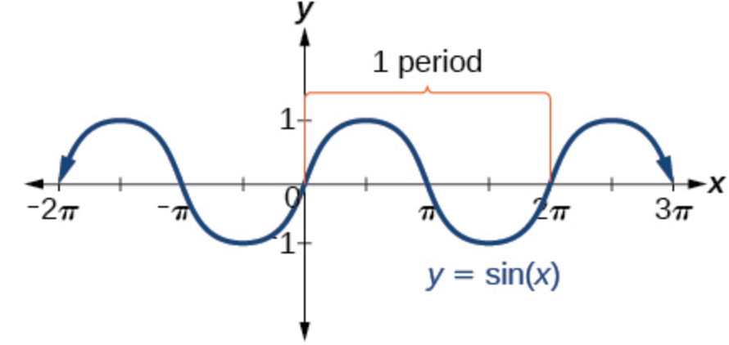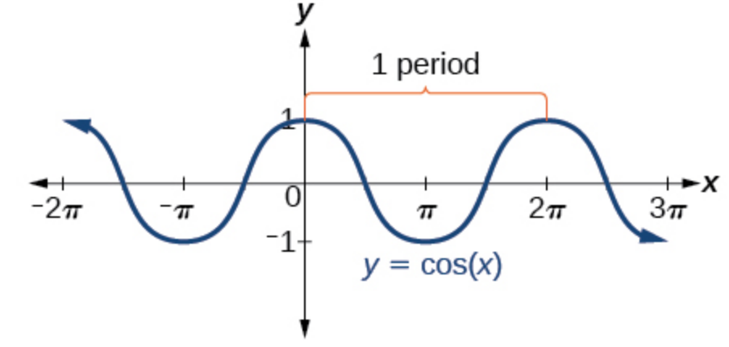
Even/Odd
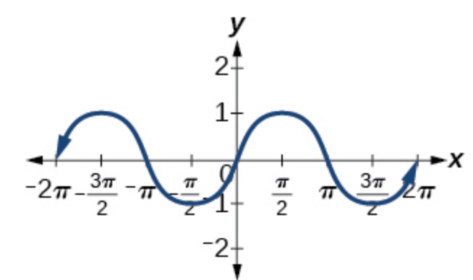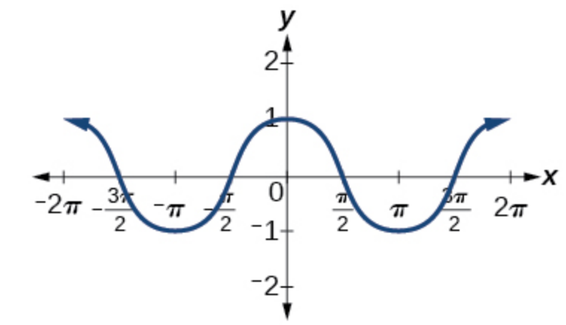
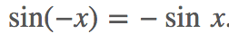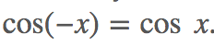
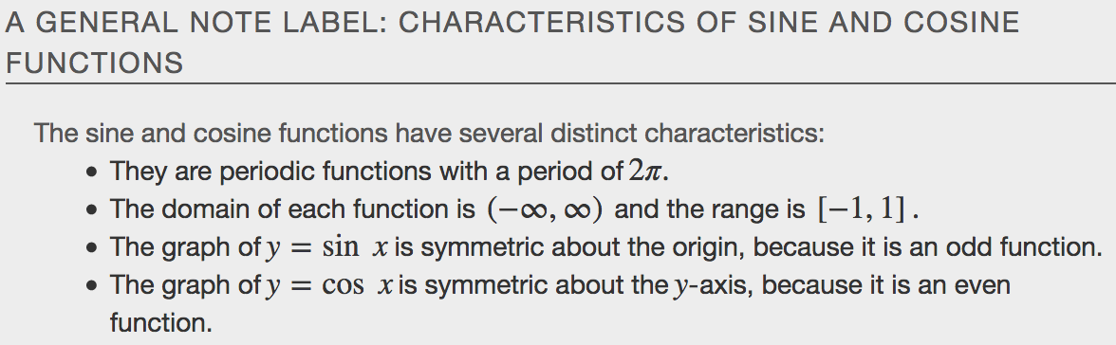
Investigating Sinusoidal Functions
A function that has the same general shape as a sine or cosine function is known as a sinusoidal function. The general forms of sinusoidal functions are
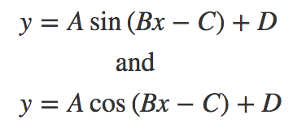

Determining the Period of Sinusoidal Functions
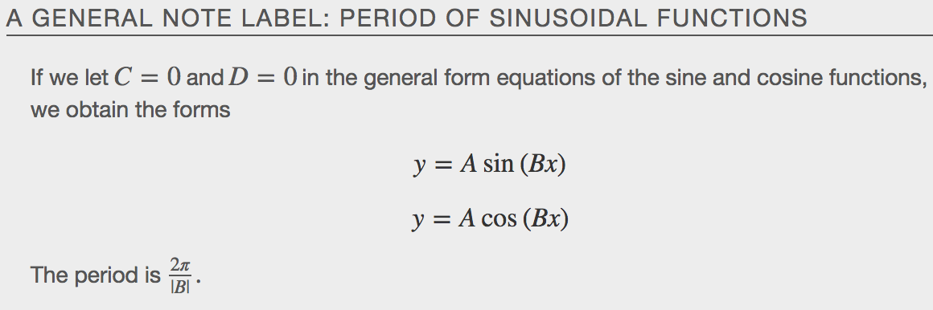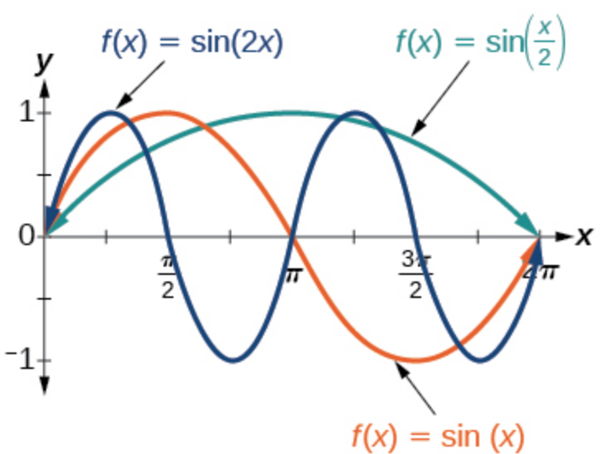
Examples
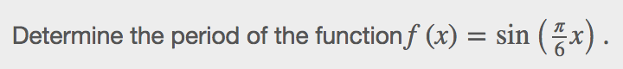

Determining Amplitude
Now let’s turn to the variable A, so we can analyze how it is related to the _____________________, or greatest distance from rest. A represents the vertical stretch factor, and its absolute value |A| is the amplitude. The local maxima will be a distance |A| above the vertical midline of the graph, which is the line x=D; because D=0 in this case, the midline is the x-axis. The local minima will be the same distance below the midline. If |A|>1,the function is stretched.
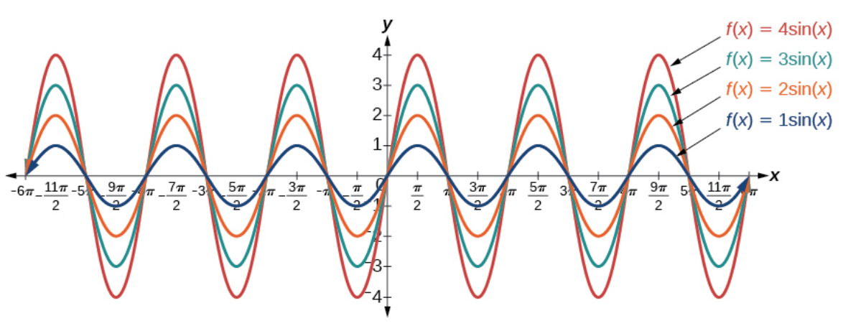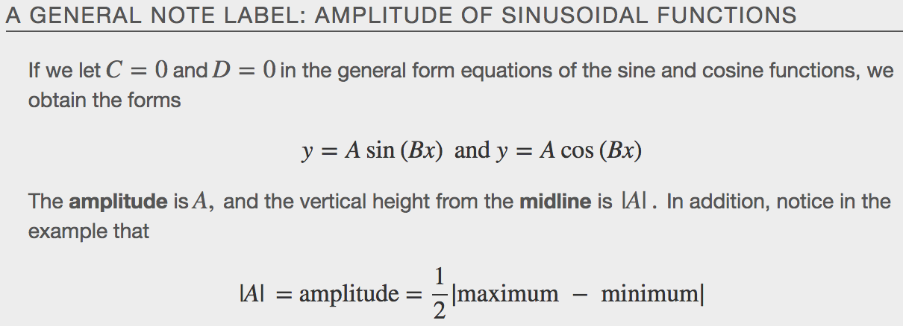
Examples

Analyzing Graphs of Variations of 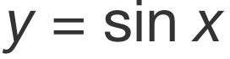 and 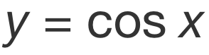
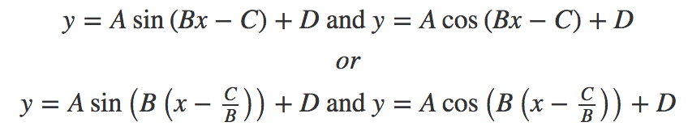
The value $\frac{C}{B}$ for a sinusoidal function is called the ______________ _______________, or the horizontal displacement of the basic sine or cosine function. If C>0, the graph shifts to the __________. If C<0, the graph shifts to the _________. The greater the value of∣C∣,the more the graph is shifted. The figure below shows that the graph of f(x)=sin(x−π)shifts to the _______ by ___ units, which is more than we see in the graph of f(x)=sin(x − $\frac{π}{4}$),which shifts to the right by _____units.
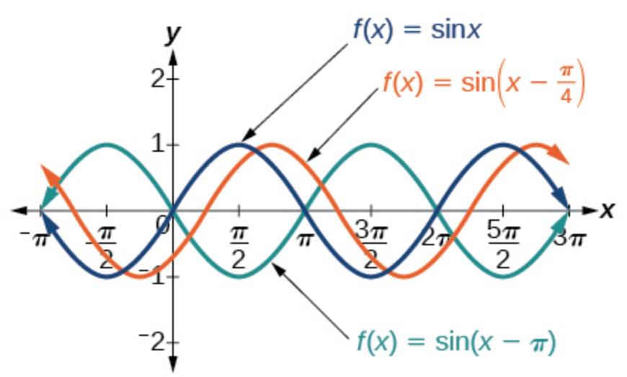
While C relates to the horizontal shift, D indicates the vertical shift from the midline in the general formula for a sinusoidal function. The function y=cos(x)+D has its midline at y=D.
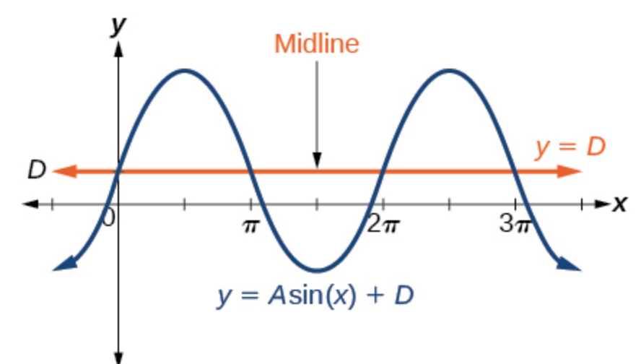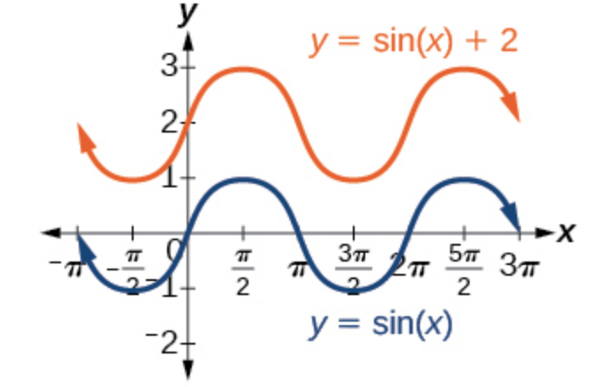
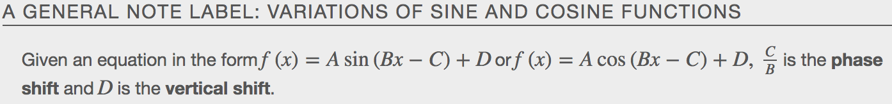
Examples

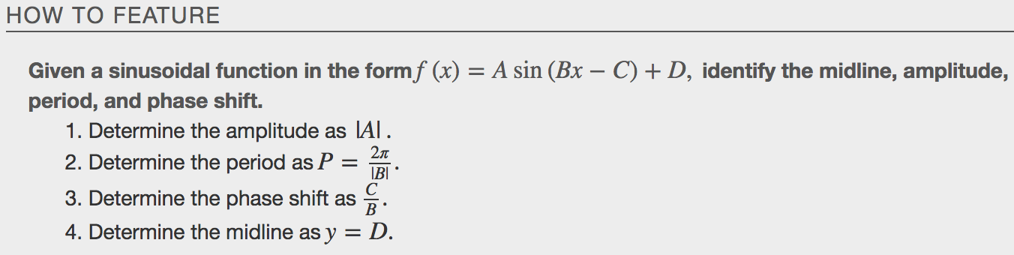
Examples
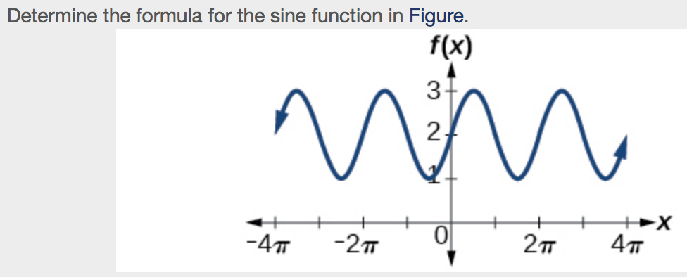

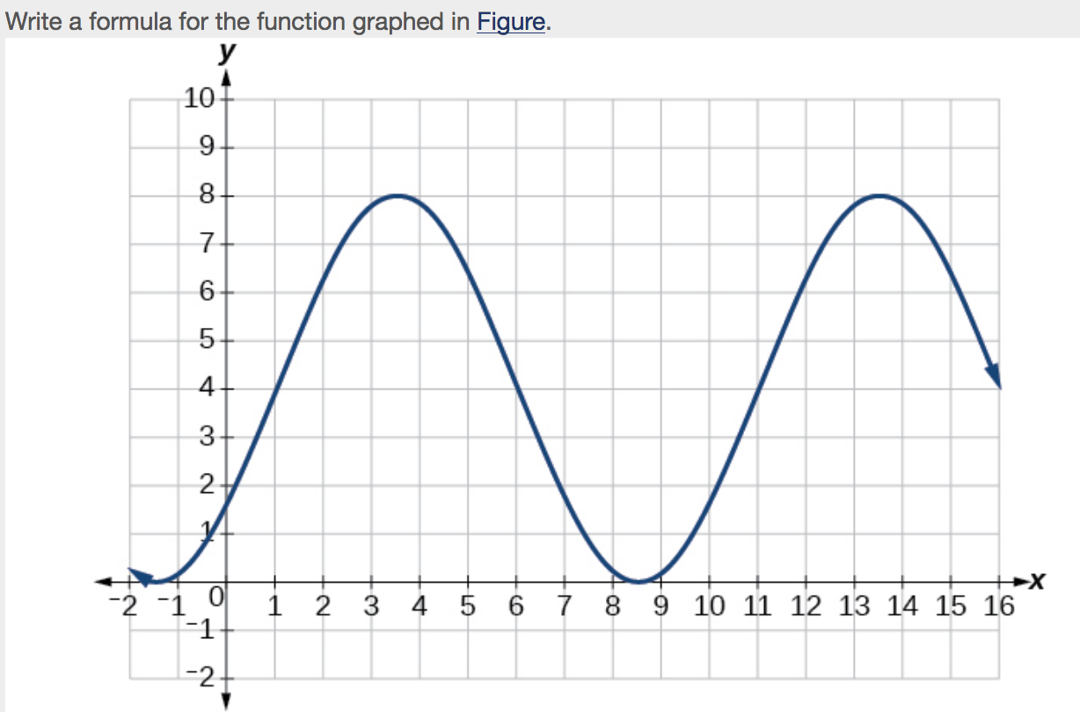

Graphing Variations of and
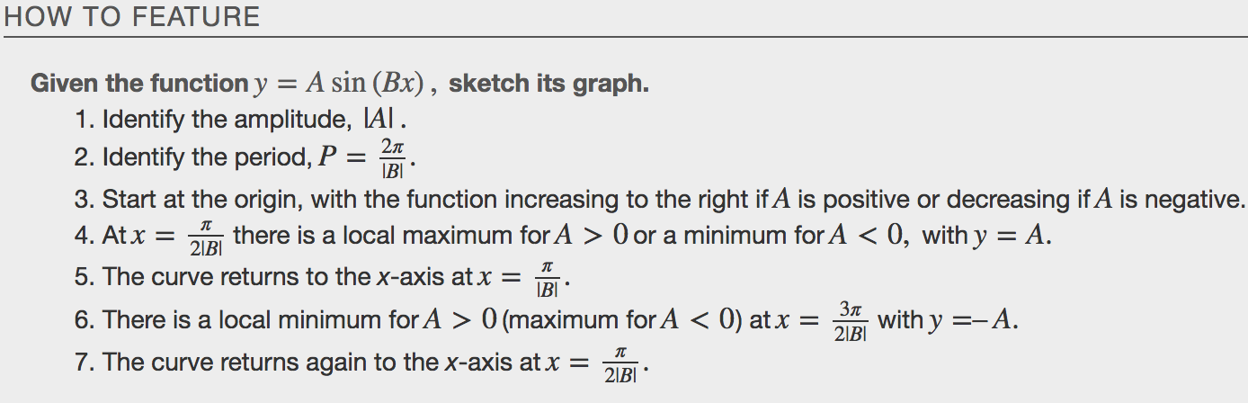
Examples
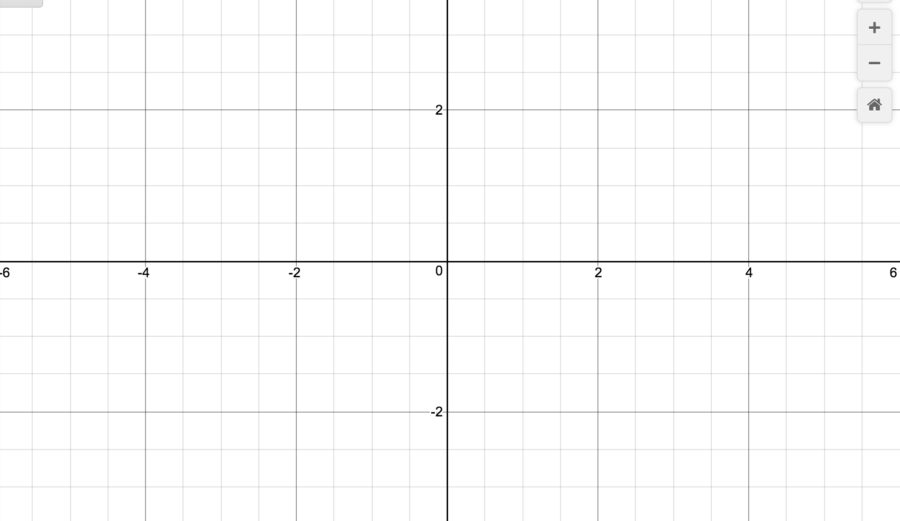

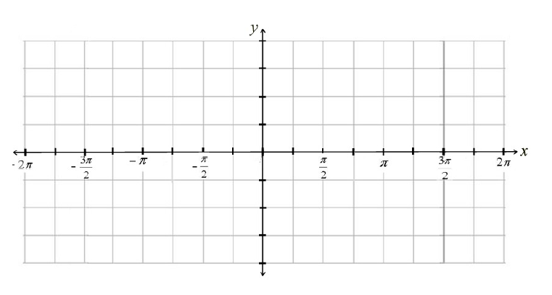

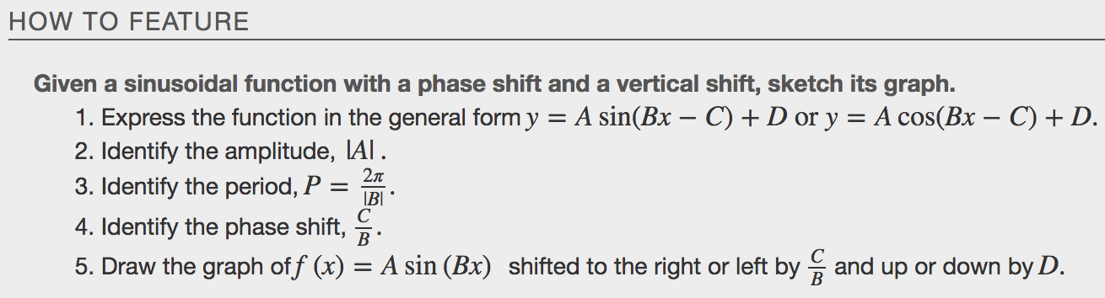
Examples
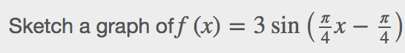
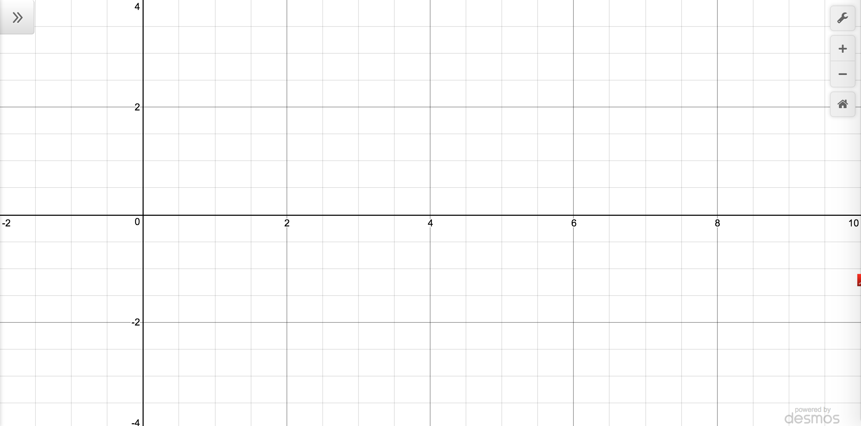

Using Transformations of Sine and Cosine Functions
We can use the transformations of sine and cosine functions in numerous applications. As mentioned at the beginning of the chapter, circular motion can be modeled using either the sine or cosine function.

Examples
