7.4 – The Other Trig Functions

Finding Exact Values
As with the sine and cosine, we can use the(x,y)coordinates to find the other functions.

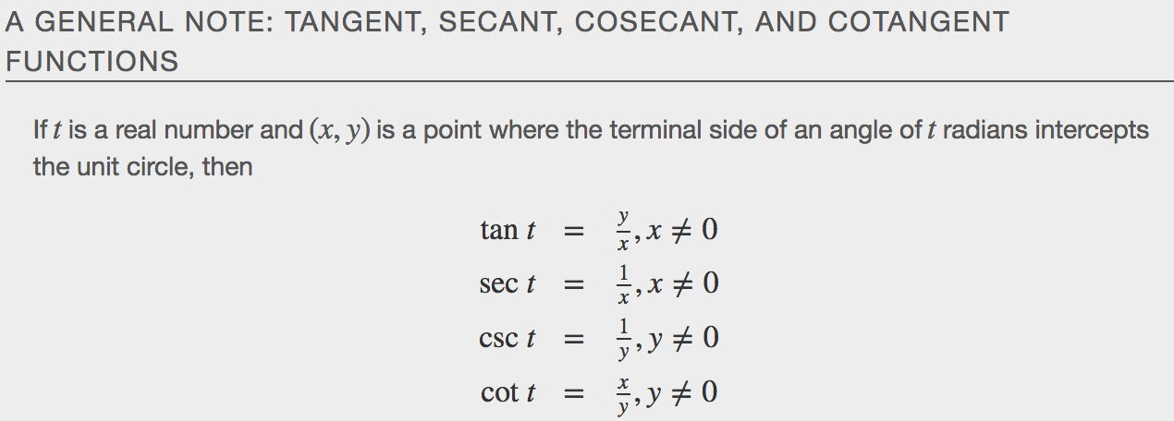
Examples
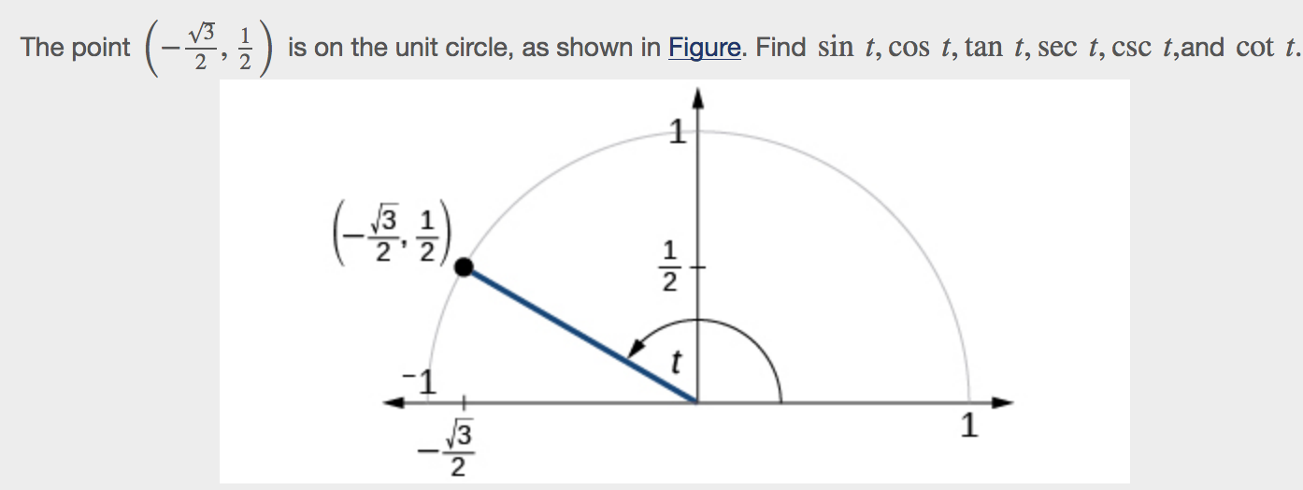

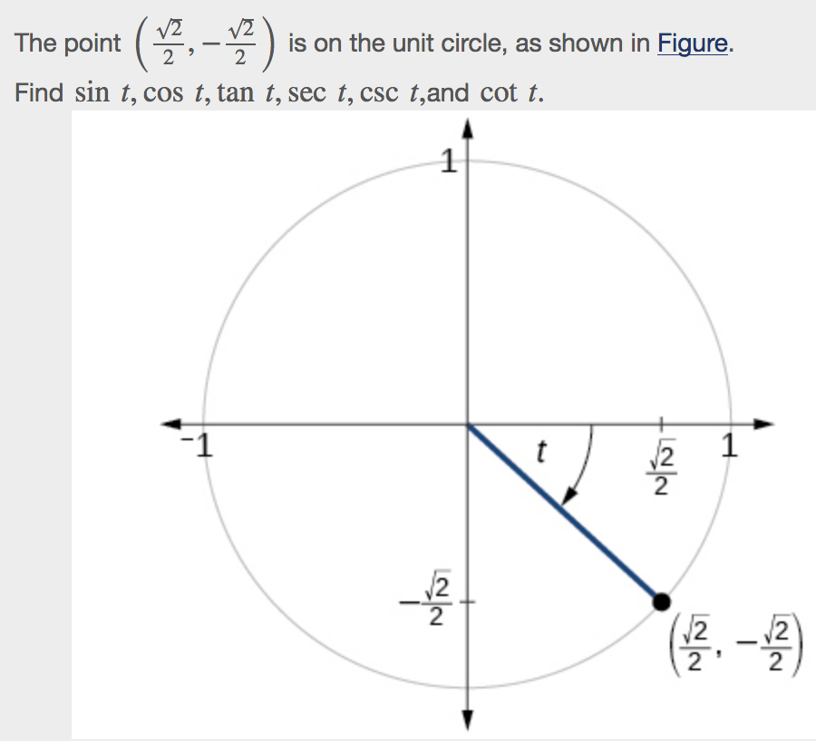
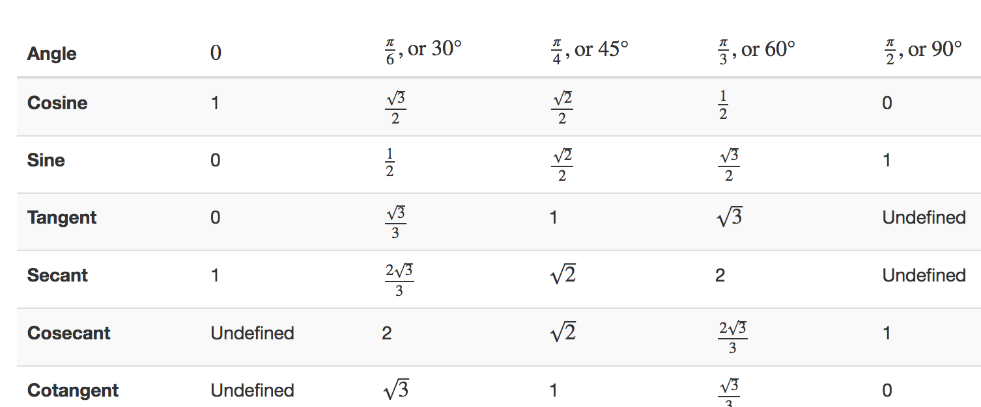

Example

Using Reference Angles to Evaluate Secant, Cosecant, and Cotangent
We can evaluate trigonometric functions of angles outside the first quadrant using reference angles as we have already done with the sine and cosine functions.
A Smart Trig Class
To help remember which of the six trigonometric functions are positive in each quadrant, we can use the mnemonic phrase “A Smart Trig Class.” Each of the four words in the phrase corresponds to one of the four quadrants, starting with quadrant I and rotating counterclockwise. In quadrant I, which is “A,” all of the six trigonometric functions are positive. In quadrant II, “Smart,” only sine and its reciprocal function, cosecant, are positive. In quadrant III, “Trig,” only tangent and its reciprocal function, cotangent, are positive. Finally, in quadrant IV, “Class,” only cosine and its reciprocal function, secant, are positive.

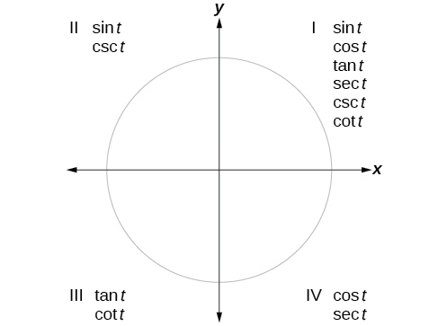

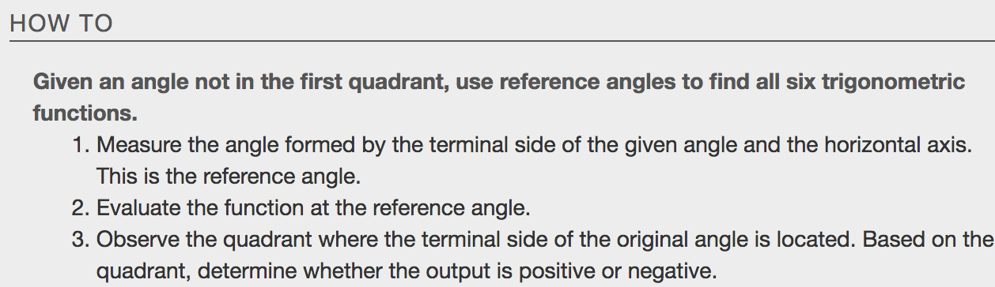
Examples

Using Even and Odd Trig Functions
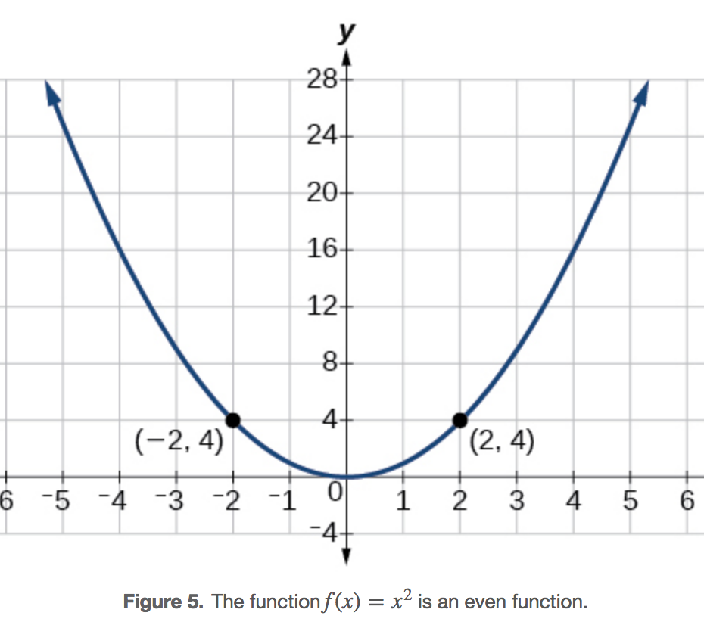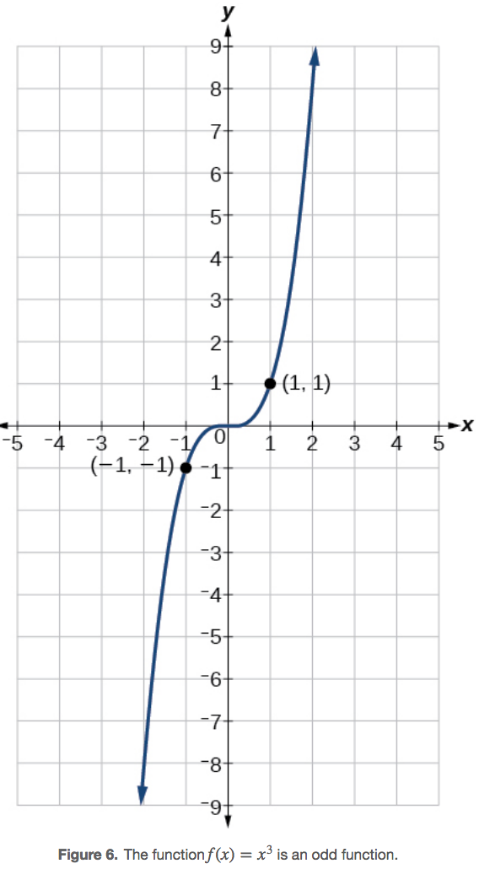

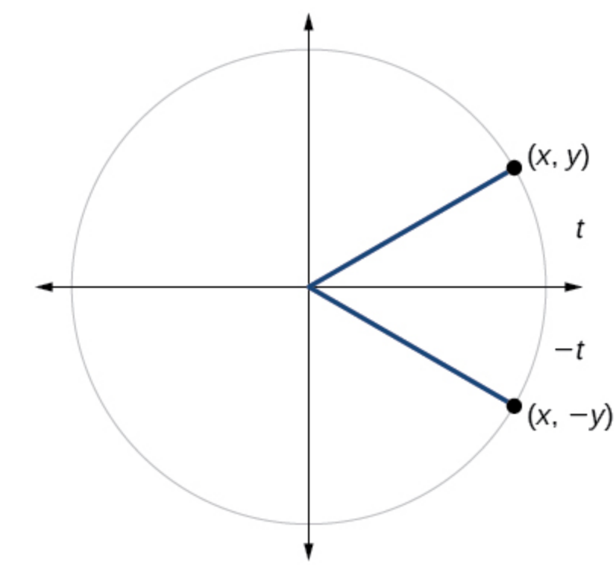
We can test whether a trigonometric function is even or odd by drawing a unit circle with a positive and a negative angle, as in Figure. The sine of the positive angle is y.The sine of the negative angle is−y. The sine function, then, is an odd function. We can test each of the six trigonometric functions in this fashion.

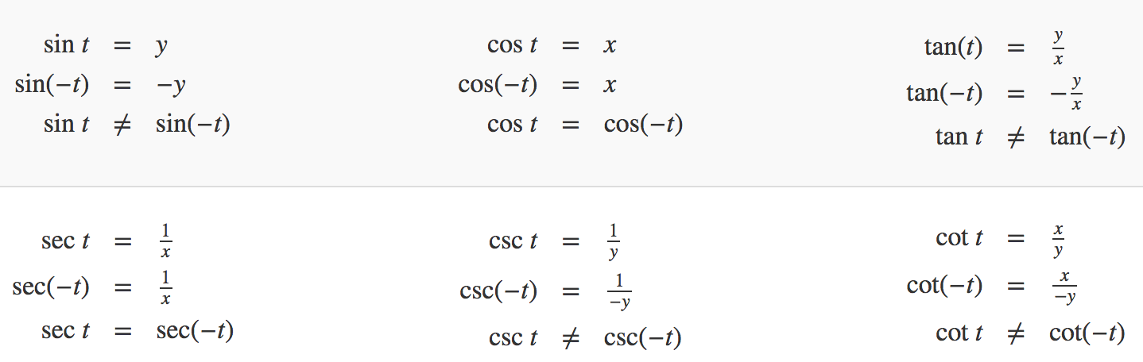
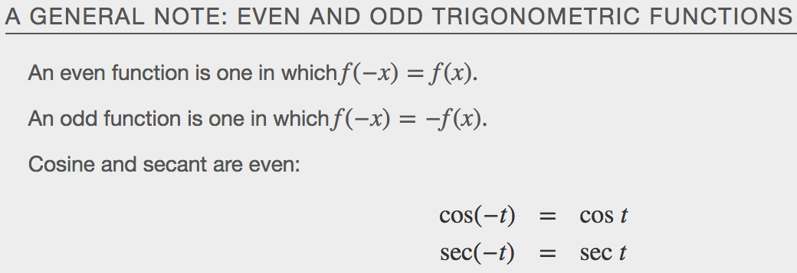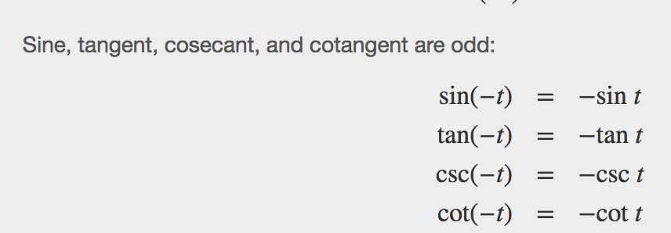
Examples

Recognizing and Using Fundamental Identities
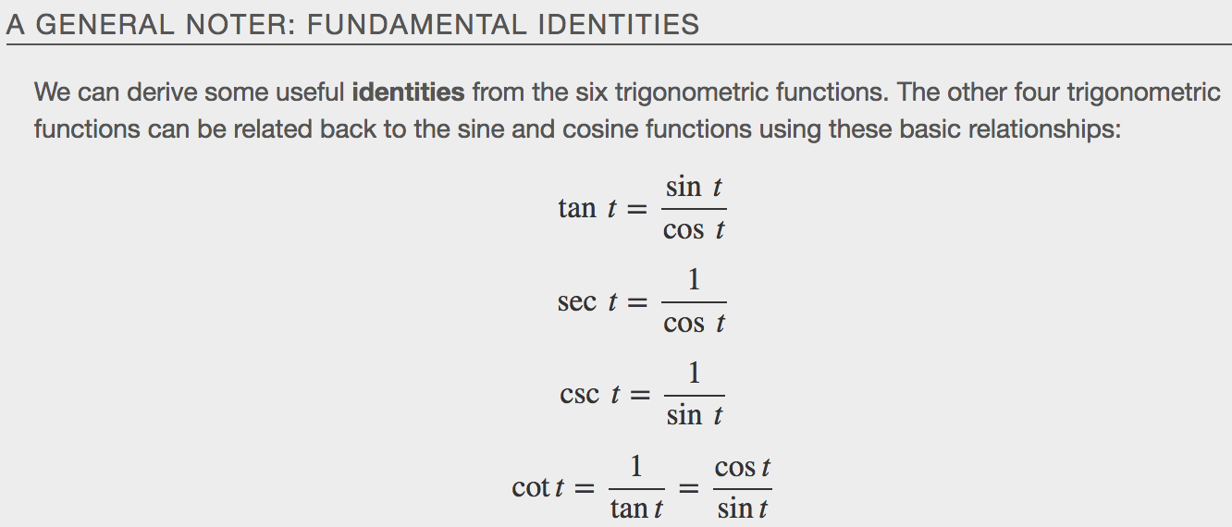
Examples
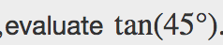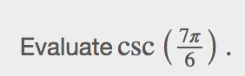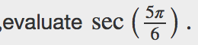

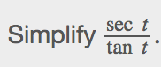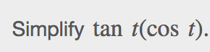

Alternate forms of the Pythagorean Theorem
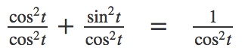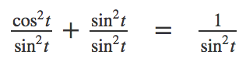

Example

As we discussed at the beginning of the chapter, a function that repeats its values in regular intervals is known as a periodic function. The trigonometric functions are periodic. For the four trigonometric functions, sine, cosine, cosecant and secant, a revolution of one circle, or 2π,will result in the same outputs for these functions. And for tangent and cotangent, only a half a revolution will result in the same outputs. A _________________________ is the shortest interval over which a function completes one full cycle.
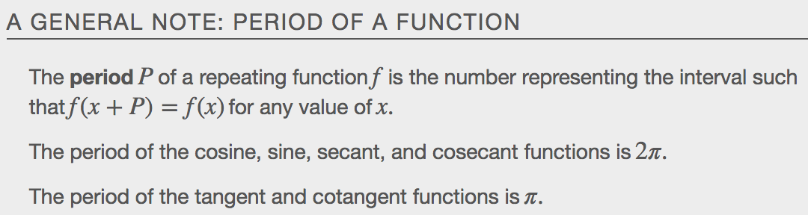
Examples
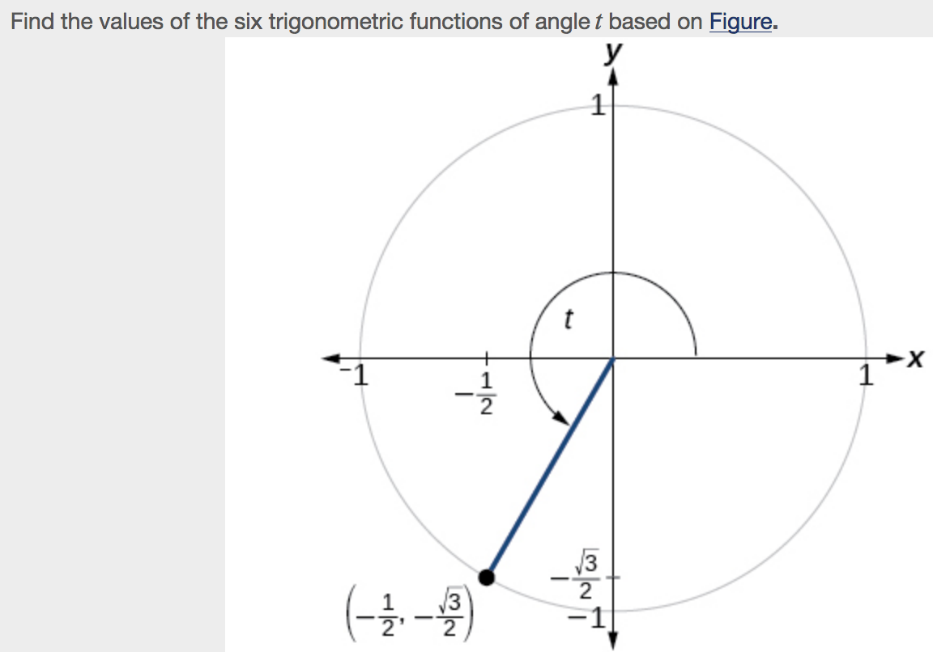

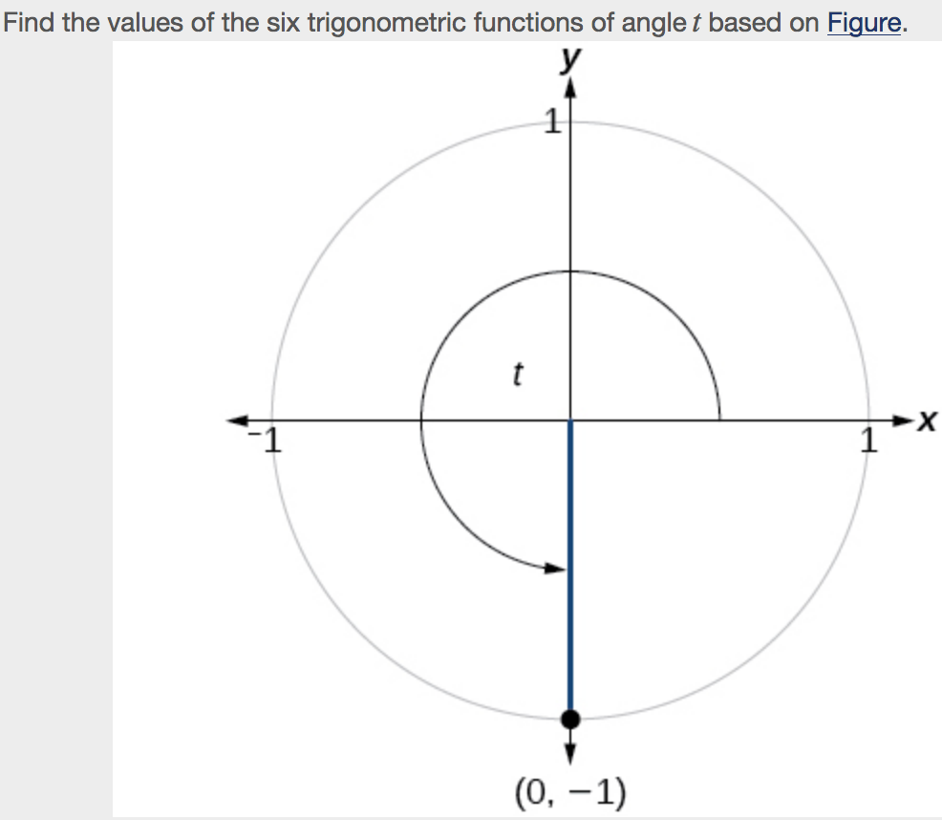

“”

Evaluating Trig Functions with a Calculator
Evaluating a tangent function with a scientific calculator as opposed to a graphing calculator or computer algebra system is like evaluating a sine or cosine: Enter the value and press the TAN key. For the reciprocal functions, there may not be any dedicated keys that say CSC, SEC, or COT. In that case, the function must be evaluated as the reciprocal of a sine, cosine, or tangent.
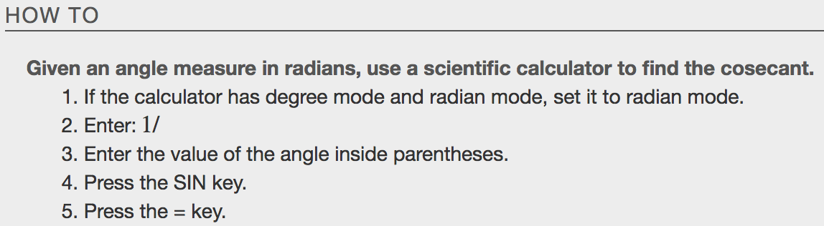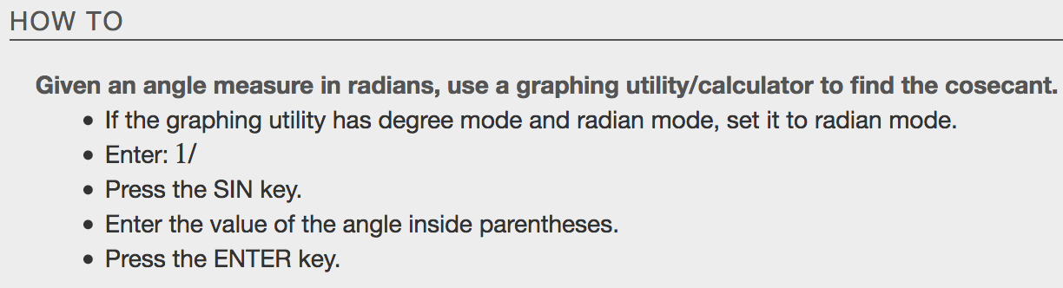
Examples
