7.3 – The Unit Circle

Finding Trig Functions Using The Unit Circle
For any angle t, we can label the intersection of the terminal side and the unit circle as by its coordinates,(x,y).The coordinates x and y will be the outputs of the trigonometric functions f(t)=cos t and f(t)=sin t, respectively. This means x=cos t and y=sin t.

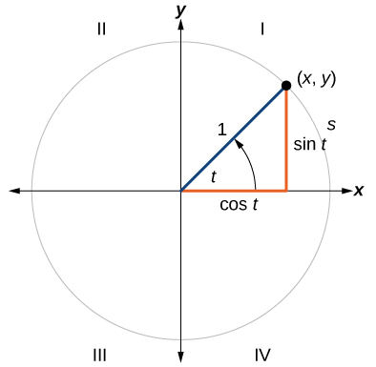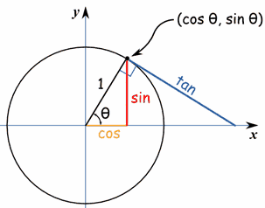

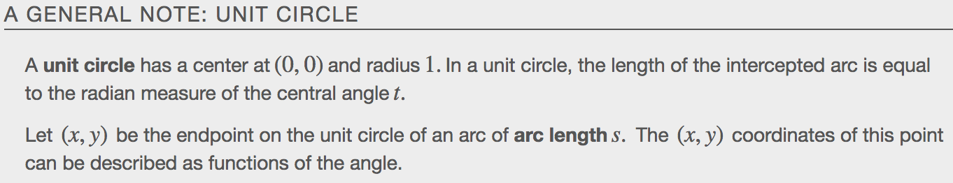

Defining Sine and Cosine Functions from the Unit Circle
Like all functions, the sine function has an input and an output. Its input is the measure of the _______________, its output is the ___-coordinate of the corresponding point on the unit circle.
The cosine function of an angle t equals the x-value of the endpoint on the unit circle of an arc of ______________ t. In the figure, cosine is equal to _____.

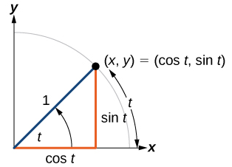
Because it is understood that sine and cosine are functions, we do not always need to write them with parentheses: sin t is the same as sin(t) and cos t is the same as cos(t). Likewise,cos²t is a commonly used shorthand notation for(cos(t))².Be aware that many calculators and computers do not recognize the shorthand notation. When in doubt, use the extra parentheses when entering calculations into a calculator or computer.

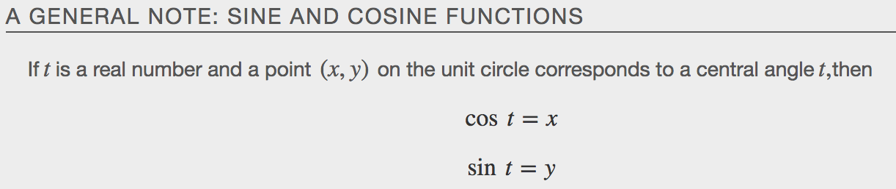

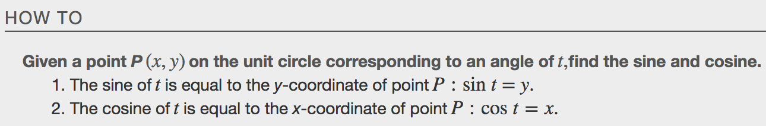

Example
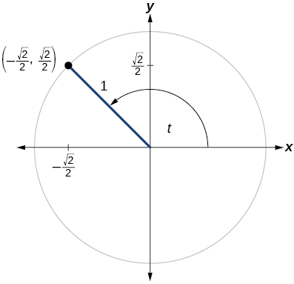

Examples
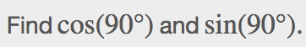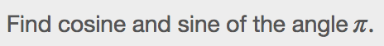

The Pythagorean Identity
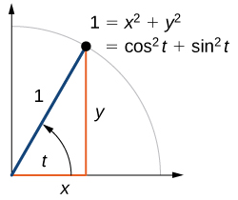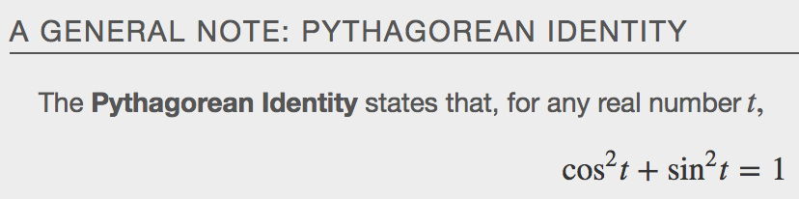

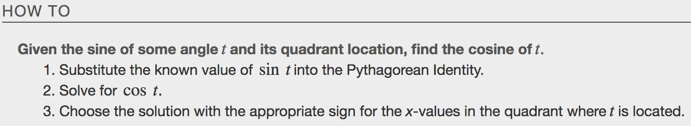

Examples

Finding Sine and Cosine of Special Angles

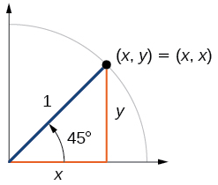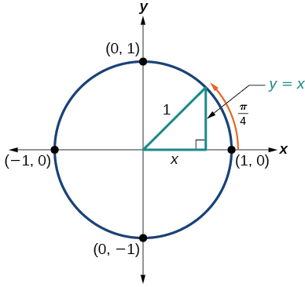
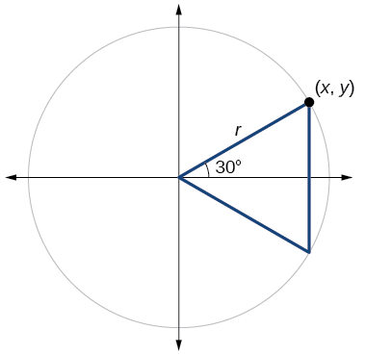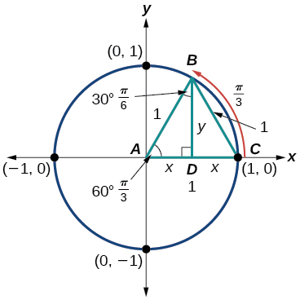

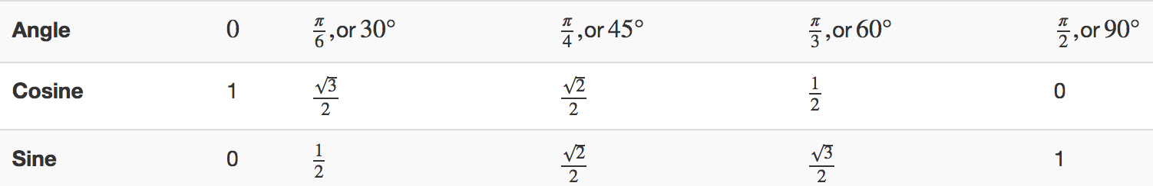
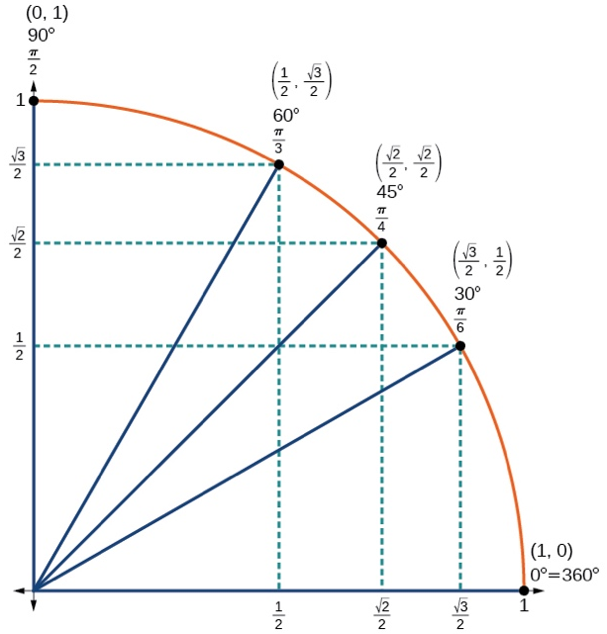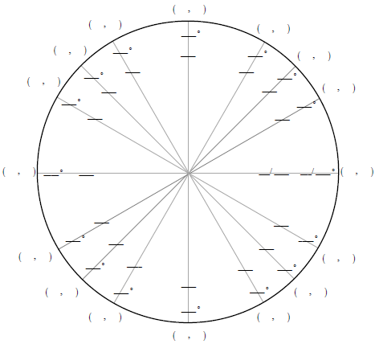
Using a Calculator to Find Sine and Cosine
To find the cosine and sine of angles other than the special angles, we turn to a computer or calculator. Be aware: Most calculators can be set into “degree” or “radian” mode, which tells the calculator the units for the input value. When we evaluate cos(30)on our calculator, it will evaluate it as the cosine of 30 degrees if the calculator is in degree mode, or the cosine of 30 radians if the calculator is in radian mode.
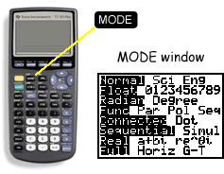
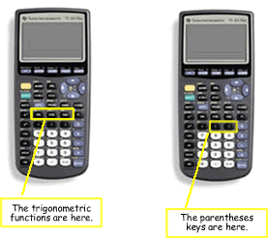

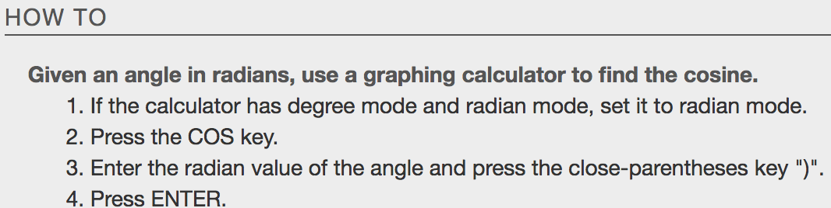

Examples
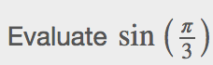

Identifying Domain and Range of Sine and Cosine Functions
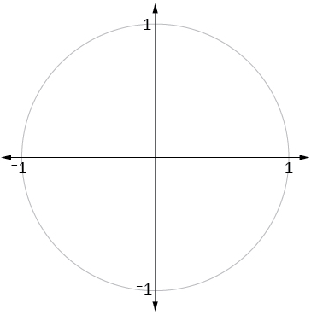
What are the domains of the sine and cosine functions? That is, what are the smallest and largest numbers that can be inputs of the functions? Because angles smaller than 0 and angles larger than 2π can still be graphed on the unit circle and have real values of x, y, and r, there is no lower or upper limit to the angles that can be inputs to the sine and cosine functions. The input to the sine and cosine functions is the rotation from the positive x-axis, and that may be ________ ____________ ____________________.

What are the ranges of the sine and cosine functions? What are the least and greatest possible values for their output? We can see the answers by examining the unit circle, as shown in Figure. The bounds of the x-coordinate are[____, ____].The bounds of the y-coordinate are also[____,______].Therefore, the range of both the sine and cosine functions is[−1,1].
Finding Reference Angles
For any given angle in the first quadrant, there is an angle in the second quadrant with the same sine value. Because the sine value is the ___-coordinate on the unit circle, the other angle with the same ______ will share the same y-value, but have the ____________________ x-value. Therefore, its _______ value will be the opposite of the first angle’s cosine value. Likewise, there will be an angle in the fourth quadrant with the _________ cosine as the original angle. The angle with the same cosine will share the _________ x-value but will have the opposite y-value. Therefore, its sine value will be the opposite of the original angle’s sine value.
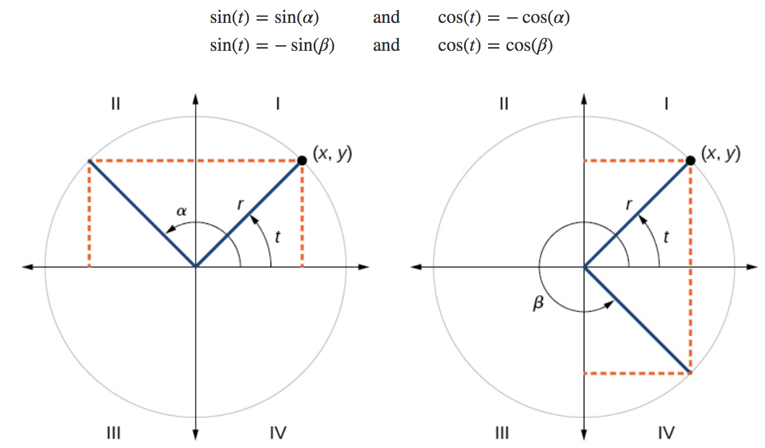
Recall that an angle’s reference angle is the acute angle, t, formed by the terminal side of the angle t and the horizontal axis. A reference angle is always an angle between 0 and 90°,or 0 and $\frac{π}{2}$ radians.
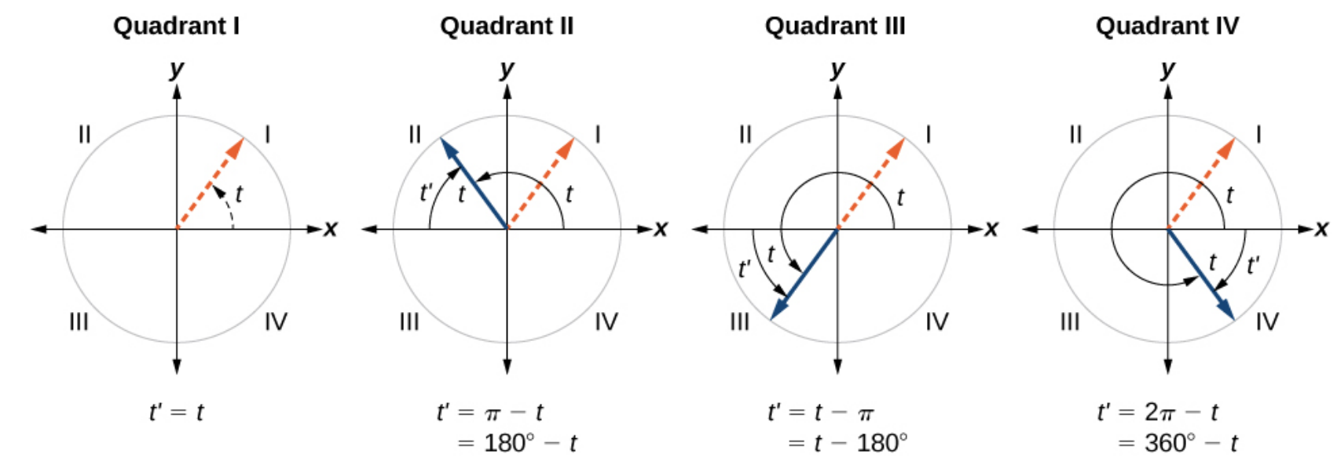
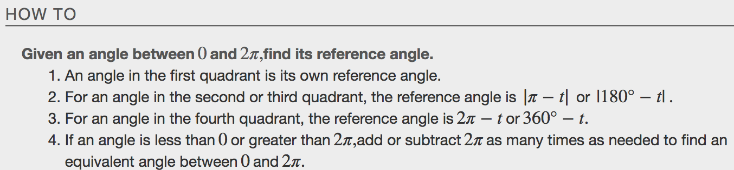
Examples
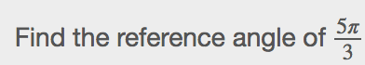

Using Reference Angles to Evaluate Trigonometric Functions
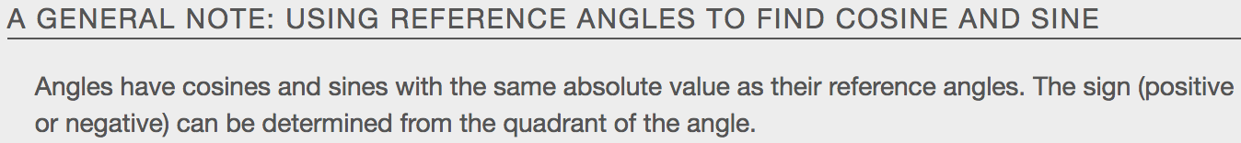

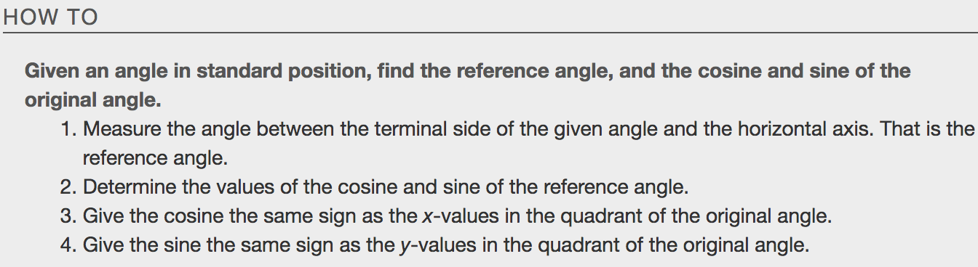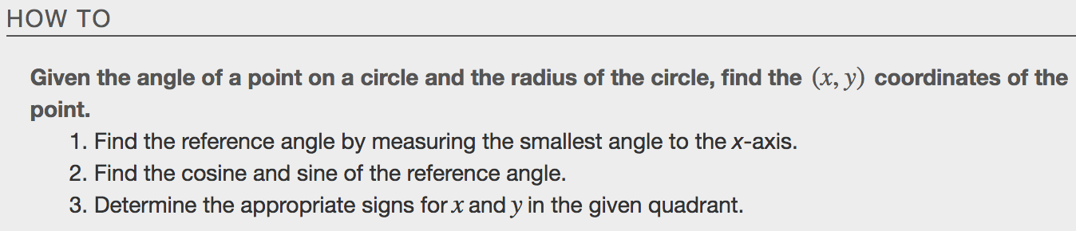
Examples
