7.1 – Right Triangle Trigonometry

Using Right Triangles to Evaluate Trigonometric Functions
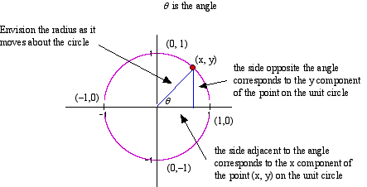

Notice that the triangle is inscribed in a circle of radius 1. Such a circle, with a center at the origin and a radius of 1, is known as a ________________ ______________________.
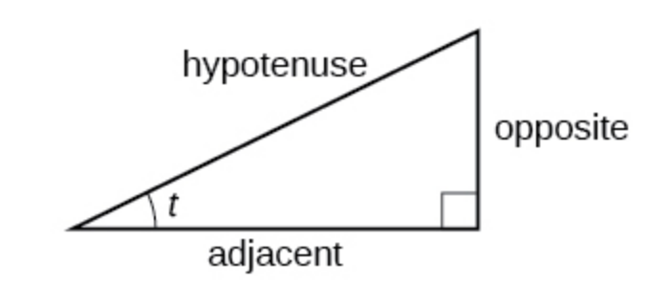
The adjacent side is the side closest to the angle, x. (Adjacent means “next to.”) The opposite side is the side across from the angle, y. The hypotenuse is the side of the triangle opposite the right angle, 1.

Given a right triangle with an acute angle of t, the first three trigonometric functions are…
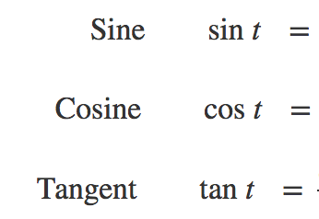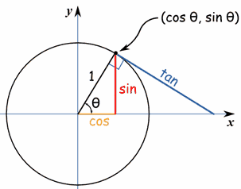

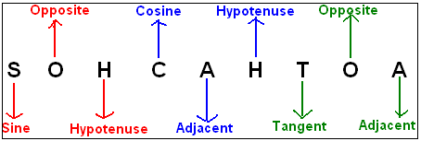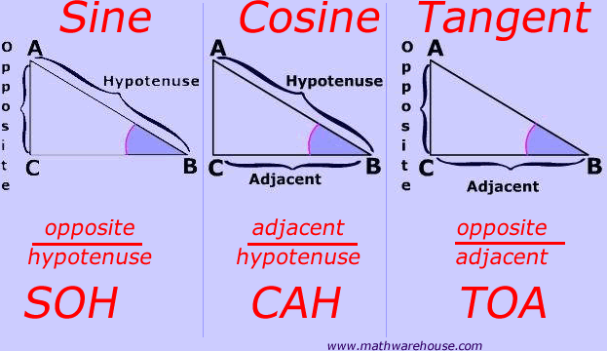
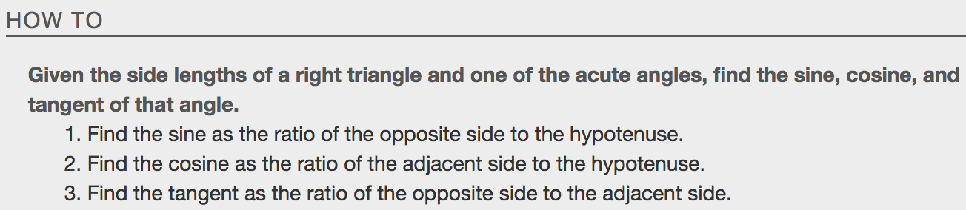
Example: Given the triangle, find the value of $\sin{t}, \cos{t}, \& \tan{t}$.
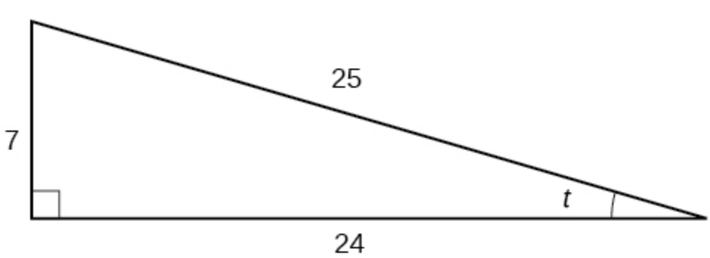

Reciprocal Functions
In addition to sine, cosine, and tangent, there are three more functions. These functions are the reciprocals of the first three functions.
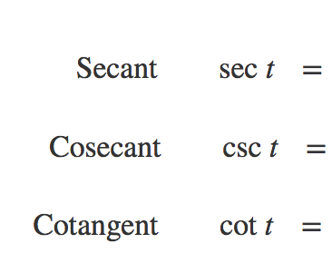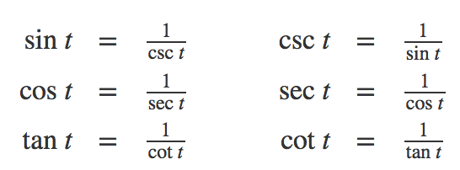
Many problems ask for all six trigonometric functions for a given angle in a triangle. A possible strategy to use is to find the sine, cosine, and tangent of the angles first. Then, find the other trigonometric functions easily using the reciprocals.

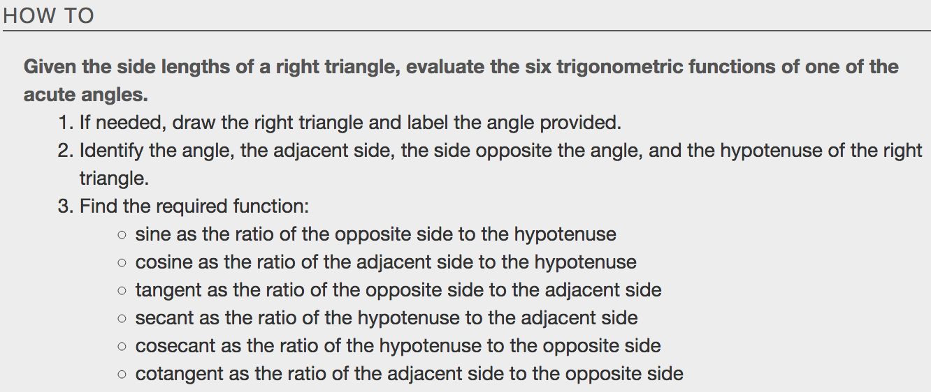
Example:
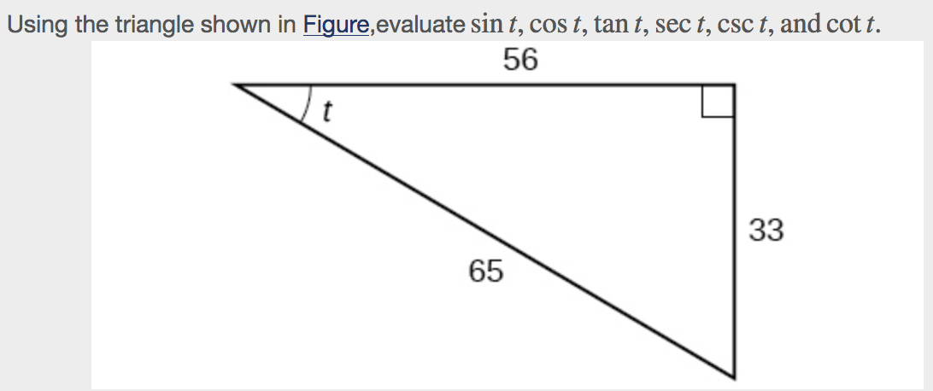

Finding Trig Functions of Special Angles Using Side Lengths
Suppose we have a30°,60°,90°triangle, which can also be described as a $\frac{π}{6}, \frac{π}{3}, \frac{π}{2}$ triangle. sides of a 45°,45°,90°triangle, which can also be described as a $\frac{π}{4}, \frac{π}{4}, \frac{π}{2}$ triangle.
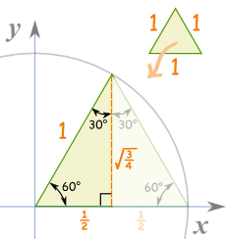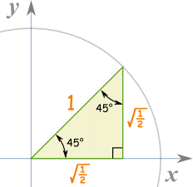
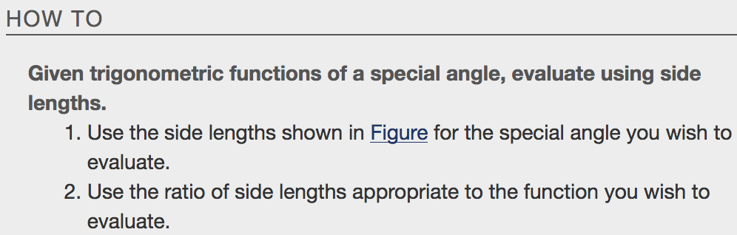
Example:
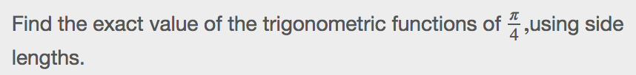

Using Equal Cofunction Compliments

Interesting relationship. Find the sin and cos of the angles $\frac{π}{3} \& \frac{π}{6}$.
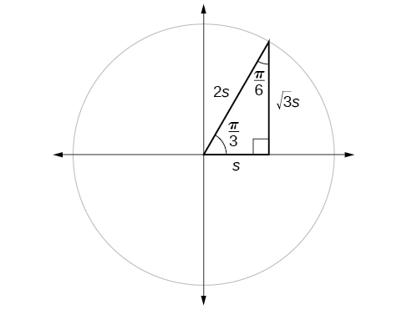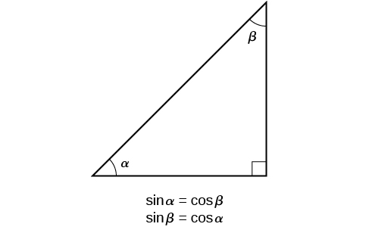

These relationships are known as ___________________________ ____________________________.

Example
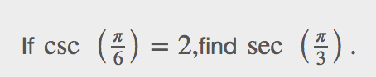

Using Trigonometric Functions
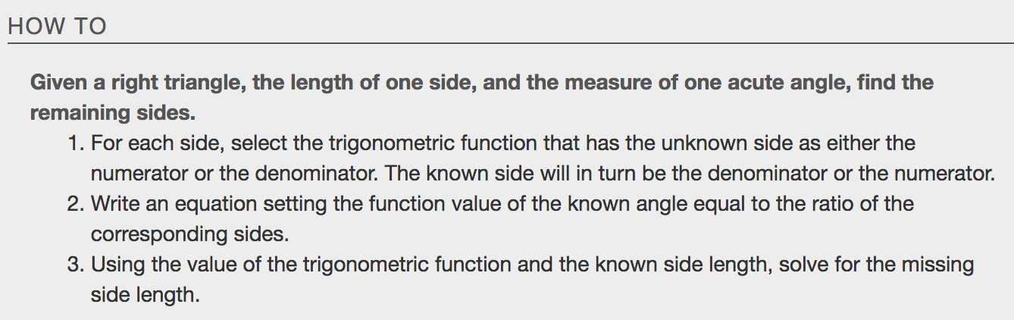
Example

Using Right Triangle Trigonometry to Solve Applied Problems
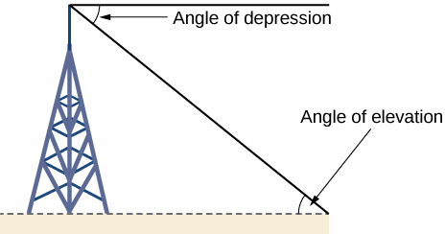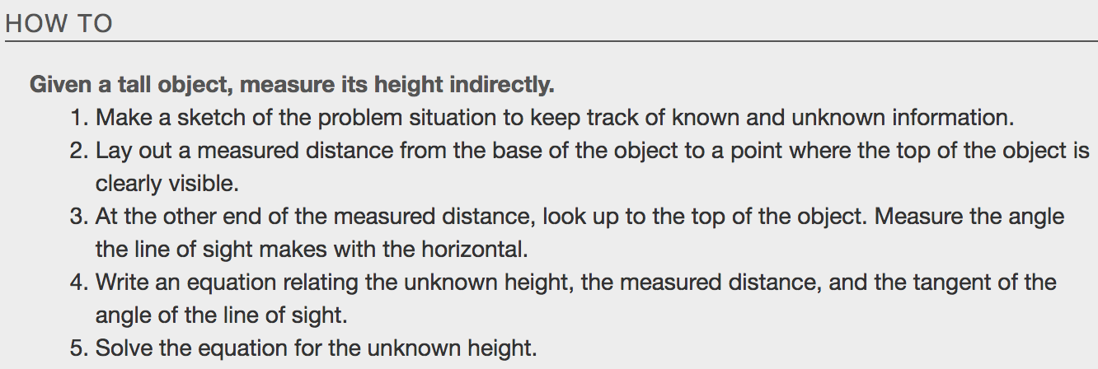
The angle of _______________________________ of an object above an observer relative to the observer is the angle between the horizontal and the line from the object to the observer's eye. The angle of _________________________ of an object below an observer relative to the observer is the angle between the horizontal and the line from the object to the observer's eye.

These right triangles created have sides that represent the unknown height, the measured distance from the base, and the angled line of sight from the ground to the top of the object. Knowing the measured distance to the base of the object and the angle of the line of sight, we can use trigonometric functions to calculate the unknown height.

Example:

