7.1 – Angles

Drawing Angles in Standard Position
A _______________ is a directed line segment. It consists of one point on a line and all points extending in one direction from that point. The first point is called the _____________________ of the ray.
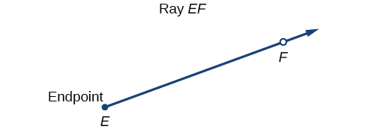

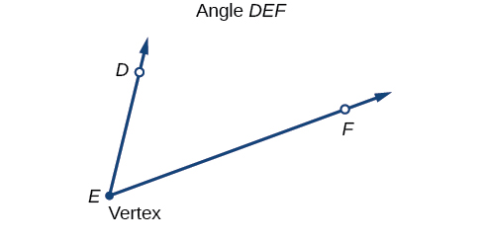
An ___________________ is the union of two rays having a common endpoint. The endpoint is called the __________________ of the angle, and the two rays are the sides of the angle.

Greek letter are often used as variables for the measure of an angle.
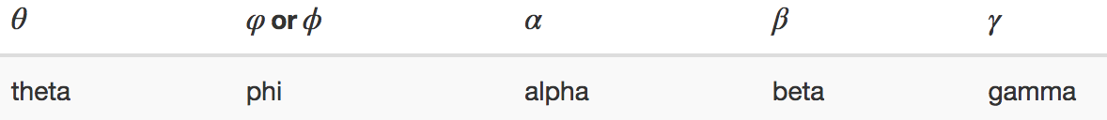

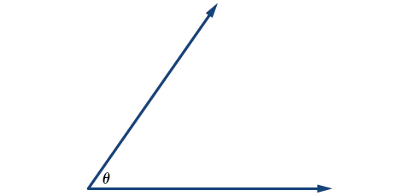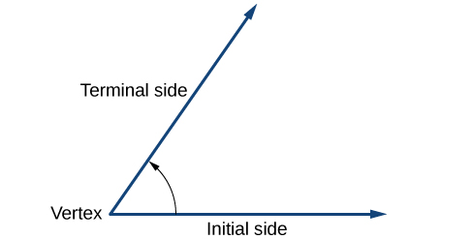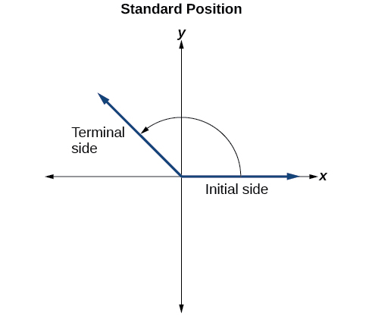

The measure of an angle is the amount of rotation from the ___________________ side to the __________________ side. Probably the most familiar unit of angle measurement is the _______________. One degree is ____________of a circular rotation, so a complete circular rotation contains 360 degrees. An angle measured in degrees should always include the unit “degrees” after the number, or include the degree symbol °. For example,90 degrees = 90°.

An angle is in _________________________ position if its vertex is located at the origin, and its initial side extends along the positive x-axis.

If the angle is measured in a counterclockwise direction from the initial side to the terminal side, the angle is said to be a _____________________ angle. If the angle is measured in a clockwise direction, the angle is said to be a _____________________ angle.
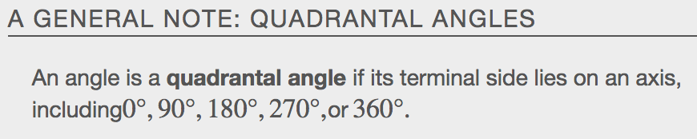

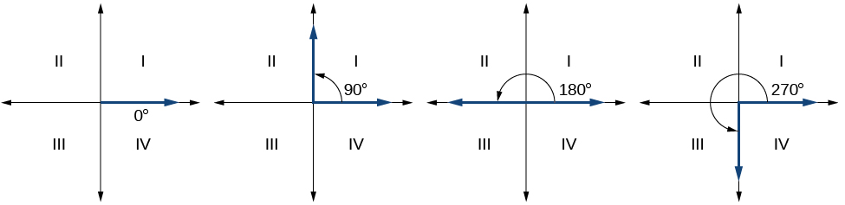

Converting Between Degrees and Radians
An _____________ may be a portion of a full circle, a full circle, or more than a full circle, represented by more than one full rotation. The _______________ of the arc around an entire circle is called the _____________________________________ of that circle.
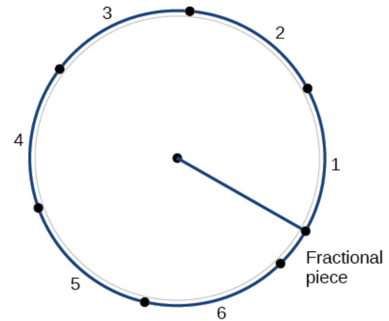
The Circumference of a Circle
$$C=2πr$$
$$\frac{C}{r}=2π$$
$$2π≈6.28$$

That means that if we took a string as long as the radius and used it to measure consecutive lengths around the circumference, there would be room for six full string-lengths and a little more than a quarter of a seventh.

What Is a Radian?
One ___________________________ is the measure of a central angle of a circle that intercepts an arc equal in length to the radius of that circle. A central angle is an angle formed at the center of a circle by two radii. Because the total circumference equals _______ times the ___________, a full circular rotation is 2π radians.
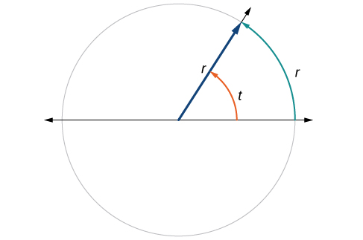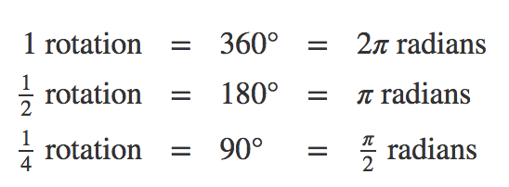
Relating Arc Lengths to Radius
An ___________ ___________________, s, is the length of the curve along the arc of a circle.

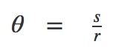

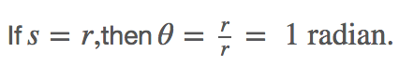

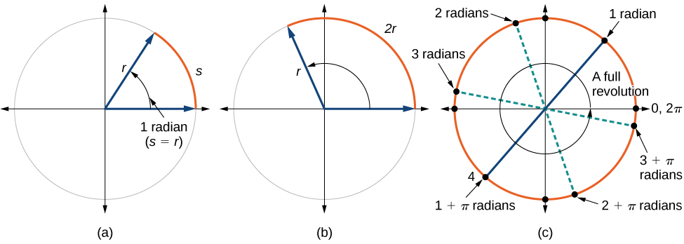
Ex.
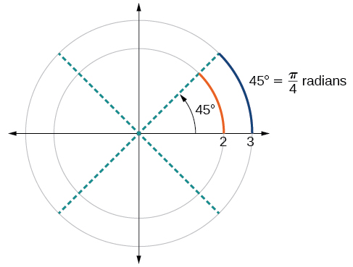
Identifying Special Angles Measured in Radians
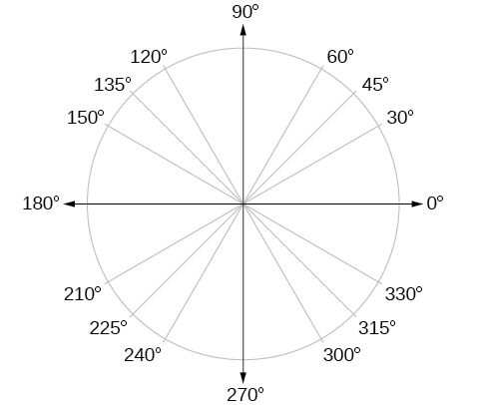

Ex.

Converting Between Radians and Degrees

Because degrees and radians both measure angles, we need to be able to convert between them. We can easily do so using a proportion where
θ is the measure of the angle in degrees and
$θ_{R}$ is the measure of the angle in radians.

Examples:
Convert each radian measure to degrees.

- $\frac{π}{6}$ 2. 3 3. $-\frac{3π}{4}$

Convert each degrees to radian measure.

- 15 deg 2. 126 deg 3. -75 deg

Coterminal Angles
If two angles in standard position have the same terminal side, they are _________________________ angles.
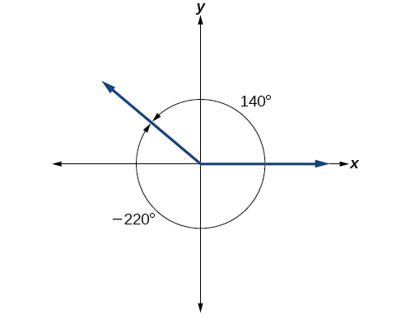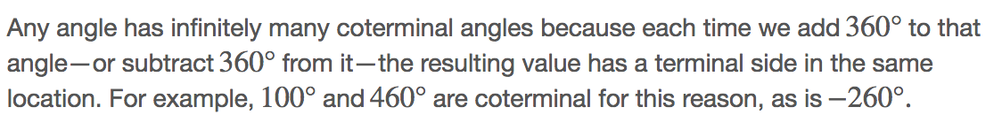

An angle’s _____________________________ angle is the measure of the __________________, _____________________, acute angle t formed by the terminal side of the angle t and the ________________________ axis.

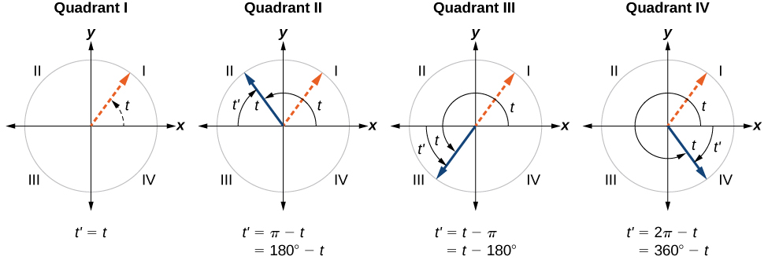

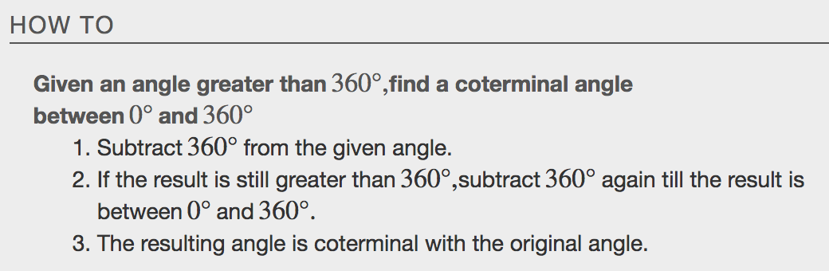
Examples

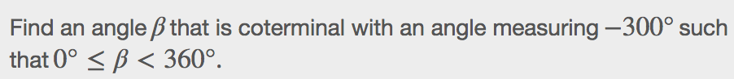
Finding Coterminal Angles Measured in Radians
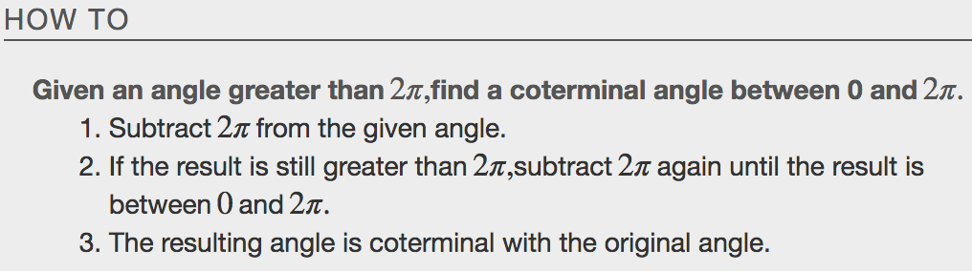

Examples

Determining the Length of an Arc
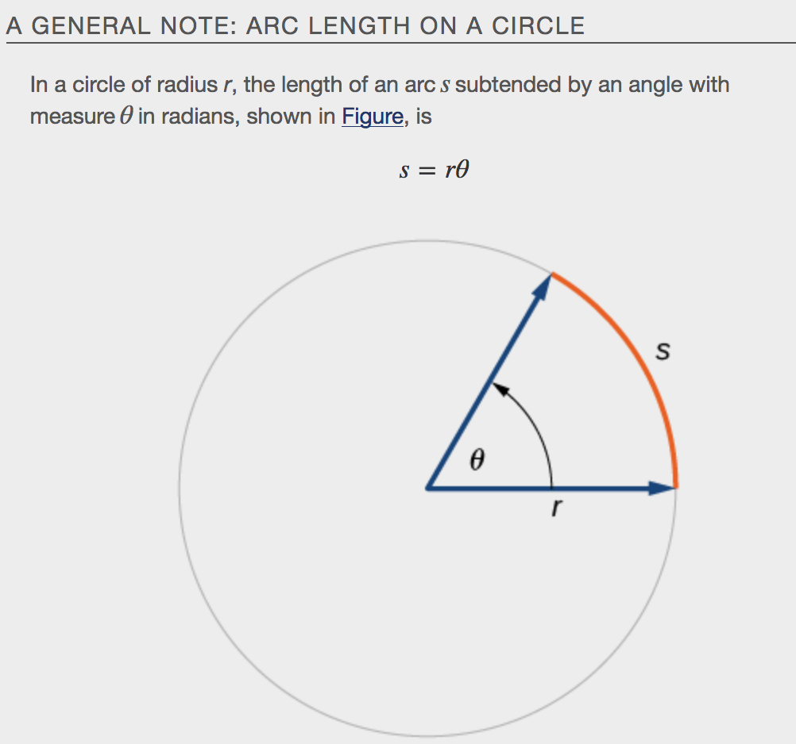
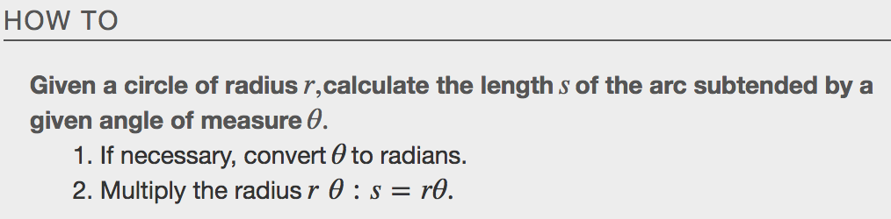
Example
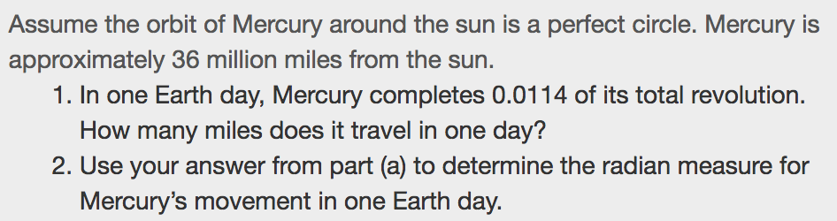

Finding the Area of a Sector
In addition to arc length, we can also use angles to find the area of a ___________________ of a circle. A sector is a region of a circle bounded by two radii and the intercepted arc, like a slice of pizza or pie.

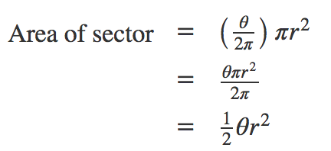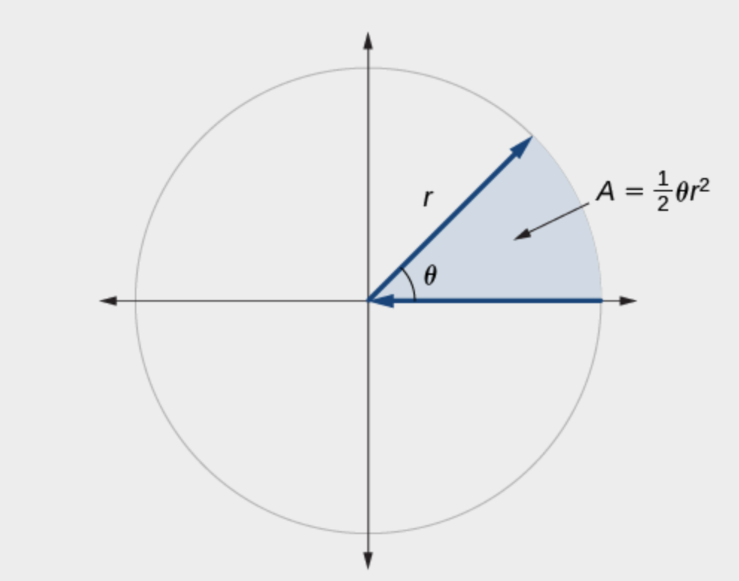
Example

Use Linear and Angular Speed to Describe Motion on a Circular Path
An object traveling in a circular path has two types of speed. Linear speed is speed along a straight path and can be determined by the distance it moves along (its displacement) in a given time interval.
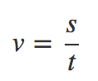
Angular speed results from circular motion and can be determined by the angle through which a point rotates in a given time interval.
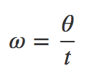
Combining the definition of angular speed with the arc length equation, s=rθ, we can find a relationship between angular and linear speeds. The angular speed equation can be solved for θ, giving θ=ωt.
Substituting this into the arc length equation gives:
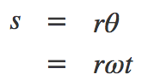
Substituting this into the linear speed equation gives:
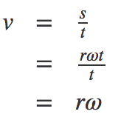
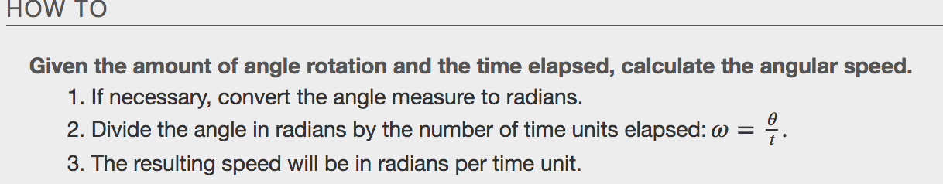
Example

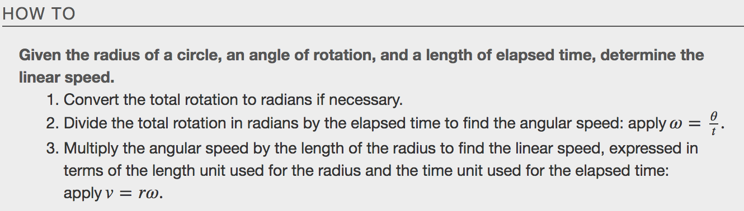
Example
