6.5 – Logarithmic Properties

Using the Product Rule for Logarithms

Recall that the logarithmic and exponential functions “undo” each other. This means that logarithms have similar properties to exponents. Some important properties of logarithms are given here. First, the following properties are easy to prove.
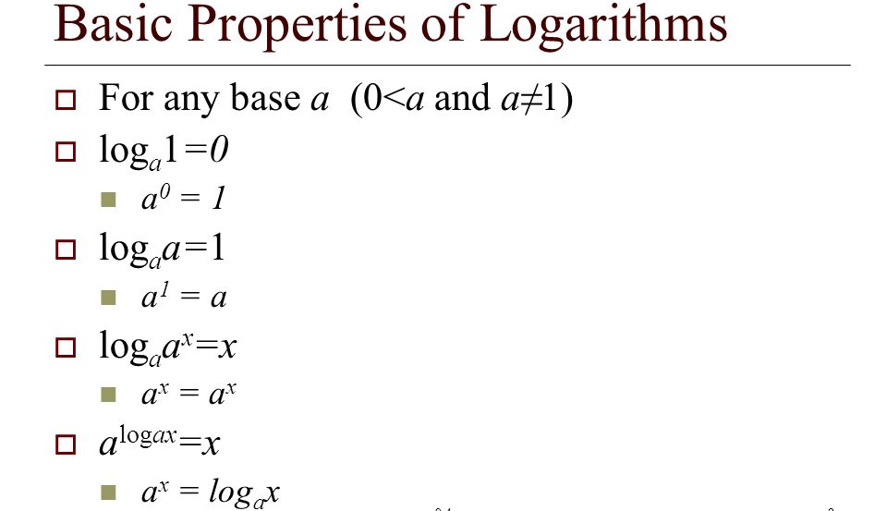
Recall that we use the product rule of exponents to combine the product of exponents by adding:
xªx^{b}=x^{a+b}
We have a similar property for logarithms, called the product rule for logarithms, which says that the logarithm of a product is equal to a sum of logarithms. Because logs are exponents, and we multiply like bases, we can add the exponents. We will use the inverse property to derive the product rule below.

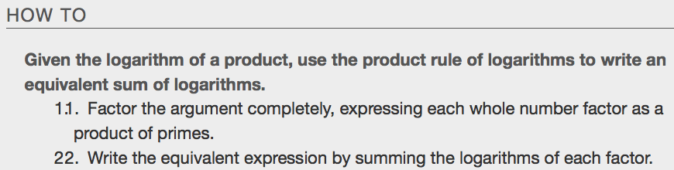
Examples

Using the Quotient Rule for Logarithms
For quotients, we have a similar rule for logarithms. Recall that we use the quotient rule of exponents to combine the quotient of exponents by subtracting:
x^{a/b}=x^{a−b}.
The quotient rule for logarithms says that the logarithm of a quotient is equal to a difference of logarithms. Just as with the product rule, we can use the inverse property to derive the quotient rule.

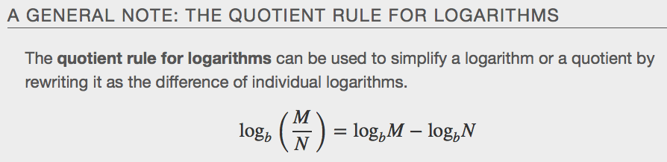
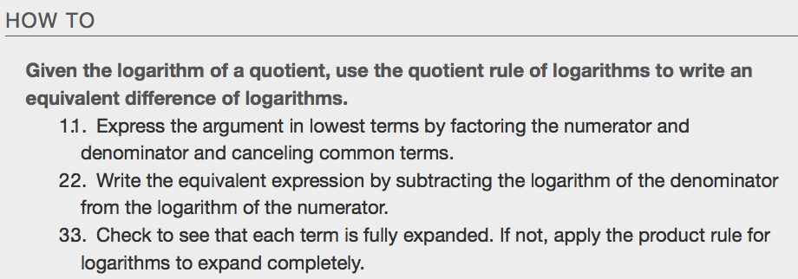
Examples
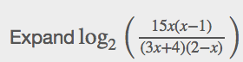

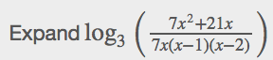

Using the Power Rule for Logarithms
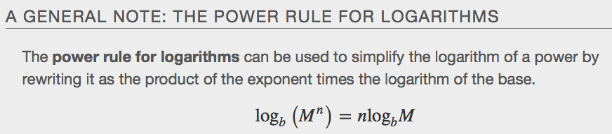

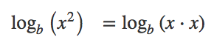

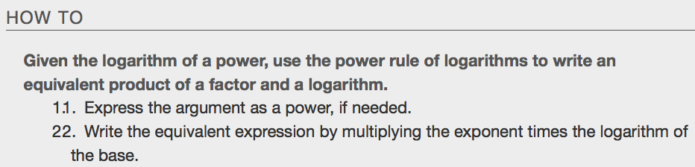
Examples
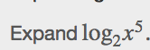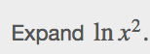

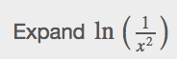

Expanding Logarithmic Expressions
Taken together, the product rule, quotient rule, and power rule are often called “laws of logs.” Sometimes we apply more than one rule in order to simplify an expression. Remember, however, that we can only do this with products, quotients, powers, and roots—never with addition or subtraction inside the argument of the logarithm.

Examples

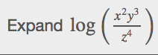

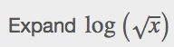

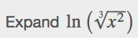

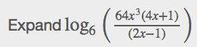

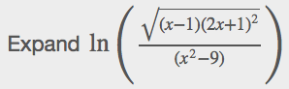

Condensing Logarithmic Expressions
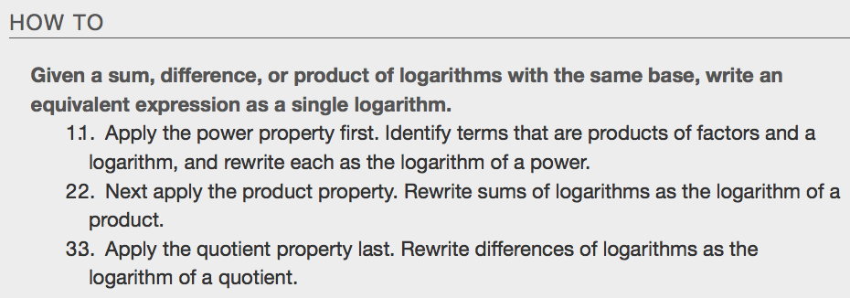
Examples

Using the Change-Of-Base Formula for Logarithms
Most calculators can evaluate only common and natural logs. In order to evaluate logarithms with a base other than 10 or e, we use the change-of-base formula to rewrite the logarithm as the quotient of logarithms of any other base; when using a calculator, we would change them to common or natural logs.

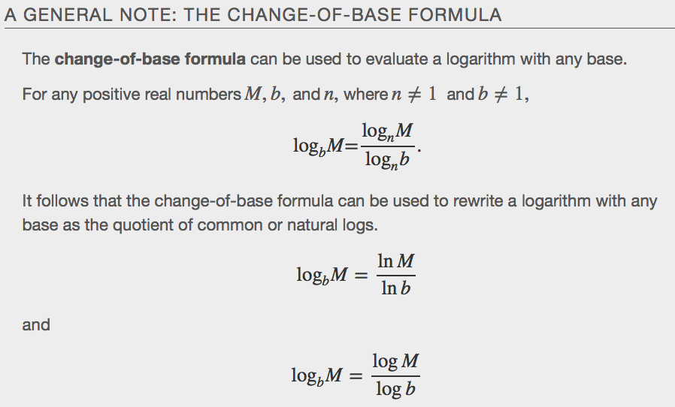

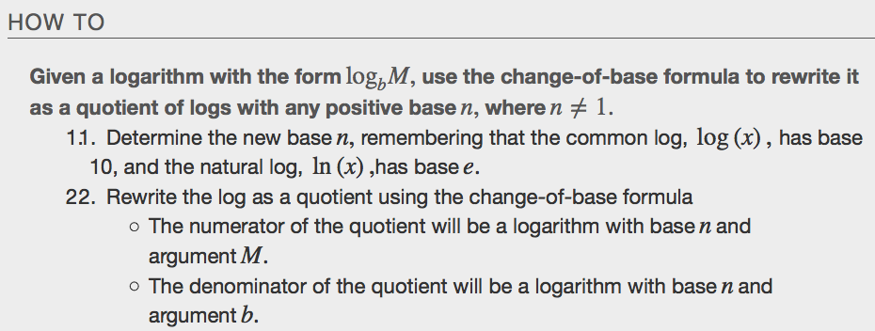
Examples

