6.1 – Exponential Functions

Identifying Exponential Functions

For us to gain a clear understanding of how an _________________________ function behaves, let us contrast exponential growth with linear growth, which we are already familiar with. We will construct two functions. The first function is exponential. We will start with an input of 0, and increase each input by 1. We will double the corresponding consecutive outputs. The second function is linear. We will start with an input of 0, and increase each input by 1.

x | $$f\left(x\right)=2^{x}$$ | $$g\left(x\right)=2x$$

- __________________________ growth refers to the original value from the range increases by the same ________________________ over EQUAL increments found in the domain.
- __________________________ growth refers to the original value from the range increases by the same _____________________ over equal increments found in the domain.

Apparently, the difference between “the same percentage” and “the same amount” is quite significant. For exponential growth, over equal increments, the constant _______________________________ rate of change resulted in doubling the output whenever the input increased by one. For linear growth, the constant ______________________________ rate of change over equal increments resulted in adding 2 to the output whenever the input was increased by one.

Let’s take a closer look at the function $f\left(x\right)=2^{x}$ from our example.
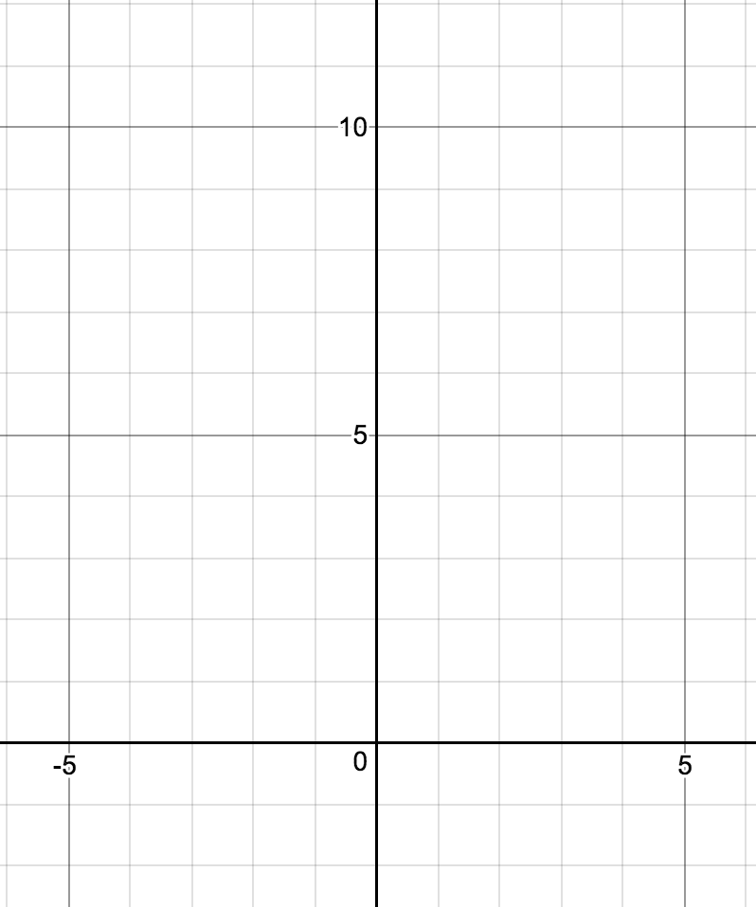
x | f(x)
-3
-2
-1
0
1
2
3

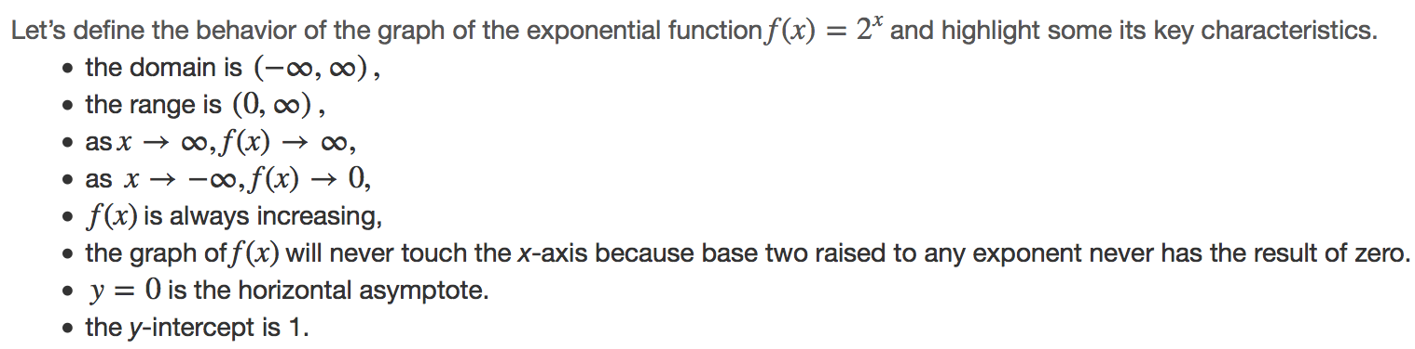
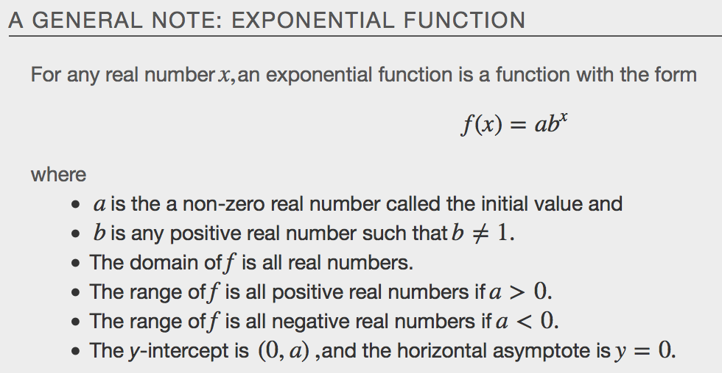
Examples
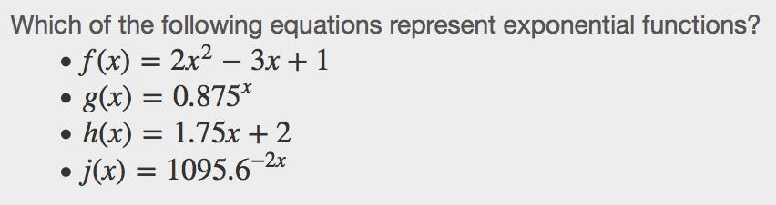

Evaluating Exponential Functions
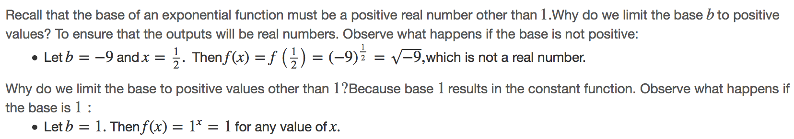

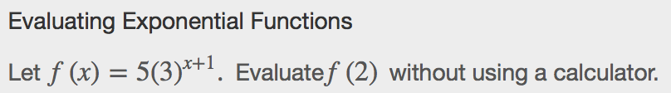

Defining Exponential Growth
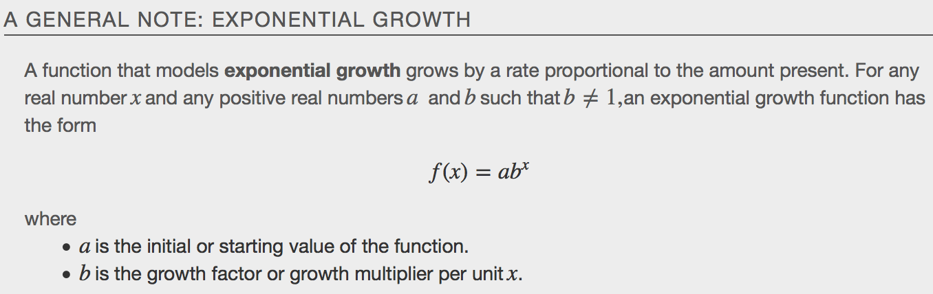
Examples

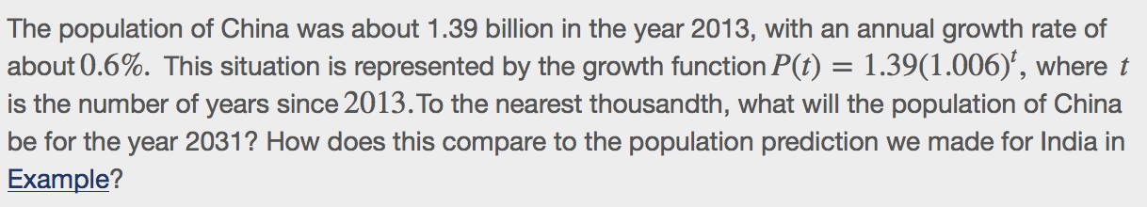

Finding Equations of Exponential Functions
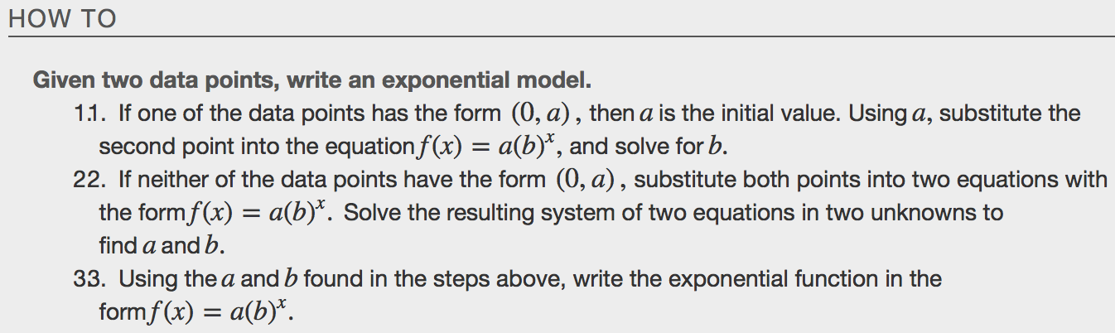
Examples
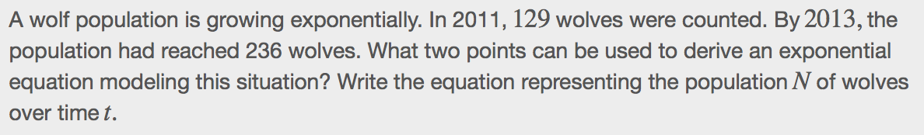

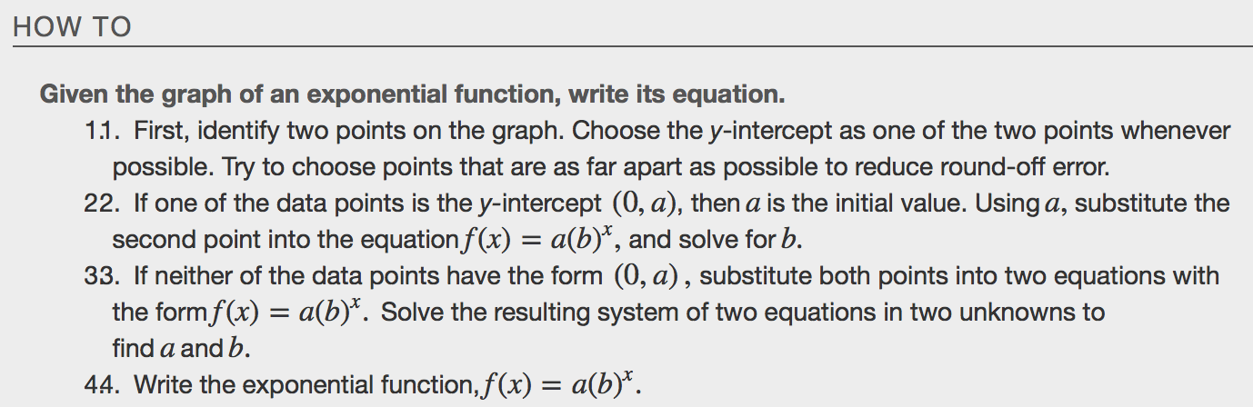
Example
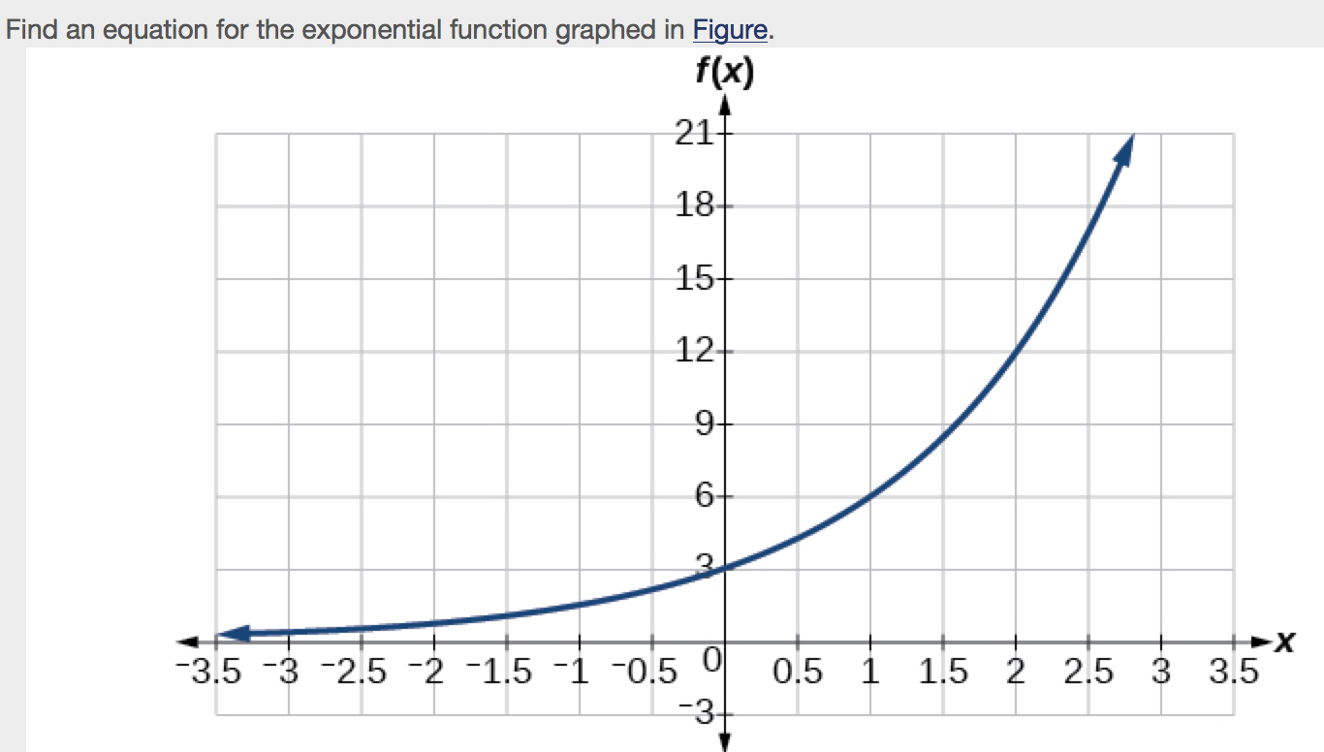

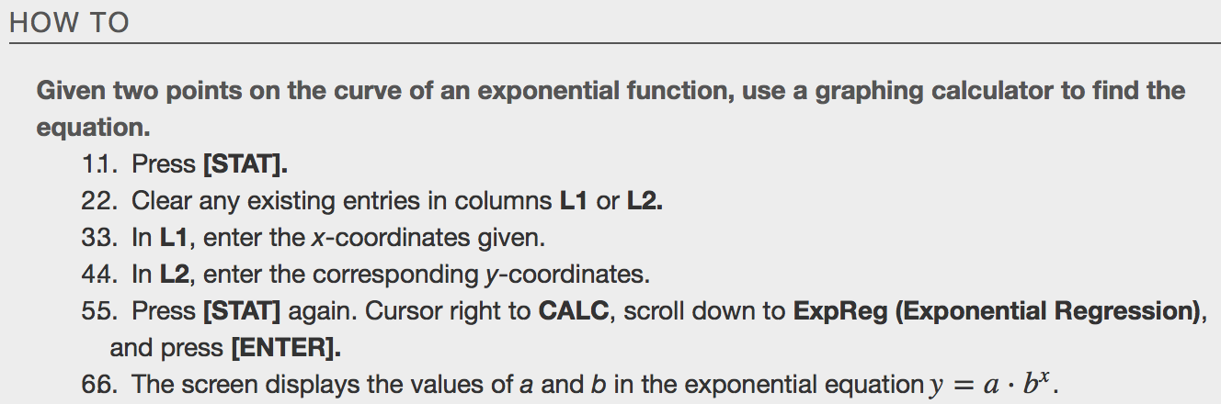
Example

Applying the Compound-Interest Formula
Savings instruments in which earnings are continually reinvested, such as mutual funds and retirement accounts, use ______________________________ interest. The term compounding refers to interest earned not only on the original value, but on the accumulated value of the account.

We can calculate the compound interest using the compound interest formula, which is an exponential function of the variables time t, principal P, APR r, and number of compounding periods in a year n:
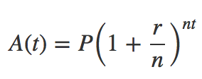
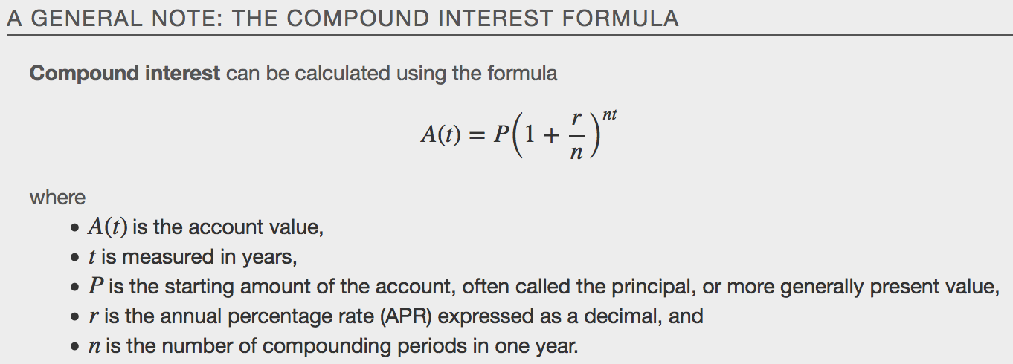

Compounding Periods
Annually | Semiannually | Quarterly | Monthly | Weekly | Daily
n=1 | n=2 | n=4 | n=12 | n=52 | n=360

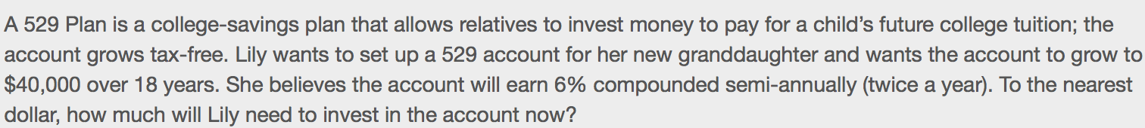

Evaluating Functions with Base e
Examine the value of $1 invested at 100% interest for 1 year, compounded at various frequencies, listed below
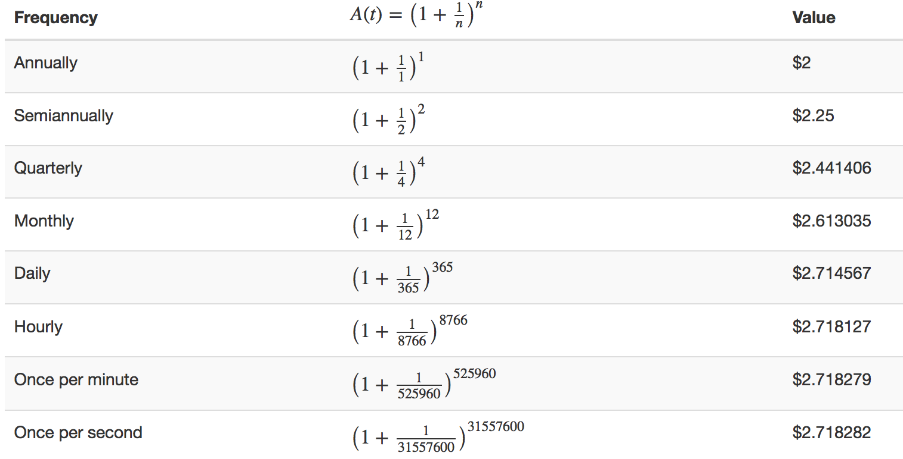
These values appear to be approaching a limit as n increases without bound. In fact, as n gets larger and larger, the expression 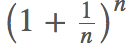approaches a number used so frequently in mathematics that it has its own name: the lettere.This value is an irrational number, which means that its decimal expansion goes on forever without repeating. Its approximation to six decimal places is shown below.

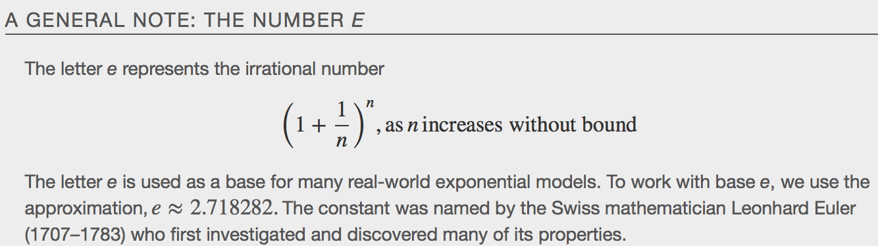
Examples

Investigating Continuous Growth
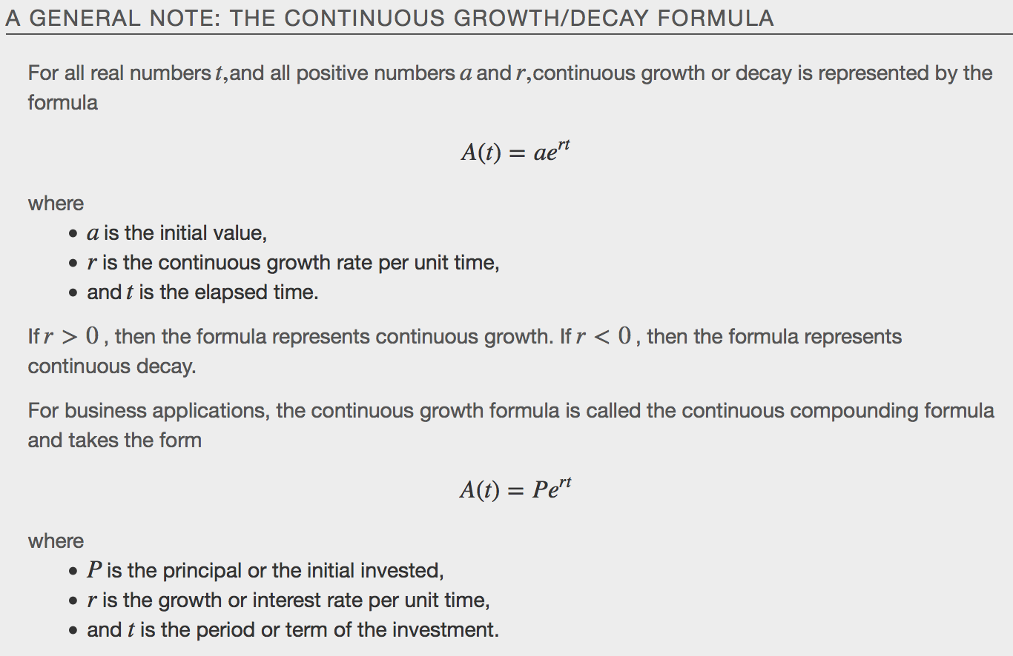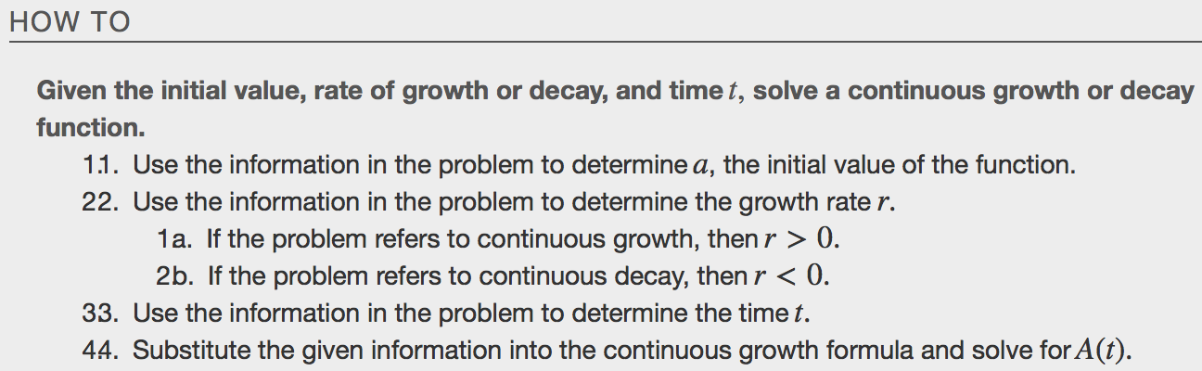
Example

