Virtual Globetrotters - To write a travel blog in English

You are going to:

- work together in a group.
- be assigned one of the countries from the Erasmus project: Sweden, Germany, England, France, Greece or Bulgaria
- be virtual globetrotters and together write a travel blog about your “trip”.
- publish the text on the Erasmus blog: eurokids100.wordpress.com

It is important that you think about:

- living conditions, traditions, social relations and cultural phenmenons in your assigned country.
- to compare with your own experiences and knowledge
- adapting your written language according to the purpose, situation and receivers. Your travel blog is supposed to attract readers of all age groups, backgrounds and so on.

As a help:

Use the template below to help you extend your writing.

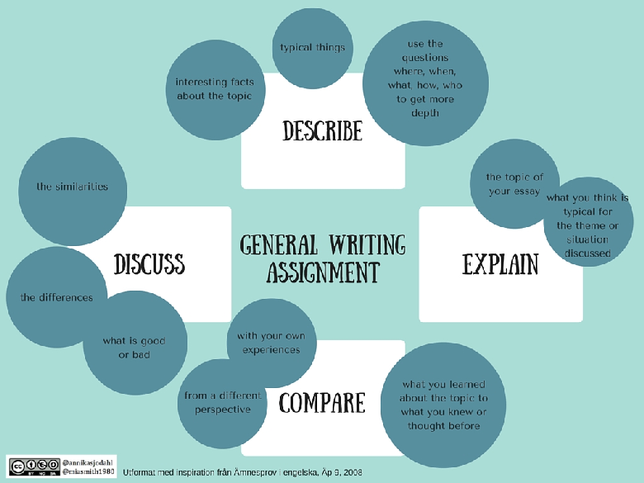

You can choose to compare your assigned country with your own. Make sure you: describe, explain, discuss and compare.

Use the venn-diagram below to compare.

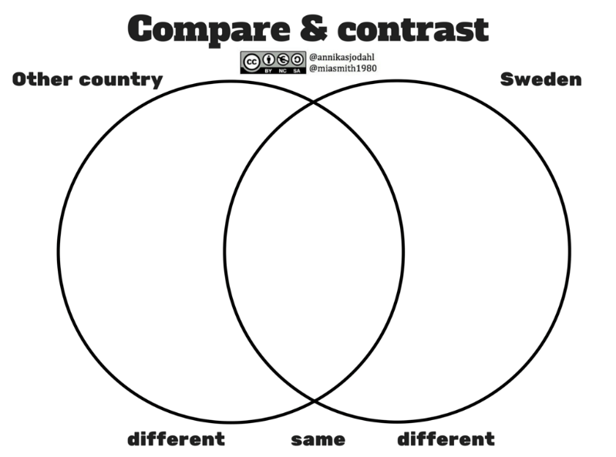

On this website, you can find information to use: http://webenglish.se/any-country/

Your group is out on an adventure together - have fun with the task! Adding “personal experiences” will capture your readers.

When your group has finished the task, please e-mail it to us for publication:

annika.sjodahl@enkoping.se

emelie.hahn@enkoping.se

Good luck with your assignment!
Annika and Emelie

