Requiem
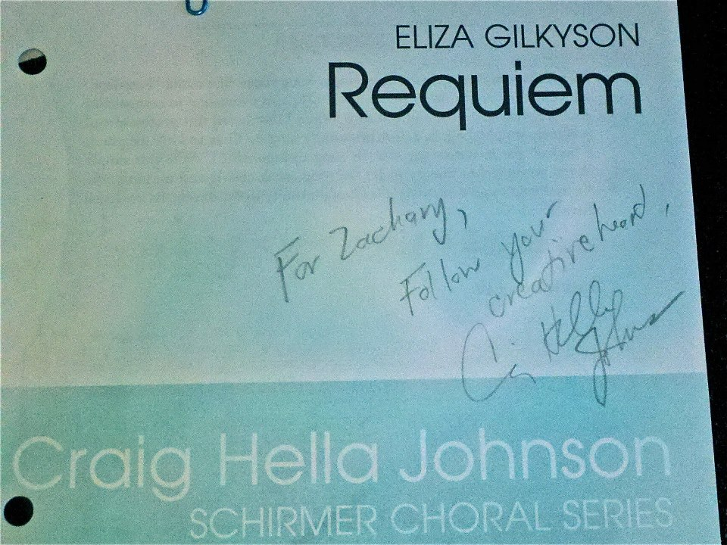
The object that I have chosen to write about is a piece of sheet music entitled “Requiem” by Craig Hella Johnson. The score is a small and light paper booklet published by Hal Lenard music. The cover of this piece has a light green and blue wash to it that fades to white in locations where text is located. In a bold text the title, “Requiem” is labeled in the upper right hand corner. Also located on the cover are various logos to the publisher (at the very bottom) as well as the choral series it is published though, which in this case is “Craig Hella Johnson”. Under the title, lightly written in pencil, is an authentic signature from Craig as well as a personal message reminding me to, “follow your creative head.” Other than the signature, all other aspects to the score are exactly the same as any other score an individual could buy online. Since 2008 I have had knowledge of this score and since 2012, I have owned this score. This piece was arranged around 2006 and is dedicated to the victims of hurricane Katrina. Other than the copyright of the score there are many aspects to this piece that establish a time period of this piece. First of all, the subject it is written for says a lot about when it was written. Considering Hurricane Katrina took place in 2005, it was shortly after that this was created. Second, the musical language and chord structure states that this is clearly a contemporary pop arrangement. A lot of the musical concepts used in this piece a very western which gives it that sound. Last, the dates of the composer also determine that this piece is truly a contemporary piece of music. The value of this score, at the time, was two dollars. Since then, the score’s price has fluctuated, but not significantly. Currently the price is, $1.90. Monetarily, this score’s value is not very high; however, this score is priceless to me.
With this item I find that I am more like Maggie in the aspect that it is hard to place a value on this object. I know some background information on it but this score means a lot more to me than its small price from the publisher. Considering this piece is the piece that determined my future of being a music major, it is hard to place any value on something that caused me to take the path that I did. Honestly, without that piece of music I don’t even know if I would have applied to go to school at UW-Eau Claire. I wouldn’t be in this class. There are so many things that would have never been had I never performed this song.
The use of this object is to produce music specified by the composer. In the past, my artifact might have been found on a piano to be played. However, my artifact is something that is fairly new. Just like the soldier’s items from “Things They Carried”, or the main character’s field in “Shoeless Joe Jackson” this is something that does not date back too far. Even though this is, this object caries a great emotional weight in my life. It is hard to say what this object says about another person’s life. What I have found in music is that people connect to songs in different ways depending upon their own personal experiences. I know what this song means to me but in the end, I have no idea what it means to others and I will never know to the full extent that I want to know. I do know that this piece does not say anything about anyone’s race, social economic status, back ground or anything like that at all. This piece is for anyone that wishes to perform it. That being said, this piece is still available today and anyone can get it from online; however, the reason why this one is so special to me is because it is signed and made out to me. Having the person that changed your entire life writing a message to you means the world. That being said, this piece of music is not currently being used for what it was initially intended for. This is because I cherish it too much. I am afraid of wearing the message off of the score. Honestly, I intend to frame that piece of music and hang it one day.
As I talk more and more about this item I can’t help but return to ideas found in “Shoeless Joe Jackson” about memories. Throughout this story I found the main character returning to memories based off of things he saw, smelt and heard. This got me thinking about this song and the sheet music. Every time I hear a chord from “Requiem”, I cannot help but think of places I have sung this song, people I was with, things I smelt and laughs I had. Just like the baseball field that meant so much to the main character of this story, my baseball field is this song. Through the notes on this music I return to memories of my high school days.
The history of this item goes back to my days in high school. However, this item initially did not physically enter my life until 2012. I would have to say in 2008 it entered my heart and soul. That is how this piece came to my possession. On another note, this piece is not necessarily something that belongs to my family, it is an item that belongs to me personally and will one day belong to my kids. This piece, after hearing it for the first time, showed me that even I could be a composer of music one day. It also showed me that I wanted to be a music educator. Ultimately, this piece showed me that I wanted to change people’s lives through music. Next, in the end, I would say a few people made this piece. First and foremost, the publisher, Hal Lenard and the composer, Craig Hella Johnson physically created this composition. Next, I would say the choir I performed with created the first sounds that I ever heard of this composition. Last, my conductor helped create meaning of this composition. Those four entities helped create this piece for me and make it what it is to me today.
In the end I would say that I am much more like Maggie. This object has a greater value than any other rich in my life. Because this object has shaped who I am today and has affected how I use every minute of my life, I would deem this item priceless. I look at this musical score in a much deeper way than just as a dollar sign. This piece also brings back precious memories to me. Just like the main character of “Shoeless Joe Jackson” this musical score’s sounds, chords, melodies, rhythms and words bring back rich memories of my sophomore year that I will never forget. On a side note, I had the opportunity of meeting Craig Hella Johnson this week in Salt Lake City. It was a nice feeling to thank and shake the hand of the person who changed my life.

