~Painting~
“White Mountains & Aspens”
10/3/12
What is it?
There is an oil painting hanging in my great-grandmother’s house. It is in a dark brown frame that is five feet long, three feet tall, and two inches wide. On the frame of the painting there is a small golden plaque with the title of the painting, “WHITE MOUNTAINS & ASPENS,” engraved on it. If you look closely you will see the artists signature blended right into the painting. To the touch the name has raised edges and the painting has the feeling of smooth canvas.
In the painting there is a large lake with the reflection of a sunset. The sunset is a light pink closest to the horizon line, then fades into a light yellow, and finally into a sky blue. In the middle of the lake is a very small island. Flying towards the horizon line are two birds. Along the back of the lake, by the horizon line, are smudgy pine trees.
Along the left side of the lake is a wooded area full of pine trees and small bushes. On one jet of land close to the front of the painting is a pine tree that is very distinct with light blue coloring and being the only tree on that specific piece of land. Along this jet of land are yellow and red bushes.
Right at the front is a big brown trunk with pretty green leaves on top, and next to this tree is a male white tailed deer looking off towards the horizon. The buck is standing in yellow-green grass right next to a small waterfall. The waterfall flows off into the edge of the painting.
On the other side of the small fall is a female, white-tailed deer standing in yellow-green grass surrounded by tiny pink flowers. The doe is drinking from the lake right above the small water fall.
If you keep heading right there is a large, light-brown rock behind the doe at the edge of the lake. A little further to the right is a light-brown, dirt path that cures off the from the lower right hand corner, goes left towards the lake then back around to the right and off the painting. In the bend of the road there are a few larger, light-brown rocks and some tiny pink and blue flowers in the yellow-green grass.
Keeping on the right side of the lake, you will see a canoe tied up along the lake right next to some gray and white barked trees with green leaves at the top. From the canoe there is a stair way leading up to a small log cabin. The window in the cabin is lit up with yellow from the interior flame. There is a chimney with smoke rolling from it.
Next to the cabin is a jet of land with another gray and white striped tree trunk with green leaves on the tippy top.
Behind the cabin is another wooded area filled with pine trees that carry off into the back woods that are next to the horizon line.
Around the entire painting is a brown mark from where the painter put it in its original frame before the painting was actually dry.

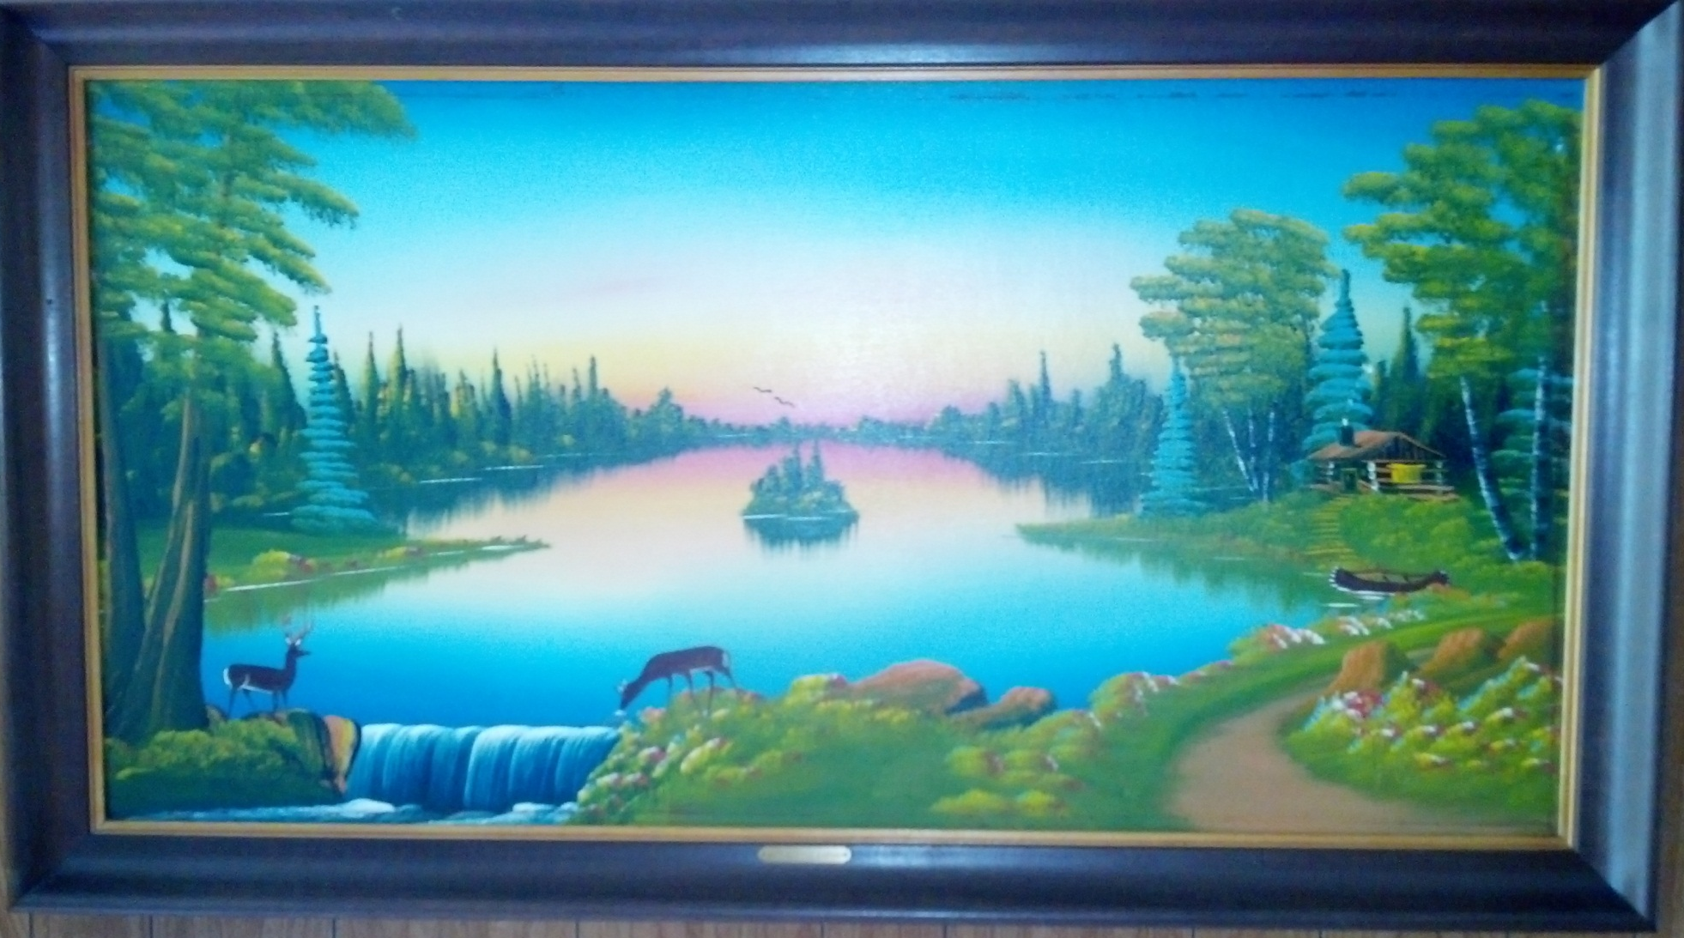
Where did it come from?
After my Great-Grandpa Pete got out of World War II in 1946 his parents decided to take a trip. They did not have very much money and neither of them drove. I am unaware of who actually drove them, but they took a trip out west to South Dakota. While there, they were wandering around and saw an old man painting a picture. He was overlooking the scene in the painting. They watched him paint it in less than 30 minutes. When he was done he sold it to them. No one knows how much he sold to them for, but we all know it could not have been very much because, as stated before, they were rather poor. My Great-Grandma Anna does not know much about this painting her mother-in-law and father-in-law bought 66 years ago, so I did some digging.
In the lower, right hand corner of the painting there is the painter’s signature. Upon further investigation, my boyfriend and I found that the man’s full name was Gijsbertus Johannes van Overbeek. Overbeek was a Dutch painter who lived in South Dakota, most likely because of the war that was going on in Europe. He died in 1947 so my great-great-grandparents got one of his last paintings.
I also learned that, according to the Mutual Arts’ site, some of his paintings can go for over $1,000. Although I can assume these were some of his best paintings that may have taken years to paint, I also know that my Great-Grandma Anna has a bit of “art history” hanging in her house.

What does it mean to me?
I have always grown up seeing the painting hanging in my great-grandparents house. I never knew much about it other than that it meant something to my family. Even before I knew the history behind the painting I wanted it as something I could easily remember my great-grandparents by.
After learning that it was actually my great-great-grandparents, I want the item even more. Although I never knew them, the painting is something special. I did not ever expect it to be worth money actually. Even with that bit of information, I do not know that I could ever sell it unless I was in desperate need of the money. When it does become mine, I will have to hang it above my couch just like my great-grandparents did for many, many years.

Bibliography
Boxrucker, Anna. Personal interview. 28 Sept. 2012.
"Gijsbertus Johannes van Overbeek (Dutch, 1882 - 1947)." On MutualArt.com. 2012. Mutual Arts Service. 03 Oct. 2012 <http://www.mutualart.com/Artist/Gijsbertus-Johannes-van-Overbeek/000C5C96605B851A>.

