

1955

Lane Cedar Chest

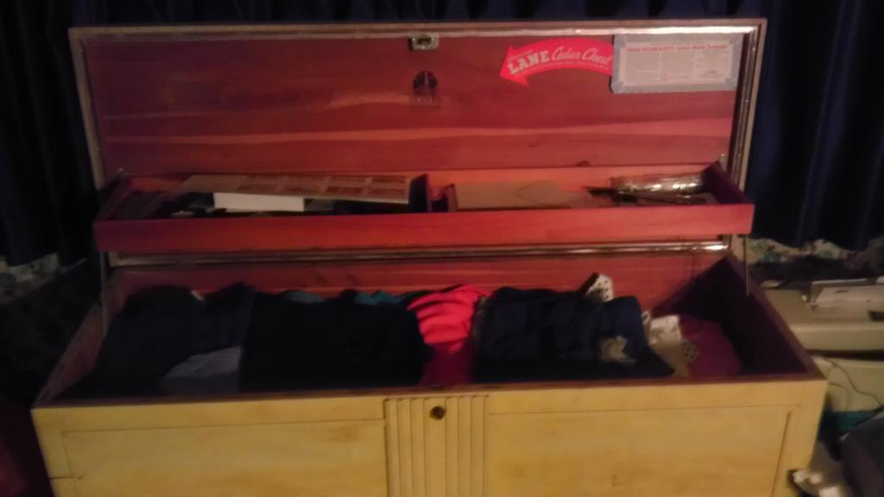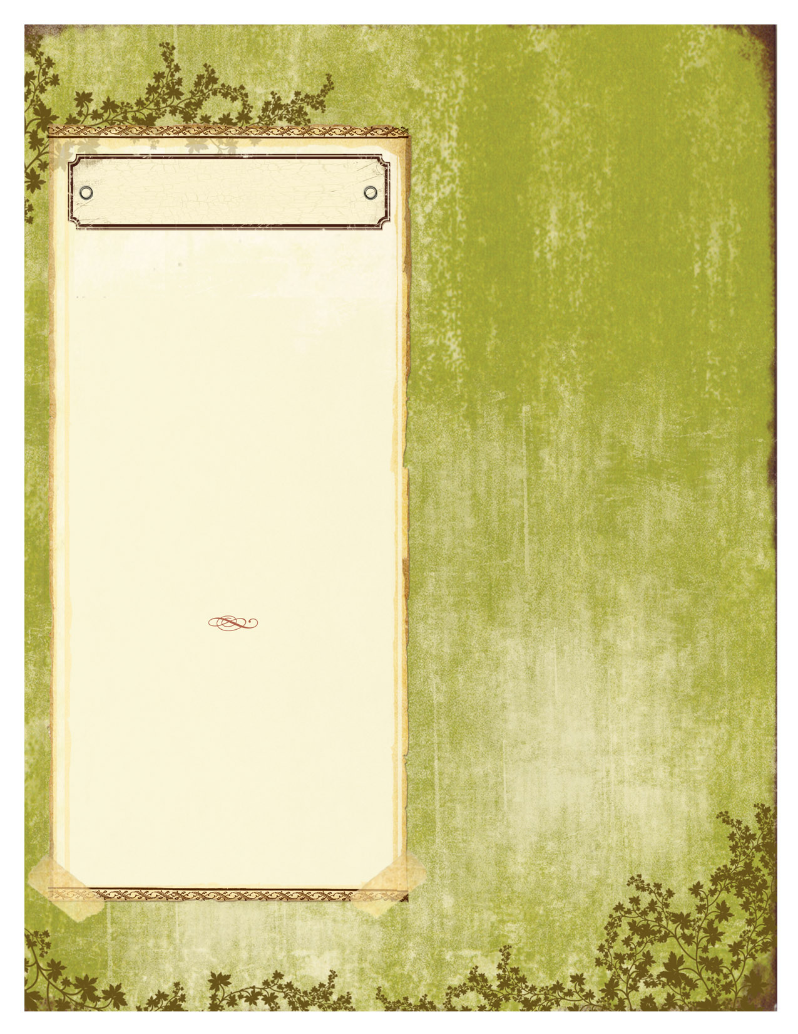

This Lane Cedar Chest is from 1955, handed down for my grandma, it has special importance. The chest was given to her as a graduation present. At the time, the idea behind getting a cedar chest was to keep things in it that would be of use once married.

Straight out of high school, my grandma left for the Air Force, and was unable to bring the chest with her. However, while in the Air Force, my grandma met my grandpa and moved into a house, bringing the chest with her. Being married to a military man, my grandma moved a lot, and this chest went with her to all these places. It’s been overseas twice, once to Germany, and another time to Japan.

This chest is made of beautiful cedar wood, with a birch tone finish. It features two panels on the front, as well as straight lines down the middle of the front panel. Inside, the finish is cherry. When the cover is lifted, a shelf is stowed, attached to the cover, with multiple compartments, perfect for holding small valuables. The cover can be secured with a secrete lock.

Adding to the history of this chest is a burn mark on the top. While giving my father a bottle, the babysitter my grandma had hired dropped a cigarette on the chest and as it rolled down, it burned the top. My grandma always wanted to fix that, but never had the money, and now chooses not to. Her decision to keep the burn is admirable, as it adds something to the character of this chest.

text here. Continue flyer text here. Continue flyer text here. Continue flyer text here. Continue flyer text here. Continue flyer text here. Continue flyer text here.

Continue flyer text here. Continue flyer text here.

Continue flyer text here. Continue flyer text here.

Lane Furniture was established in March on 1912, by John Lane in Altavista, Virginia. The Lane Furniture company proved to be a very respectable company, always providing sturdy and elegant furniture. While Lane Furniture still produces solid furniture, it doesn’t compare the exquisite handiwork of its older pieces.

They have a guaranteed warranty on all of their furniture. It will repair or replace any wood furniture for one year after purchase date.

This particular chest had a moth damage repair warranty, for a repair cost of up $250.00. While this warranty is expired, it was never really needed, as no moth damage was inflicted on the chest.

At the time of purchase, this chest was worth $190. Currently, a chest that was this well preserved, and of this age can be sold for about #300.

Lane Furniture