DIARY ENTRIES 1942
Day 401
The days have really started to blur together and it seems as if the 24 hours in a day are somehow growing longer. It’s hard to remember what happened from one day to the next. Writing down my thoughts and daily duties is helping me to distinguish the days though. I heard our Lieutenant say yesterday that he was so lucky to be alive, even if he is in France. Maybe he’s right but I just can’t seem to use the word “lucky” while people I know are dying almost every day and my closest companion is my M-1 Grand.
Day 406
A man in our platoon died last night. I kept asking around to find out the guy’s name so that I could maybe pray for him and any family he might’ve had, but nobody seemed to even know the guy’s name. I wonder if he had anyone back home that cared…doesn’t seem like anyone here did...God I miss Alice.
Day 407
God truly does work in mysterious ways! Just when I thought he’d forgotten about me he sends a sign! I was digging a foxhole with my E-tool (if you’re alive to read this in a few decades Al, that’s your entrenching tool-Multi-purpose E-tool. Remember?). I hate those things…foxholes. Being confined to a 5ft. deep hole with another man for days on end-UGH! So there I was, just digging; I was cursing this stupid place and thinking of my Alice, wishing I was back home with her. I was getting angry and digging with all my strength (or whatever was left) when I hit something. I was shocked for a second but then realized how many times I had hit one of those damn rocks while digging these damn holes. Something told me to stop though. I looked over my shoulder to make sure none of the other men were watching me. We were all told not to stop until our foxholes were done and we were drenched in sweat. I sure as hell didn’t want to catch the Lieutenant’s wrath. Nobody was paying any attention to me though. They were all cursing under their breaths (or out loud) just as I had been. I slowly got closer to the small indent I had made in the earth but didn’t see anything. I kicked up some of the dirt and saw something sticking out of the ground. I was a little cautious and definitely nervous. I mean hell, this is war! Who knows what could be buried in this area. Once again I felt something pulling me towards the mystery item. After getting my hands dirty with the soil of France, I found it. A horseshoe! Can you believe it?! I guess the Lord hasn’t forgotten me! I heard our lieutenant awhile back saying he was lucky and I couldn’t bring myself to agree-then I find a horseshoe; a symbol of good luck! Now I believe everything will be okay. Even when things seem the bleakest and like I’m never going to leave this damn place, I now know that I’m going to make it.
p.s. I’m planning on bringing this horseshoe back home (I already put it in my pack). I want to show Alice and tell her the story. Aside from her, I think this horseshoe will be the only thing to get me through this. God willing I’ll even be able to show my children someday!

19 Sept 2012
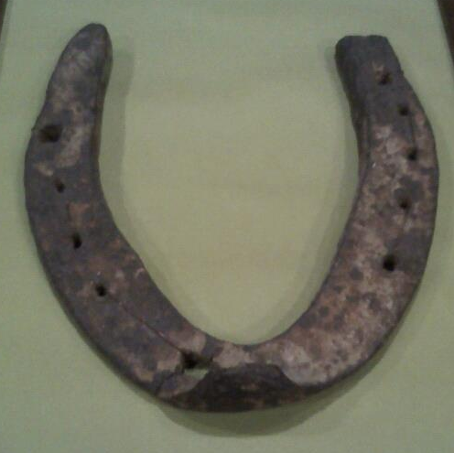
Ms. Hanrath,
First of all we’d like to thank you for bringing in the horseshoe that your grandfather found. At the Gold & Silver Pawn store, we obviously love being able to tell a customer that they’re family heirloom is worth more than they could have ever thought. However, what my dad and I like even more is hearing some really cool stories from people just like you! Thank you for sharing your awesome story with us.
I really don’t know much about horseshoes or anything else pertaining to animals (especially farm animals) and none of the guys in the shop knew much either. I called up Mark Hall-Patton , who is an expert in historical artifacts and works with the Clark County Museum System. Although he agreed that it most likely came from the World War II era like you suggested, he really couldn’t tell me anymore about it. There aren’t any markings on it that could possibly lead him to a particular blacksmith, manufacturer or even a specific geographical location. With that dead end, I asked Dana Linett to swing by and take a look at it. Dana is the President of Early American History Auctions, Inc. in Sante Fe, CA. After looking at the shoe and calling a few of his artifact pals, he said that he thought it was a very interesting piece and knew of a couple people who might be interested in it, but he had no idea how much to sell or auction it for.
Unfortunately the pawn business relies heavily on high demand for an item to sell fast and for a decent profit. I’ve seen old horseshoe’s sell online from anywhere to a few bucks to $100. I have absoulutely no idea how much blacksmith’s would charge for a horse shoe back in the 30’s and 40’s or if you would have to go through a farrier. I found out that shoeing a horse today can cost anywhere from $20-$200 depending on what you’re buying, which hooves are getting shoes, trimming and a lot of other factors. Even after talking with Mark and Dana, we really couldn’t come up with an estimated price for you. I really wish I could give you and your family a better idea of what the shoe could be worth and more about its origin. Lucky for you, you have a story that’s worth more than anyone could ever offer you for that incredible piece of history!
Even though your grandfather has passed, I think it’s really important for you to hold on to this artifact and also pass down the story that goes along with it to your children and other members of your family. The horseshoe definitely did bring your grandpa luck so who knows what it will bring for you and your family?
Best wishes Megan,

Rick “The Spotter” Harrison The Old Man (The Appraiser)
Gold & Silver Pawn Shop
713 Las Vegas Blvd S
Las Vegas, NV 89101

