A Nontraditional Tradition
My family has always been musical. My mother sings alto and plays clarinet and piano; my brother played trumpet in high school; my dad sings and plays guitar; my sister sings alto and plays saxophone, flute, guitar, piano, and mandolin; and I sing alto and play clarinet, flute, saxophone, guitar, piano, and cello. We could probably form a band if we wanted to, but none of us has ever made an instrument. Unfortunately, that skill has been both gained and lost in our fairly recent past.
My paternal grandfather, Clarence Miller, was a tobacco farmer in Kentucky. As far as I can tell, his main hobbies were music-related, though he also enjoyed playing checkers. He played guitar and sang (or tried to—he was not blessed with a beautiful voice or an impeccable sense of time), and he taught himself how to play violin. His playing and singing skills might not have been as advanced as those of our family now, but he made his own instruments. To someone who is not aware of the complexities of whittling and shaping wood, of teasing metal strings and movable parts into the right positions, the previous sentence probably didn’t sound too impressive. Grandpa had his own methods, though—he crafted his instruments with his own personal flair and he had a lot of raw talent. For instance, he sometimes whittled out guitar necks…with an axe. Of course, he’d use more appropriate tools to smooth it once he got to finer details, but my dad recalls that Grandpa was capable of wielding awkward tools with unusual finesse.
I never saw Grandpa at work on his instruments. He passed away in 2000, and he never passed on his skills. Unfortunately, instrument making isn’t a tradition in my family the way quilt making is in “Everyday Use.” The ability to make instruments in my family started and ended with Grandpa. He probably would have passed on his skills, but his only son’s talents were elsewhere—Dad couldn’t whittle a round peg, let alone a guitar neck. In fact, no one taught Grandpa how to make instruments. In the 1950s or maybe earlier, he acquired a couple of broken guitars and repaired them. He decided that if he could fix them, he could make them, and so he did. He was a talented woodworker to begin with, and he could handle small details. That man could even paint beautiful scenic pictures. He was a genius in an unorthodox way; I wish I had known him better. My paternal grandparents lived in Kentucky during my lifetime, and I only got to see them during some summers. We have a couple of Grandpa’s instruments in our home in Wisconsin—a guitar and a violin. Both have been played regularly in the past, but they’ve mostly been in storage or on display for the past couple of decades. The guitar is just as fascinating, but the violin will be the main focus of this project. *I have included pictures at the end of this document because those who have no knowledge of stringed instruments need to see them to understand some of the concepts in this paper.*
The violin is similar to a typical violin in shape, size, and weight…well, perhaps it’s a little heavier than usual because of its untraditional components, which I will explain in a moment. When I run my fingers over it, the texture is smooth and dry, and I can feel and hear the presence of the hollow inside. The wood is very blonde and is not varnished with the eye-blinding shine that most stringed instruments have (see Figure 1). The difference between the tuning mechanisms is also apparent when Figure 1 and Figure 2 are compared—Grandpa’s violin has metal tuning gears which were intended for use with a mandolin, and the violin has straight pegs to tighten and loosen the strings. Also related to tuning, there is another significant difference between a typical violin and Grandpa’s version—on the tailpiece (see Figure 3), there would normally be four small pegs called fine tuners that adjust the four strings’ tightness by tiny increments, but Grandpa didn’t include them. This is probably because the mandolin tuning gears already allow for easier tuning than straight pegs, which tend to overcompensate or do other annoying things when you try to use them for fine tuning. I know; I’m a cellist. The tailpiece is also unusual because these days, tailpieces are not usually made of maple (compare Figure 1 and Figure 3) because it is not as resonant and hard as other woods like rosewood, boxwood, or pernambuco. Baroque instruments often had maple tailpieces, but the instruments back then were not intended to be loud.
Grandpa used Elmer’s wood glue to hold the body of the violin together, which would probably make every instrument maker I’ve met (along with my cello teacher) cringe if they knew about this instrument’s construction. Normally, hide glue is used, and it’s a weak glue. The weakness of the glue is actually an asset because when a violin is exposed to changes in humidity and temperature, the wood will expand or contract accordingly, and if the glue holding the components together is too strong, the wood itself will crack. It is far preferable to have the parts of a stringed instrument separate at the seams than to have a crack in the wood, so hide glue is important because it usually gives in to the pressure before the wood does. If seam separation occurs, it’s a simple matter to have it re-glued if hide glue was used. So, as a result of the rigidity of the glue Grandpa used, his violin has another distinct feature: a five-inch-long crack in the back (see Figure 4). The sight of this crack would probably make any string player cry, but my family figures the wood has settled by now and won’t crack any further. It’s possible to get it fixed. It would be expensive, but it might raise the value of the instrument, although its current condition is exactly as Grandpa made it with no modifications.
The back of the violin (the piece with the crack in it) is yellow poplar; the neck, fingerboard, and tailpiece are maple; the top is spruce; the strings are probably mandolin strings; and heavy-gauge insulated copper wire holds the tailpiece to the instrument. Spruce and maple are normal woods to use with stringed instruments, but I’ve never come across a violin with a yellow poplar back before. Maybe if it had been made of maple as normal violin backs are, it wouldn’t have cracked—Dad actually stated that theory during a phone conversation on 10/7/12. It’s also possible that the back of the violin didn’t quite fit the front, but I doubt it. Grandpa had another instrument-making quirk. He almost never measured, and Dad told me that Grandpa never had a failure based on structural or measurement problems before. The violin is the only instrument of his that cracked, and it’s pretty minor, considering.
Not only did Grandpa make a violin, but he also made two violin bows out of black walnut—one strung with nylon “hairs” (actually they were lightweight fishing line), and the other with actual horsehair that he got from a horse’s tail. Both of his bows are still strung the way he strung them, so they don’t work anymore. We’d have to re-string them if we wanted to use them. Bows are very complicated to make, as they require a tightening mechanism to raise and lower the tension on the hairs. Also, if the hairs are too coarse or if there are too many, or if the wrong rosin is used on the bow, the friction could break a high violin string. Amateur though he was, Grandpa must have mostly known what he was doing. I think he was somehow emulating the really old ways of making instruments, because I showed one of my friends a picture of the violin bows he had made and she said, “Wow! That looks like a Baroque bow!” When I remembered this, I realized that the violin does look very old-fashioned. Grandpa had no Internet access because it didn’t exist yet, and I don’t think he was a scholar at all. He must have stumbled upon these Baroque-like techniques by himself and by making his own version of instruments he fixed. Had he been trained as a luthier (a string instrument maker), the quality of his instruments would have been phenomenal and this violin would have automatically been more valuable. Another Baroque quality of Grandpa’s instrument handling was the fact that he tuned them a half step lower than concert pitch. It’s not likely that he came across this information in the working-class life he led, but he knew that higher string tension was harder on instruments and he (probably) unconsciously used Baroque techniques, also known as Baroque tuning.
The value of this instrument is very hard to assess, as it is unique and made up of unusual components. A typical amateur violin maker could sell his or her violins at a price anywhere between $500 and $4500 (http://www.maestronet.com/forum/index.php?/topic/274399-determining-price-of-handmade-violin/). I honestly have no idea how to assess a violin made with components that are not usually on violins, and in order to get a clear picture I would have to take it to the Antiques Roadshow or something similar, along with a full historical account. I believe the history of this instrument and its maker, along with a description of what other instruments he created, would be closely tied with the monetary value of the violin. Our culture seems to value prodigies (i.e. people who have a natural knack), so maybe Grandpa’s lack of training would have been in his favor. People will pay whatever they feel things are worth, and monetary value is very subjective anyway. Grandpa took his time with his instruments and thought everything through, so he definitely put his best effort into everything he made, using the things he could acquire with what little money he had. I would say the violin is more valuable now than it was when it was finished because it has stood up to the test of time. Other than the crack in the back, there are no structural problems. If we put new violin strings on it and got the crack repaired, it would be a fully functional violin. Perhaps not at concert pitch, though.
Years ago, Grandpa traded an arch-top guitar he’d made to acquire a washing machine, and he never dreamed that his wife’s brother-in-law would sell the guitar for $100 after the trade. That was probably back when $100 was like $500, at least, in today’s money. The family is still a little sore about that deal because we wanted to keep as many of the instruments as possible in the family’s possession. Judging by that, I would say the main value of the violin is its sentimental value. This instrument is no Stradivarius, since Grandpa built it for strength and never researched methods for the best tone, but almost all of his instruments have a pleasing, unique tone. We keep the ones we still have in memory of him and Grandma, who made the tag for the inside of the violin (the only reason we knew when it was made). One story that Dad told me about the violin is that Grandpa joked about how hard it was to curl the scroll (see Figure 2) when no such curling actually took place (it is carved). I’d say we are at a happy medium when it comes to Grandpa’s artifacts—we aren’t quite like Dee in “Everyday Use” (she would be ignorant of their sentimental value and their use), and we aren’t quite like Maggie either (using them every day until they wear out, but able to produce more of them). We display the instruments, talk about their history, keep them safe, and play them gently because they are precious things shaped by Grandpa’s hands. We cannot make more of them, but our artistic, musical family understands the considerable effort and talent that went into making them.
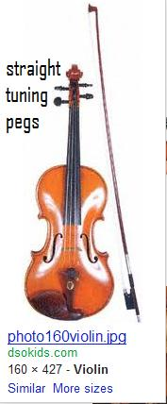 Figure 1—a typical violin

Figure 2 (below)—the scroll and tuning gears of Grandpa’s violin (photo by Michael Miller, my dad)
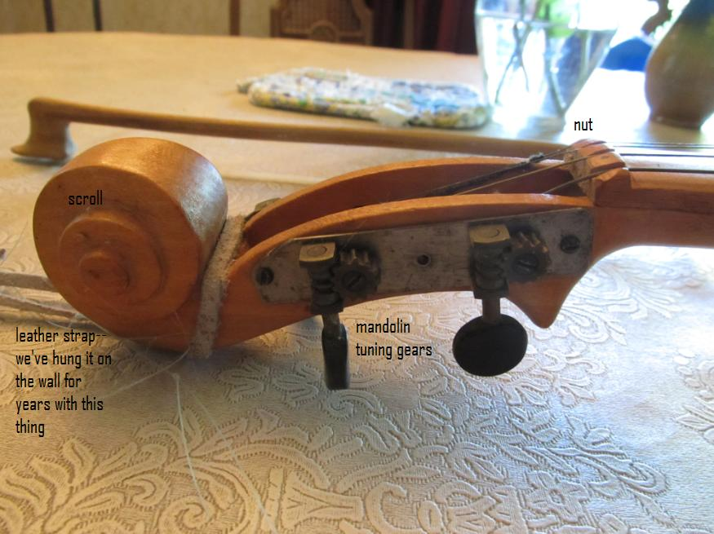
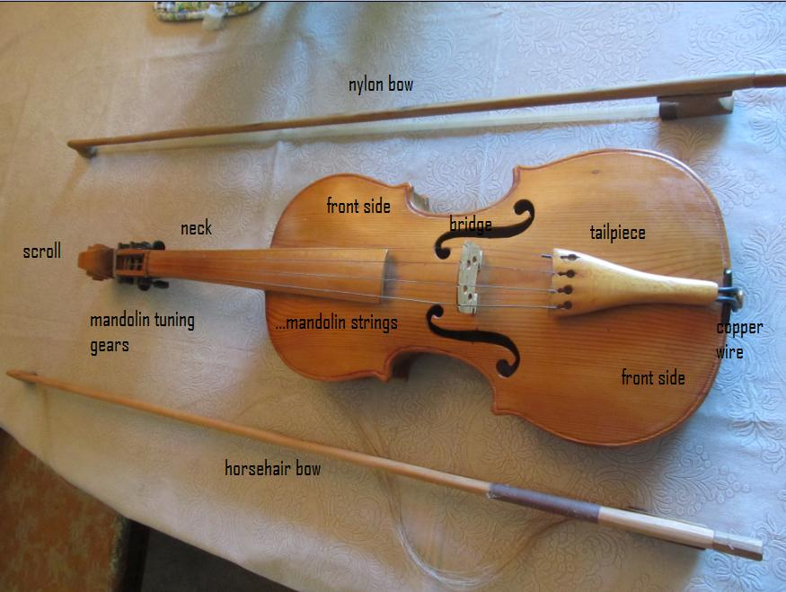
Figure 3 (above)—front view of Grandpa’s violin, along with handmade bows (photo by Michael Miller)

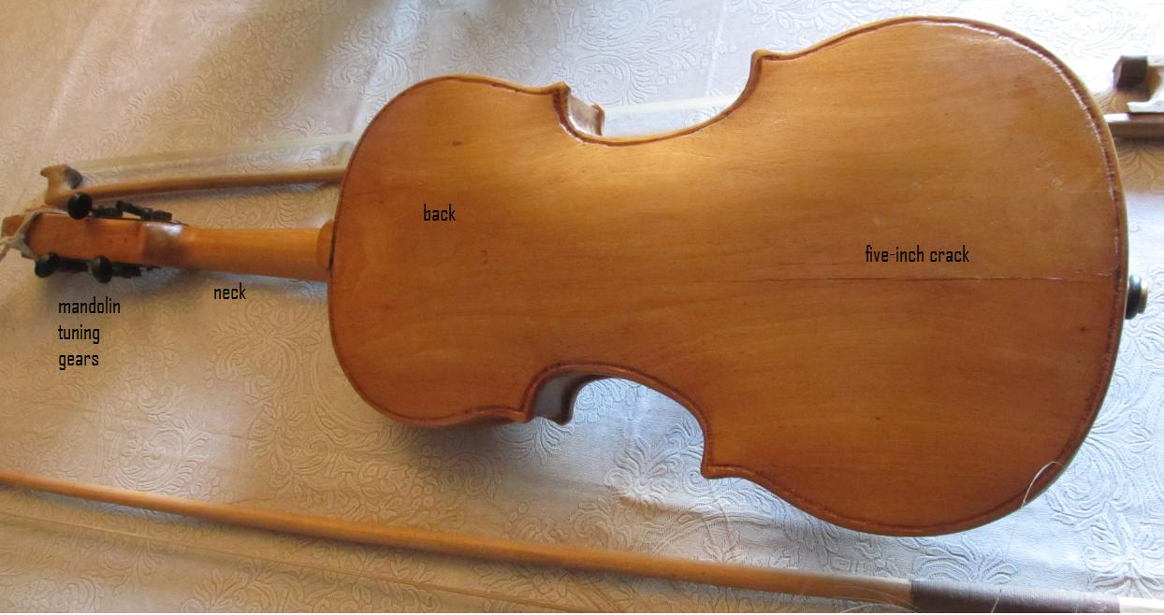
Figure 4—the back of Grandpa’s violin, including the noticeable crack (photo by Michael Miller)

