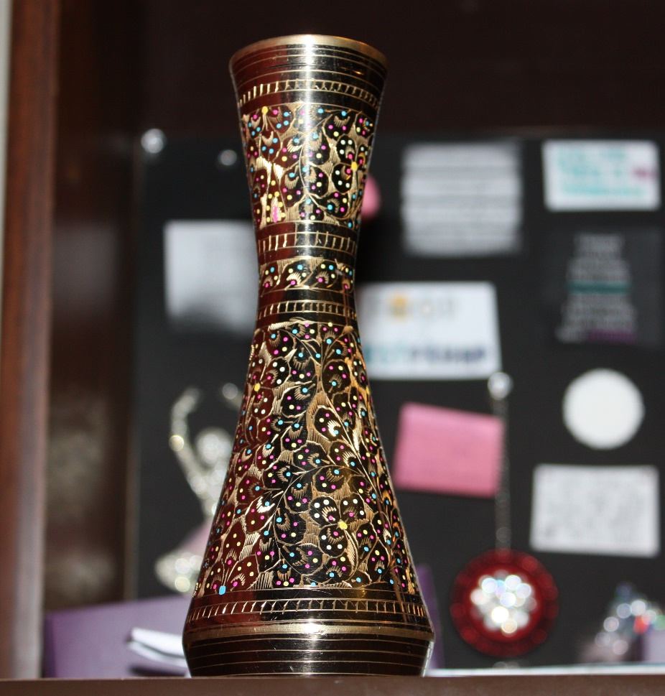The artifact that I picked is a gold vase, beautifully hand carved with beautiful, neat and delicate patterns on it. It is shiny, glossy and has small colorful paint dots on it that make it one of a kind. This art is called “Meena Kari”. The vase is about 8 inches in height and it is pretty heavy because it is made out of gold. It’s very lustrous, sleek and shiny with fines edges. It does have an old smell to it. To me, it smells like sand.
The artifact is about 300 years old. It was made by somebody in my ancestors in 1700s and it just went down the family like that. So, my grandfather got it from his father and now my grandmother has it because my grandfather is no more but after my grandmother my uncle will have it and it will go down in his family because he is the oldest in my dad’s siblings. This handicraft was personally made by somebody in my ancestors and his name was Syed Qutub Qazi and he used to live in the province of Rajasthan in India. It has always been in our family and is thought to always be in our family too. Nobody in our family now knows exactly how to do Meenakari. But it can be found in artifacts markets. Meenakari is still famous and people still buy Meena but it’s no longer commonly done on gold and it is no longer a family thing. It has become like a cultural thing and people from the villages do it to earn money even when their families don’t have a Meenakari background.
Meenakari basically is the art of coloring, decorating and ornamenting the metallic surfaces by fusing colored materials such as cobalt oxide for blue and copper oxide and are adorned in a very complex design. The Mughal Emperors of Indian subcontinent invented the art of Meenakari and it was in trend for both the Mughals and the princes of Rajasthan. My family is from Rajasthan, India. My grandparents migrated to Pakistan during the partition so we don’t live in that part anymore. Meenakari is a hereditary craft and in the time when this artifact was made it was rare that outsiders were allowed to acquire any knowledge of our craft. The process was long and extremely complex. During this process one piece of Meena was decorated by several people before it was considered ready.
Gold has been used for Meenakari because it holds the enamel better and does really last longer and its vibrant yellowish glow really brings out the colors of the enamels and makes it even more attractive. Also gold is very expensive so it is just a matter of pride too. Silver was not used for Meenakari in the early days but later on people started using silver too because it was cheaper and so if they did Meenakari on silver the art would become more common and more common people would buy it and keep it, wear it and so in that way the art will be preserved too. So silver is used for artifacts like boxes, bowls, spoons, and art pieces while Copper or brass which is used for handicraft products were introduced only after the Gold Control Act. Even in that time when this vase was made, it was very expensive firstly because it was a royal art and secondly because the vase was made out of gold. I don’t know what its exact value but recently a man offered us 1 Million Rupees for the vase but my grandma refused the offer because the vase can’t go out of the family and according to our family it doesn’t equal any amount of money.
The traditional process of Meenakari starts with the designer then the goldsmith does his work and then it goes to the engraver who engraves the design, the enamellist who applies the color then to the polisher, the stone-setter, and the stringer, all of whom are equally important in the chain of craftsmen that create the finished product. However, due to a fairly small number of skilled people often a single person does everything as it is the knowledge expanded over the years.
The Meenakars engrave the surface of the metal with elaborate patterns and designs using a metallic stylus which is then later filled in with colors. The Meena craft is then placed in a furnace where the colors fuse and they basically harden to become unified with the surface. The piece is the filed and cleaned with a mixture of lemon and tamarind that emphasizes the luster of each color. Before enameling, the surface of the ornament is carefully cleaned. The colors emerge only when the crafts are fired in the kiln. The average firing temperature is about 850 degrees Celsius.
When my grandfather got this vase from his dad, he knew that it was something very important and he has to keep it safe but during the migration from India to Pakistan, he lost that vase because everything was chaotic and there was no proper transportation and people were being killed. But when he came to Pakistan, and found out that the vase was missing, he became worried. He wasn’t worried that he left his home and his lands behind in India but he was worried about the Meena Vase and then he announced on the radio that whoever finds the vase will get a big prize but fortunately he found out that it was in his neighbors luggage and he didn’t have to give a prize to anybody but it was surprising for me that he cared about a vase and his lands.
The usage is similar, our ancestors used it for decorating and so do we but we use it as if we might not have such a piece ever again but they used to do it and so they knew the process but we take it as an artifact because nobody in our family knows how to do Meenkari. Although I might not become the owner of this artifact, I deem it very important for our family.
