Kevin Holzworth, Assistant Professor of Automotive Technology
2017 OER for Little River Institute
OER Title – Student-generated lab demo videos
Activity – Peer-to-peer instruction

With class sizes reaching 20:1, instructors are unable to view how students are satisfying learning objectives. This leads to poor student performance and unrealistic outcomes.
Tharp’s Standard IV: Modeling and Demonstration: Learning through Observation

This activity was achieved by instructor generated lab videos that students then duplicated. This modeling technique helps bridge the gap between industry expectations and college learning outcomes. By demonstrating the exercises, students can then “model” how it’s done in the industry. This provides the educator one on one interaction without physical presence of the educator.
Instructor tools, technologies & materials –
- Smartphone, GoPro, or other video recorder
- Internet access and a Gmail account so that Google Form and YouTube are available.
- Lab worksheet & grading rubric (all worksheets and links appended to this document)
**It's helpful if the instructor has an iPad or other tablet for student use in case there is a lab group without a smartphone available.
Student tools, technologies & materials –
- Smartphones if available
- YouTube app such as YouTube capture (free)
- Lab worksheet & grading rubric
- Google Form submission link from instructor

Activity Sequence
Step 1: The instructor creates short (2 min.) demo video that pertains to lab learning outcomes. In this instance, my video demonstrates a routine pressurized cooling system test.
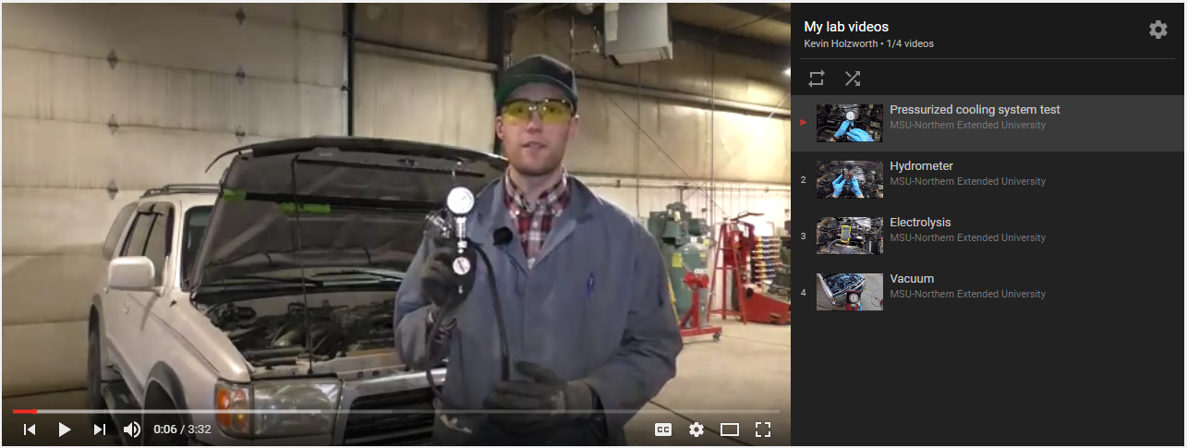
Instructor demo link: https://www.youtube.com/watch?v=FDgPwonzHGE&list=PL5QtNN5uXqt23zF52IJtzCoi8qkwcuLKS
Step 2: Instructor makes video available to students on D2L or other learning management system. Students can either view the demo video on
their own or the instructor can show the video in the classroom preceding the lab. Especially if lab space is tight, showing a video
instead of a live demonstration can ensure that all students see the
task to be performed.
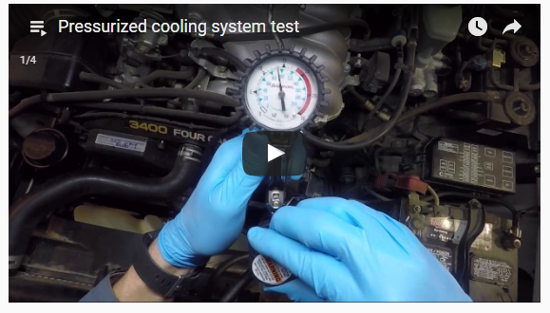
Step 3: Students view the video to get idea of how to perform the
demonstration and satisfy the learning objective.

Step 4: Students “practice” exercise and complete lab worksheet prior to
generating video for instructor viewing.

Step 5: Students create a lab demo video modeled after instructor demo.
The first time they do this, students must download and use a
YouTube based app. At the beginning, students may need guidance on how to use the app to create videos and import straight into
YouTube.
**Students should be warned that there are different
privacy settings on YouTube: private, public and unlisted. If they want the video to be share-able to the instructor but not available to
the public, they should mark it as "unlisted."
Step 6: Once students have completed the demo video to their satisfaction,
they need to submit it to the instructor. To do this, they need to copy the the YouTube video url and submit it in the Google Form
provided.

See Appendix 2 for more info on creating a Google Form for link submission.
My form is here: https://goo.gl/forms/3R719EHFTBtV62dC2

The following image shows the Google Form link for my course on the D2L platform and an image of what the form looks like to students.
The Google Form automatically generates a spreadsheet with the video links and all of the student information submitted. The spreadsheet creates a nice
overview of student work completed and makes for easy grading.

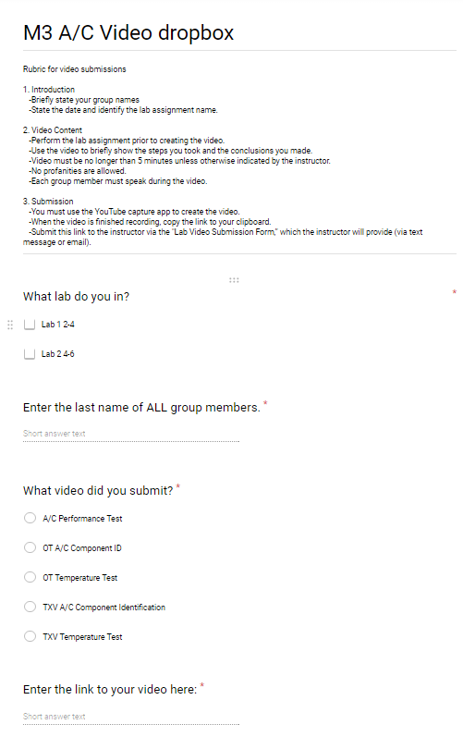

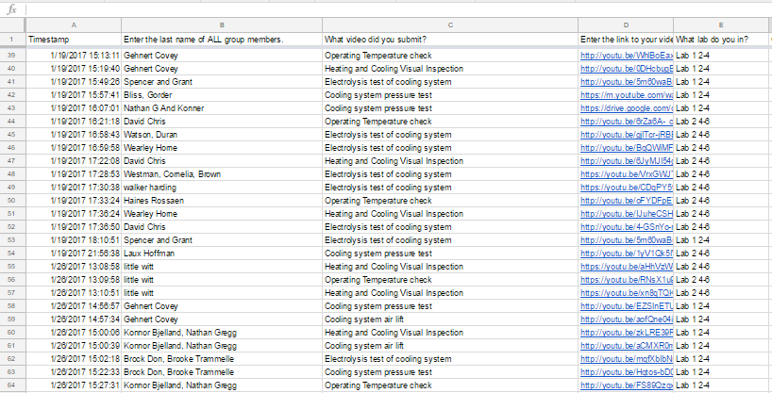

Step 7: Once steps 1-6 are complete, instructor can grade the video by
clicking on the links submitted. This gives the instructor the
opportunity to focus on monitoring and helping students during the lab because he/she can view and grade the student after class time.
The sample grading rubric is appended to this document.
Sample student video: https://youtu.be/1yV1Qk5lVSQ

Review and Revision

Initially, the students were hesitant to the entire process but once they discovered how easy and interactive the activity was, they excelled greatly. By modeling and demonstrating the objective, the students understood how I performed the objective, which gave them a firm understanding of what I expected out of them. This entire process proved that the students learned how to work together by talking and interacting with each other without my supervision. A huge majority of my students modeled and spoke with the same jargon that I used in my videos.

I regret to say that this activity should be used sparingly and for the most important parts of your lesson plan or module. For example, my students produced nearly 275 videos over the course of 10 weeks. I would recommend requiring not more than 10 throughout the entire semester.
The student video assignment, being a somewhat formal format, also gives them a chance to practice speaking and demonstrating tasks in a professional manner.
I found that students performed their lab objectives much more thoroughly than they did previously. They also took a lot of ownership in their videos and easily took on the role of instructor when demonstrating the tasks at hand.

Appendix 1: Lab objective & grading rubric
Sample grading rubric
https://docs.google.com/document/d/1mPBLJy667-ytkaHr4JkTtLHZh3DHjeTLwZG40g_-4EM/edit?usp=sharing
Appendix 2: How to create a Google Form
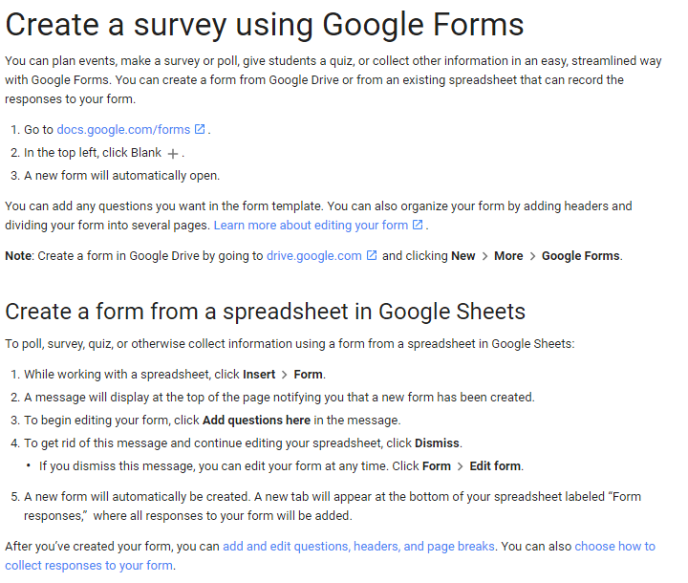
Create a survey using Google Forms - Docs editors Help. (n.d.). Retrieved April 21, 2017, from https://support.google.com/docs/answer/87809?hl=en

